**Preface**

**What Is Data Science?**

Data science comprises three distinct and overlapping areas: the skills of a statistician who knows how to model and summarize datasets (which are growing ever larger); the skills of a computer scientist who can design and use algorithms to efficiently store, process, and visualize this data; and the domain expertise—what we might think of as “classical” training in a subject—necessary both to formulate the right questions and to put their answers in context.

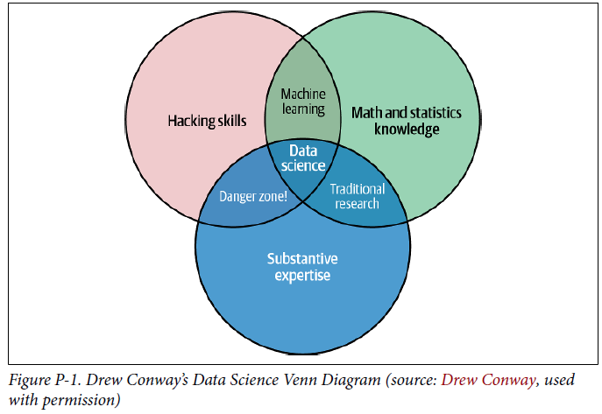

**Why Python**

* NumPy for manipulation of homogeneous array-based data,
* Pandas for manipulation of heterogeneous and labeled data,
* SciPy for common scientific computing tasks,
* Matplotlib for publication-quality visualizations,
* IPython for interactive execution and sharing of code, Scikit-Learn for machine learning

**Jupyter: Beyond Normal Python**

**Getting Started in IPython and Jupyter**

* **IPython shell** for trying out short sequences of commands
* **Jupyter Notebook** for longer interactive analysis and for sharing content with others
* **Interactive development environments (IDEs)** like **Emacs** or **VSCode** for creating reusable Python packages.

**The IPython Shell**

* Start the *IPython Shell* by typing ipython in the *Anaconda Prompt*.
* Launch Jupyter lab (?) $ jupyter lab

**Access documentation** with help() like help(len). The alternative is ? like len?. Get information on objects using ? like in the example below:

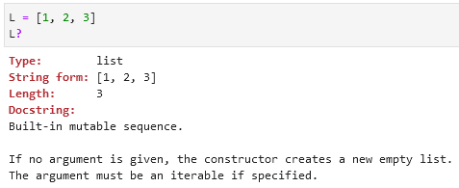

You can also get information on functions or other objects you create like in the example below which has a docstring (a description of the function):

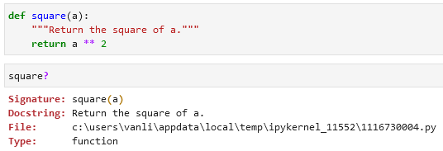

?? provides the source code of the object you are curious about:

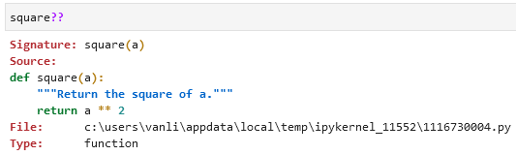

Use wildcard matching (character *) to list every object in the namespace whose name ends with *Warning*:

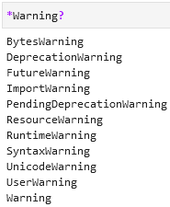

In the example below we area looking for a string method that contains the word *find* somewhere in its name:

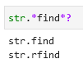

**Keyboard Shortcuts in the IPython Shell**

**Navigation Shortcuts**

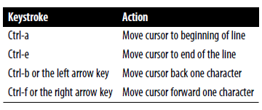

**Text Entry Shortcuts**

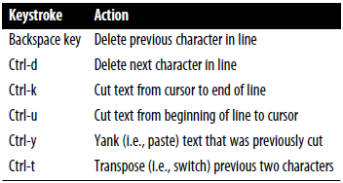

**Command History Shortcuts**

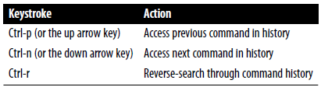

Use *Ctrl-r* to browse the search results. When you’re done press *Enter*.

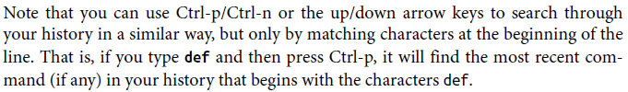

**Miscellaneous Shortcuts**

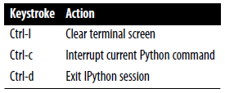

**Enhanced Interactive Features**

**IPython Magic Commands**

Magic commands are prefixed by the % character.

* **Line magics** are denoted by a single % prefix. They operate on a **single line of input**.
* **Cell magics** are denoted by a double %% prefix and operate on **multiple lines of input**.
* Magic commands documentation %magic.
* Quick and simple list of all available magic functions %lsmagic.

If you have a *.py* file you can execute it / run its script in IPython using %run filename.py:

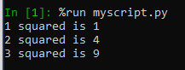

To time code execution use %timeit or %%timeit for multiple lines of code:

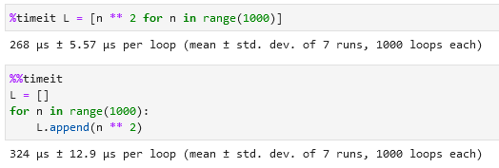

You can check you input and output history using In and Out codes. You can also select specific steps like print(In[1]).

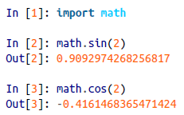

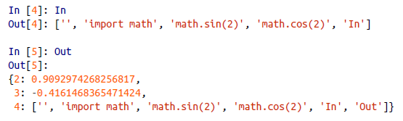

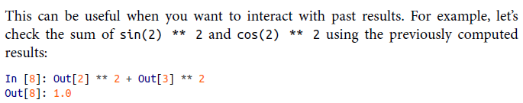

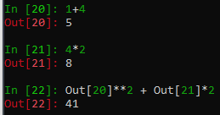

An alternative to Out[20] is _20:

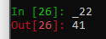

Use print(_) to get access to the previous output:

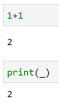

You can also use print(__) and print(___) to get access to the second/third-to-last outputs.

If you want to suppress you output you can do it using ; at the end of the line:

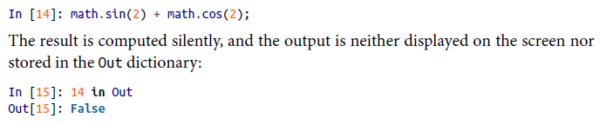

Use %history to get an overview of your commands, use %history -n to get an numbered overview of your commands. To select a command/commands add a number like 3-5:

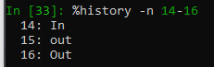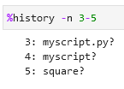

Other useful commands are %rerun (re-execute some portion of the command history) and %save (saves some set of the command history to a file).

**Quick Introduction to the Shell**

Some shell commands:



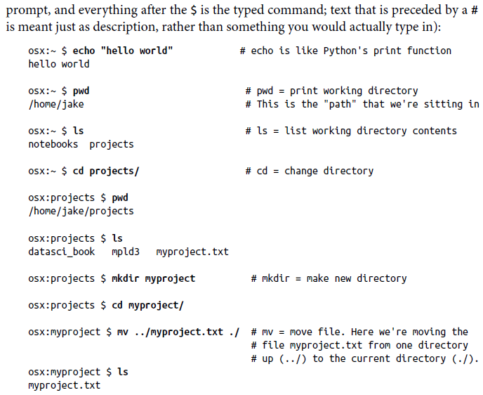

echo, pwd, ls, cd, mkdir, mv

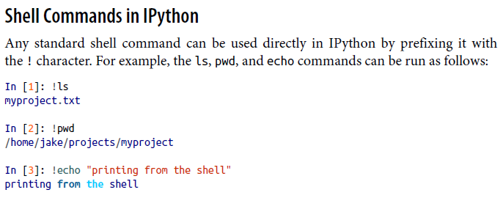

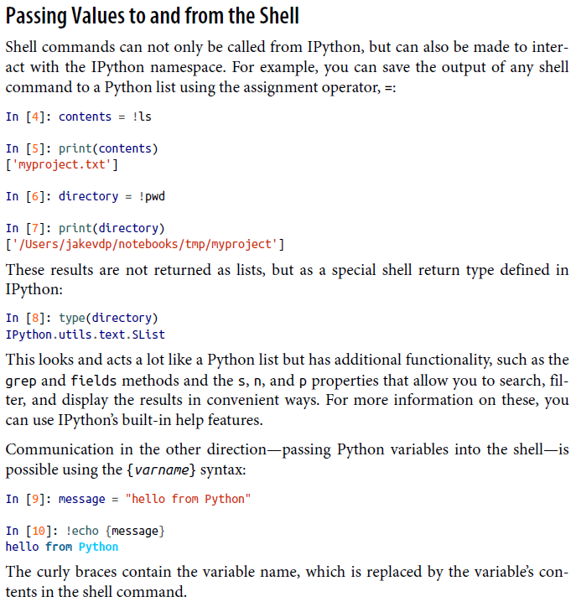

!echo

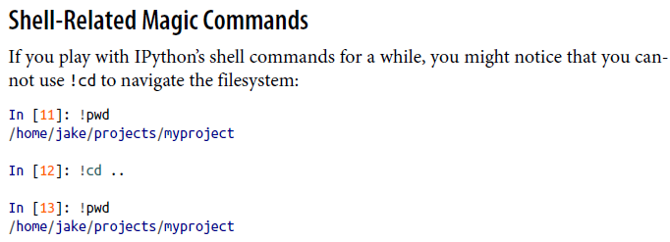!pwd !cd

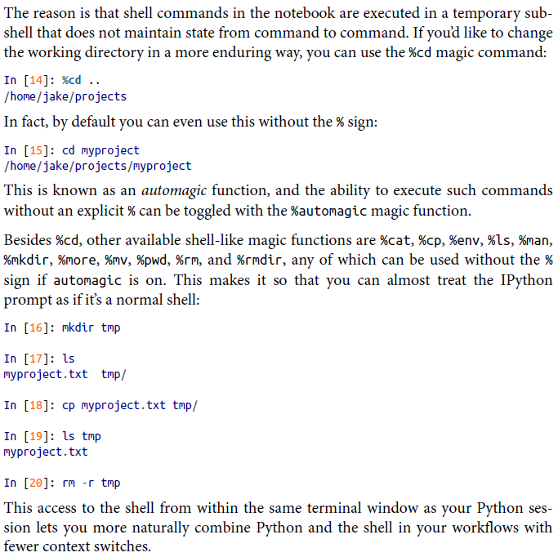%cd mkdir ls cp rm -r

**Debugging and Profiling**

**Controlling Exceptions using %xmode**

There are 3 formats for errors: Plain, Context, and Verbose.

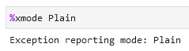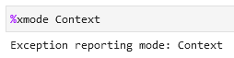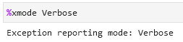

The last provides the most information but can be bulky.

**To launch a debugger** write %debug.

**Launch the Sdebugger automatically** whenever an exception is raised using

%xmode Plain

%pdb on

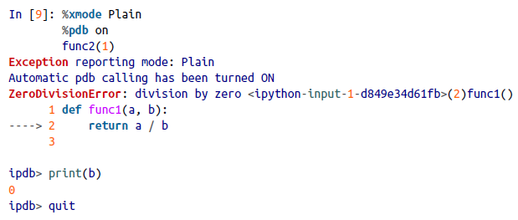

**Partial list of debugging commands:**

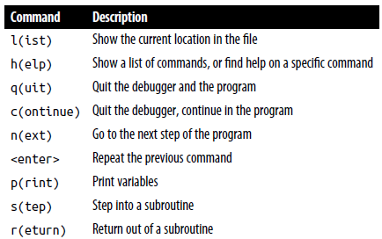l(ist) h(elp) q(uit) c(ontinue) n(ext) <enter> p(rint) s(tep) r(eturn)

**Profiling and Timing Code**

%time Time the execution of a single statement

%timeit Time repeated execution of a single statement for more accuracy

%prun Run code with the profiler

%lprun Run code with the line-by-line profiler

%memit Measure the memory use of a single statement

%mprun Run code with the line-by-line memory profiler

%timeit

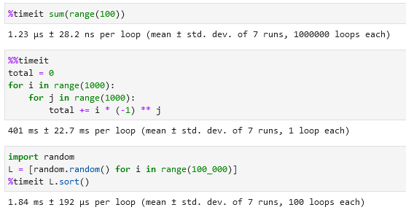

%time

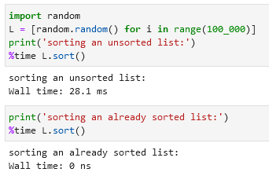

%prun

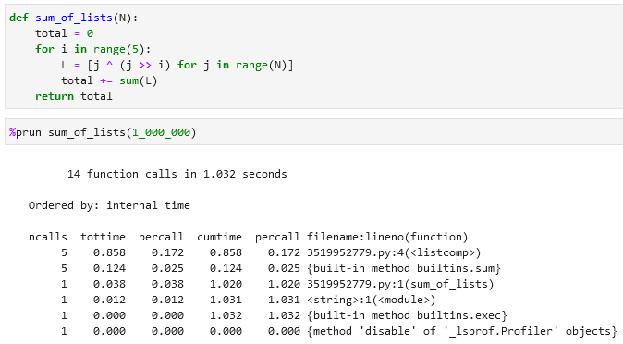

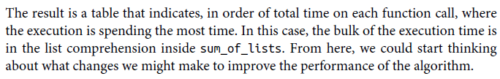

%lprun

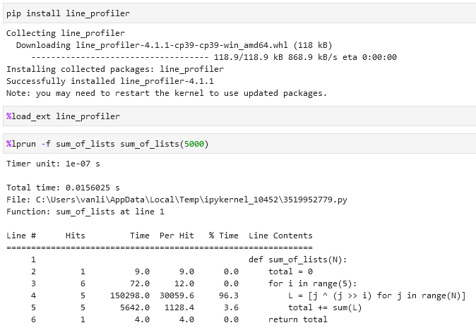%load_ext line_profiler %lprun -f

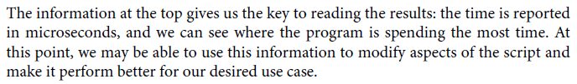

%memit (is a memory-measuring equivalent of %timeit) and %mprun (memory-measuring equivalent of %lprun)

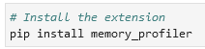 pip install memory_profiler

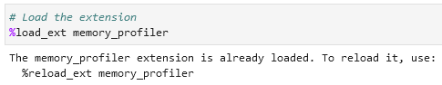%load_ext memory_profiler

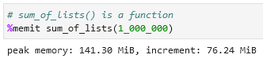 %memit

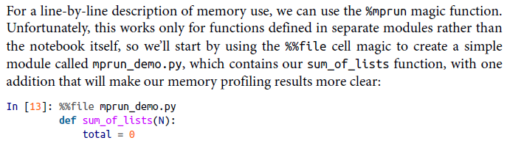

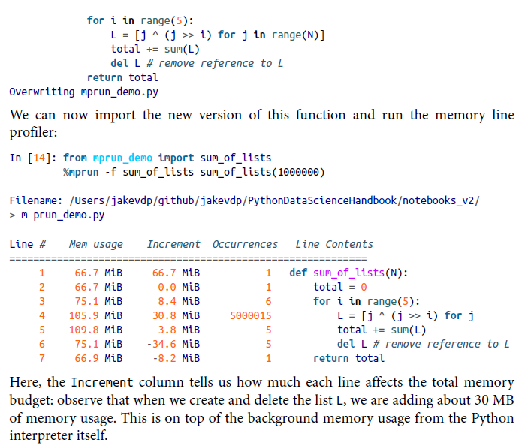

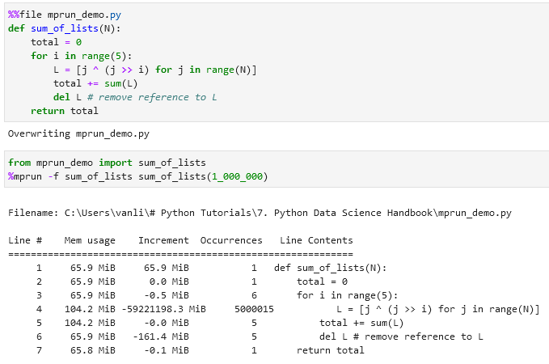%%file %mprun -f

**NumPy**

In some ways, NumPy arrays are like Python’s built-in *list* type, but NumPy arrays provide much more efficient storage and data operations as the arrays grow larger in size.

Check NumPy version: numpy.__version__

**Fixed-Type Arrays in Python**

Example of an array in Python:

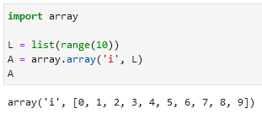import array, array.array



Python arrays objects provide efficient storage. NumPy adds to this efficient operations on that data.

**Creating Arrays from Python Lists**

NumPy arrays can only contain data of the same type. This is unlike Python lists.

NumPy arrays can be multidimensional. Python lists are always one-dimensional sequences.

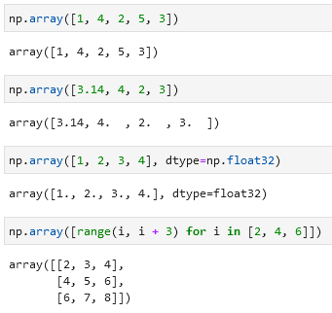

**Creating Arrays from Scratch**

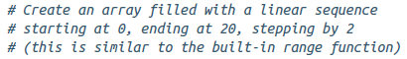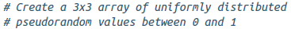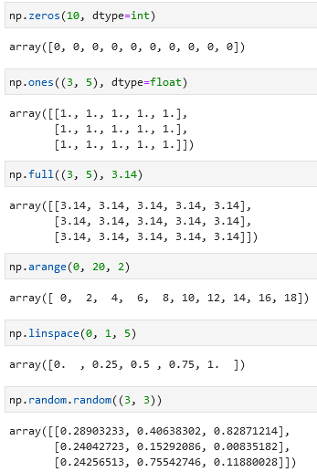

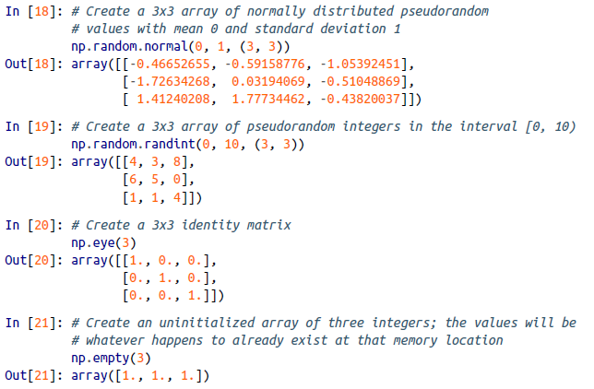

**Specify data type when creating an array using dtype=’int16’ or dtype=np.int16:**

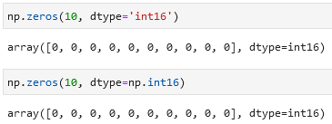

**Standard NumPy data types:**

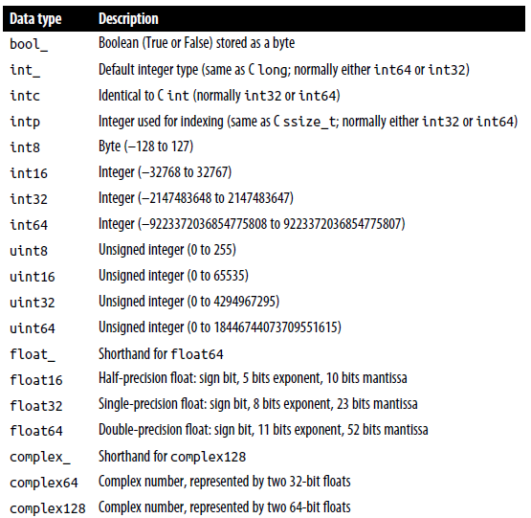

**NumPy Array Attributes**

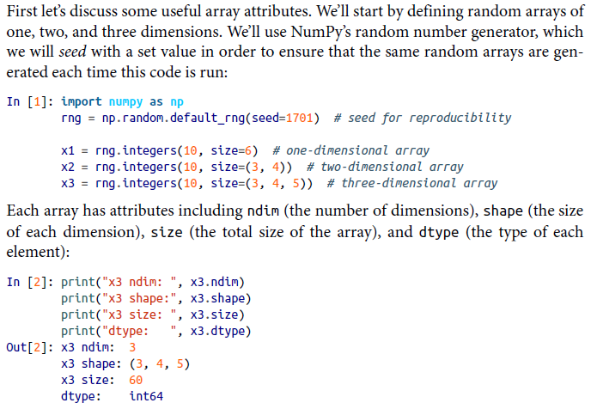

ndim, shape, size, dtype, default_rng(seed= integers

**Array Slicing: Accessing Subarrays**

Follow this logic to access a slice of an array x:

x[start:stop:step]

If any of these are unspecified, they default to the values start=0, stop=<size of dimension>, step=1.

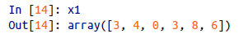

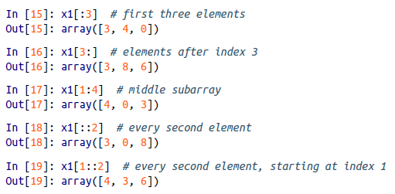

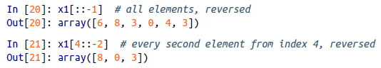reverse an array [::-1]

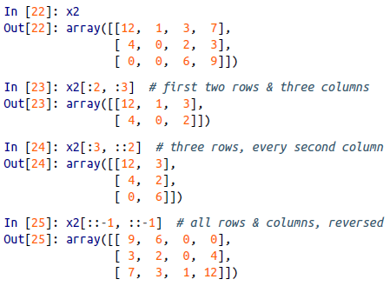reverse a multiarray [::-1, ::-1]

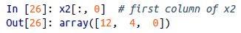 first column of a multiarray [0, :]

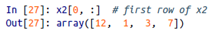 first row of a multiarray [0] or [0, :]

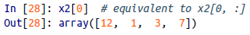

**Subarrays as no-copy views**

Unlike Python list slices, NumPy array slices are returned as views rather than copies of the array data.

In the example below if we modify the subarray *x2_sub* the original array *x2* will also change.

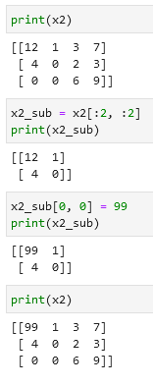

It can be advantageous when working with large datasets. We can access and process pieces of these datasets without the need to copy the underlying data buffer.

If you want to create a copy that can be changed without affecting the original data use the .copy() code:

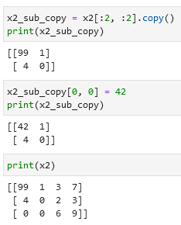

**Reshaping of arrays**

Use .reshape() to put if you want to put e.g. numbers from 1 to 9 in a 3 × 3 grid:

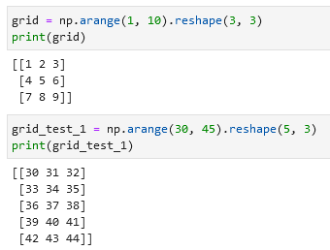

Note that the size of the array should match the size of the reshaped array.

You can also use .reshape() to convert a one-dimensional array into…

…a two-dimensional row matrix: …or a column matrix:

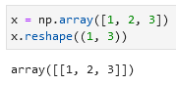 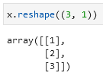

You can achieve the same using np.newaxis in the slicing index:

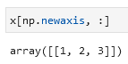 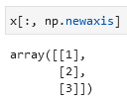

**Array concatenation (combine multiple arrays into one)**

Use np.concatenate, np.vstack, and np.hstack to join two arrays.

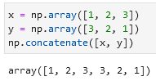 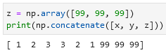

Concatenate a two-dimensional array along the first axis: …and among the second axis:

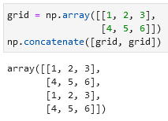 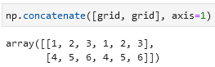

When you have arrays of mixed dimensions you can use np.vstack and np.hstack:

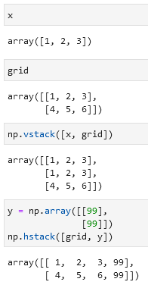

For higher-dimensional arrays np.dstack will stack arrays along the third axis.

**Array splitting (split a single array into multiple arrays)**

To split arrays use functions np.split, np.hsplit, np.vsplit.

Using np.split(array_name, [splitting_location(s)]):

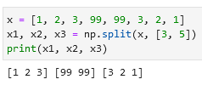

Splitting using np.hsplit and np.vsplit:

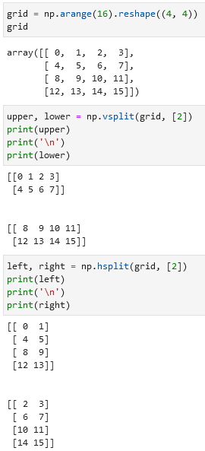

For higher-dimensional arrays np.dsplit will split arrays along the third axis.

**NumPy universal functions (ufuncs)**

To make computation on NumPy arrays fast use vectorized operations that are generally implemented through *universal functions (ufuncs)*.

There are *two types of ufuncs:*

* *Unary ufuncs* operate on a single input
* *Binary ufuncs* operate on two inputs.

**Arithmetic operators examples in NumPy:**

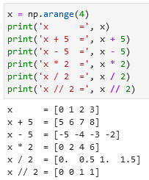 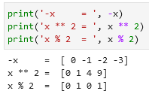

- is negation (turn *1* into *-1*), % is an operator for *modulus \**.

These arithmetic operations are convenient wrappers around specific ufuncs built into NumPy. For example, the + operator is a wrapper for the np.add() ufunc:

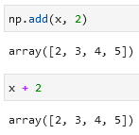

*\* Modulus:*

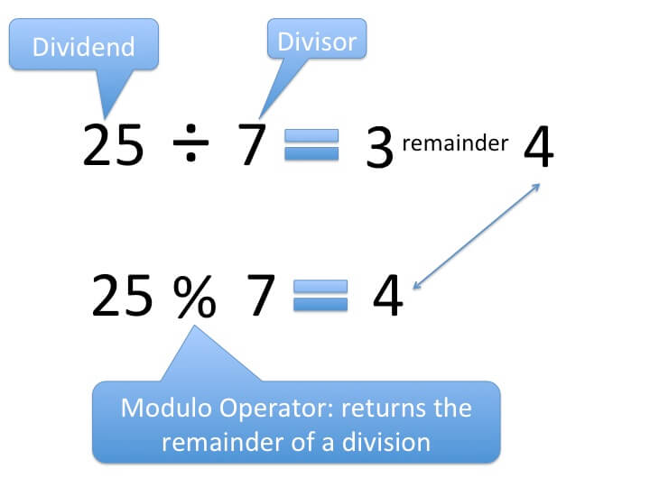

**Arithmetic operators implemented in NumPy:**

|  |  |  |
| --- | --- | --- |
| **Operator** | **Equivalent ufunc** | **Description** |
| + | np.add | Addition (e.g., 1 + 1 = 2) |
| - | np.subtract | Subtraction (e.g., 3 - 2 = 1) |
| - | np.negative | Unary negation (e.g., -2) |
| * | np.multiply | Multiplication (e.g., 2 * 3 = 6) |
| / | np.divide | Division (e.g., 3 / 2 = 1.5) |
| // | np.floor_divide | Floor division (e.g., 3 // 2 = 1) |
| ** | np.power | Exponentiation (e.g., 2 ** 3 = 8) |
| % | np.mod | Modulus/remainder (e.g., 9 % 4 = 1) |

To make values absolute (e.g. from -2 to 2) use abs(name), np.absolute(name) or np.abs(name):

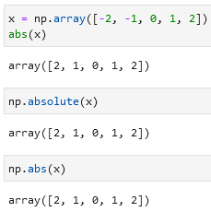

**Trigonometric functions**

Functions like np.sin, np.cos, np.tan:

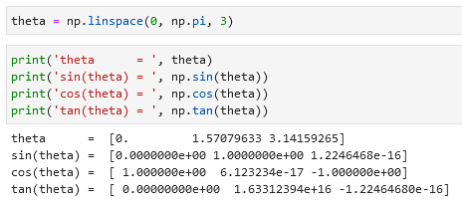

Inverse trigonometric functions like np.arcsin, np.arccos, np.arctan:

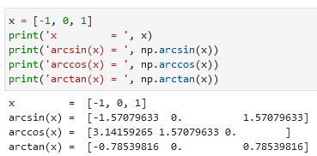

**Exponents and logarithms**

Exponentials in NumPy like np.exp, np.exp2, np.power:

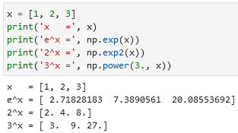

Inverse of the exponentials or the logarithms are computed using np.log (natural logarithm), np.log2 (base-2 logarithm), and np.log10 (base-10 logarithm):

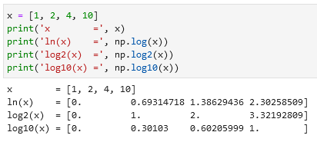

Specialized versions useful for maintaining precision with very small input (np.expm1 and np.log1p). When x is very small, these functions give more precise values than if the raw np.log or np.exp were to be used.

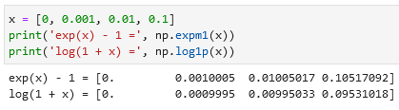

**Specialized ufuncs**

You can use scipy special for specialized functions. For example gamma functions (generalized factorials) and related functions (special.gamma, special.gammaln, special.beta):

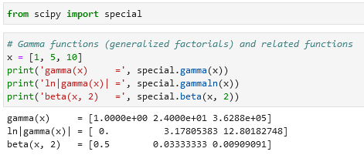

Error functions (integral of Gaussian), its complement, and its inverse (special.erf, special.erfc, special.erfinv):

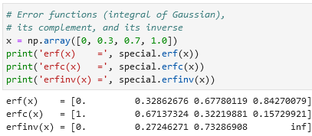

**Specifying output of an array**

For large calculations, it is sometimes useful to be able to specify the array where the result of the calculation will be stored. For all ufuncs, this can be done using the out argument of the function:

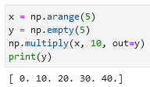

This can even be used with *array views*. For example, we can write the results of a computation to every other element of a specified array (in the example below every second):

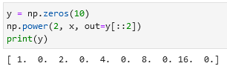

If we had instead written y[::2] = 2 ** x, this would have resulted in the creation of a temporary array to hold the results of 2 ** x, followed by a second operation copying those values into the y array. This doesn’t make much of a difference for such a small computation, but **for very large arrays the** **memory savings from careful use of the out argument can be significant**.

**Aggregations**

Use the reduce function to reduce an array with a particular operation.

You can use np.add.reduce, np.multiply.reduce to sum or multiply an array. If you want to store intermediate results use np.add.accumulate or np.multiply.accumulate.

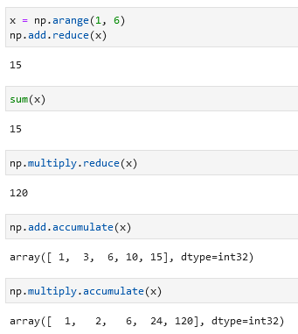

**Outer products**

Compute the output of all pairs of two inputs using np.multiply.output(input_1, input_2):

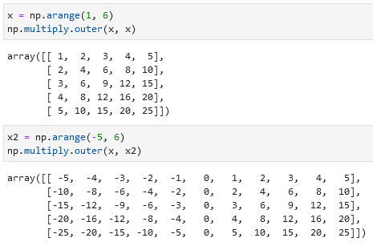

**Aggregations in NumPy: min, max, and everything in between**

**Summing the Values in an Array**

You can sum using Python like sum(x) or you can use NumPy’s np.sum(x). Because NumPy executes the operation in a compiled code, **NumPy’s version of the operation is computed much more quickly**:

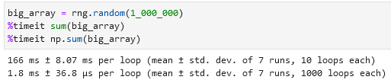

However, sum(x) and np.sum(x) are not identical. Their optional arguments have different meanings. Python’s *sum(x, 1)* initializes the sum at *1* (meaning that if your sum(x) is equal to *5*, your sum(x, 1 or 10) will be equal to *5 + 1 or 10 = 6 or 15*), while np.sum(x, 1) sums along *axis 1*.Also, np.sum is aware of multiple array dimensions.

**Minimum and maximum (min, max)**

Same as with summing you can use Python’s min(x) or NumPy’s np.min(x) or max(x) / np.max(x). An alternative is x.min() / x.max() / x.sum(). Same as with summing, **NumPy’s version is faster**.

**Multidimensional Aggregates**

Finding the minimum value within each column/row by specifying axis=0 / axis=1:

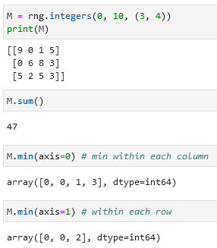

The axis keyword specifies the dimension of the array that will be *collapsed*, rather than the dimension that will be returned. So, specifying axis=0 means that axis 0 will be collapsed: for two-dimensional arrays, values within each column will be aggregated.

**Other aggregation functions**

Most additional aggregation functions have a NaN-safe counterpart that computes the result while ignoring missing values.

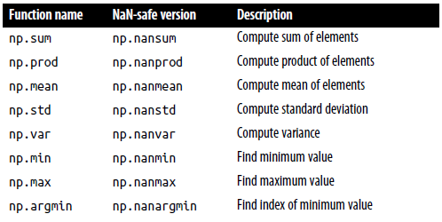

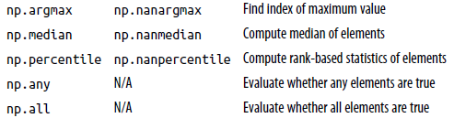

np.sum, np.prod, np.mean, np.std, np.var, np.min, np.max, np.argmin, np.argmax, np.median, np.percentile, np.any, np.all

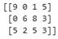

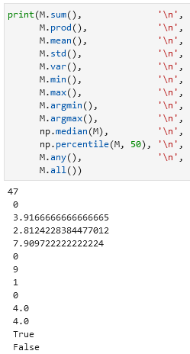 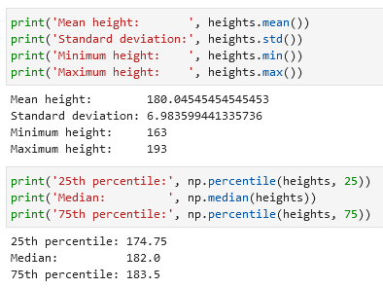

**Broadcasting**

Broadcasting allows these types of binary operations to be performed on arrays of different sizes—for example, we can just as easily add a scalar (think of it as a zerodimensional array) to an array:

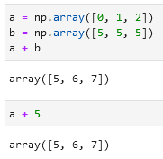

We can think of this as an operation that stretches or duplicates the value 5 into the array [5, 5, 5], and adds the results.

**Broadcasting is stretching an array** across a (in the example below) second dimension:



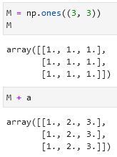

You can also stretch or broadcast both arrays to match a common shape:

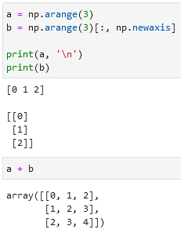

**Visualization of broadcasting:**

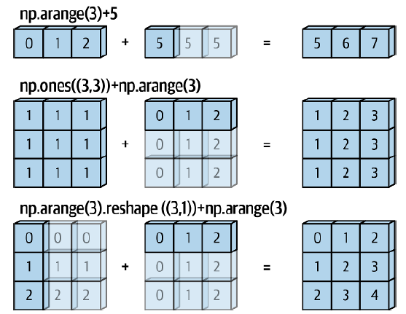

**Rules of broadcasting**

1. If the two arrays differ in their number of dimensions, the shape of the one with fewer dimensions is padded with ones on its leading (left) side.
2. If the shape of the two arrays does not match in any dimension, the array with shape equal to 1 in that dimension is stretched to match the other shape.
3. If in any dimension the sizes disagree and neither is equal to 1, an error is raised.

Rule 1 example: Rule 2 example:

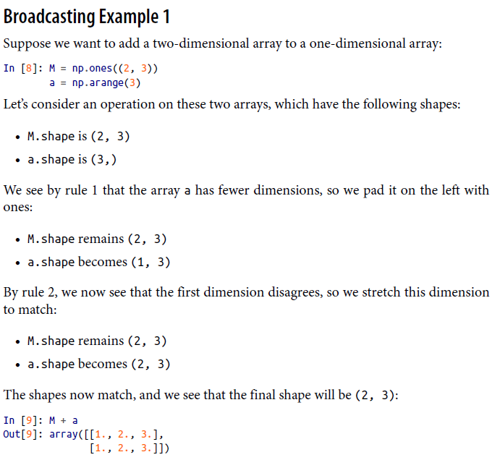 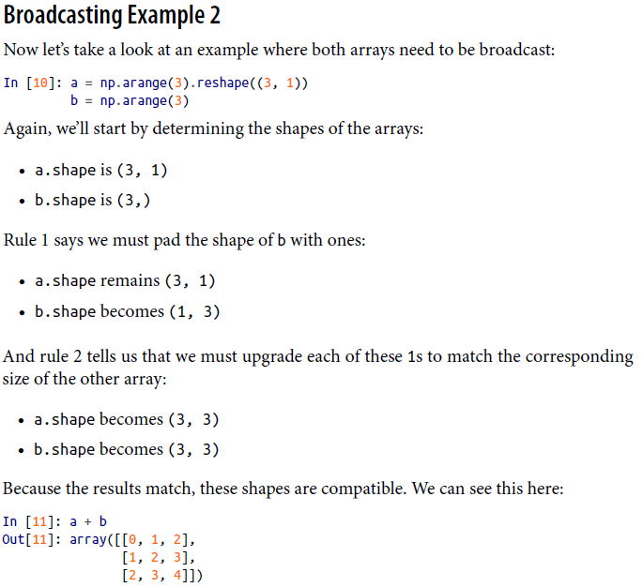

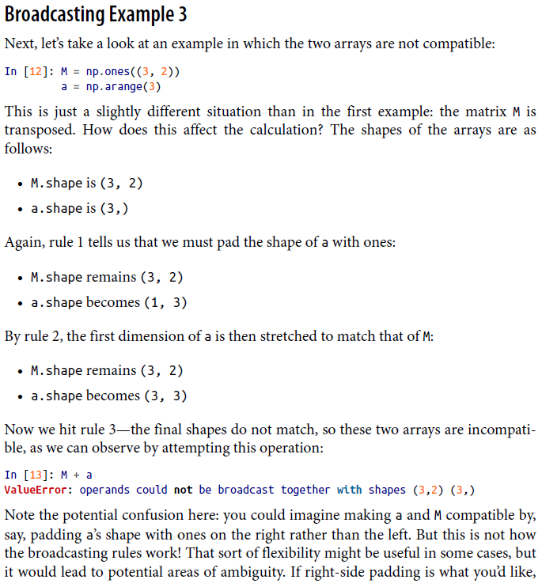

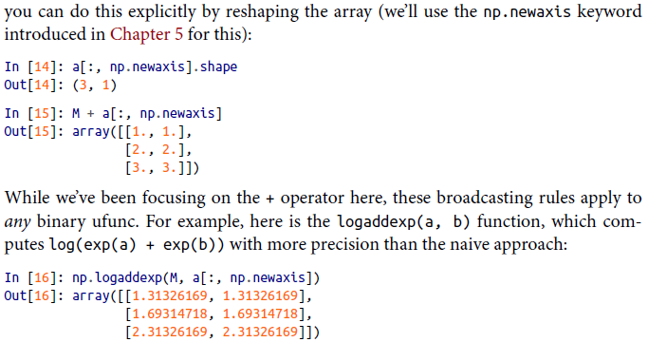

**Using broadcasting for centering an array**

You can subtract from an array the mean of that array.

|  |  |
| --- | --- |
| **Array:** | **Centered (difference to mean):** |
| 34 | -4 |
| 65 | 27 |
| 23 | -15 |
| 76 | 38 |
| 22 | -16 |
| 43 | 5 |
| 63 | 25 |
| 32 | -6 |
| 23 | -15 |
| 27 | -11 |
| 5 | -33 |
|  |  |
| **Mean:** |  |
| 38 |  |

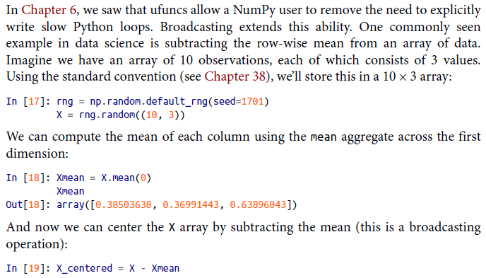

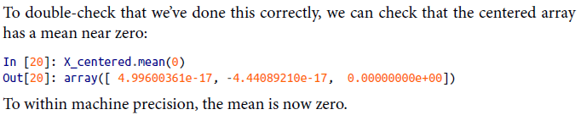

**Comparisons, Masks, and Boolean Logic**

**Comparison Operators as Ufuncs**

As in the case of arithmetic operators, the comparison operators are implemented as ufuncs in NumPy; for example, when you write x < 3, internally NumPy uses np.less(x, 3). These operators will work on arrays of any size and shape.

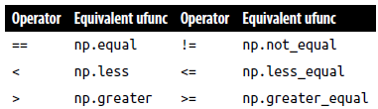np.equal, np.less, np.greater, np.not_equal, np.less_equal, np.greater_equal

Example:

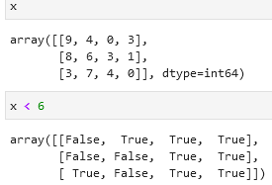

In each case, the result is a Boolean array, and NumPy provides a number of straight-forward patterns for working with these Boolean results.

**Working with Boolean Arrays**

**Counting Entries**

To count the number of True entries you can use np.count_nonzero:

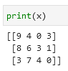

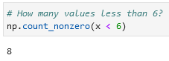

**Alternatively you can use np.sum (*False* is *0* and *True* is *1*).** With np.sum you can sum along rows or columns.

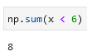 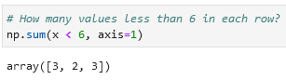 ← e.g. in row 1 there are 3 values below 6, in row 2 2 values, in row 3 3.

If you want to count the number of True entries that fulfill multiple conditions like *x > 10 AND x < 20* you can use symbols like &, |, ^, and ~:

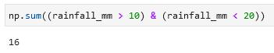

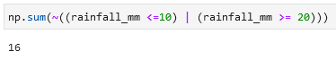 ← same result in a different manner

Note that parentheses are important. Without them this code with result in an error.

**If you want to check if an array has values that fulfill a specific condition you can use np.any or np.all.**

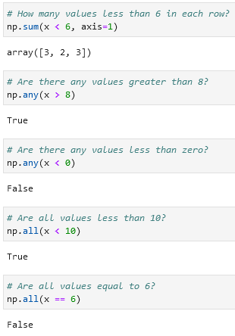

You can also use np.any and np.all along a particular axis:

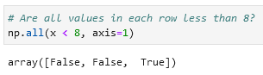

**Boolean operators and their equivalent ufuncs**

|  |  |
| --- | --- |
| **Operator** | **Equivalent ufunc** |
| & | np.bitwise_and |
| ^ | np.bitwise_xor |
| | | np.bitwise_or |
| ~ | np.bitwise_not |

Examples:

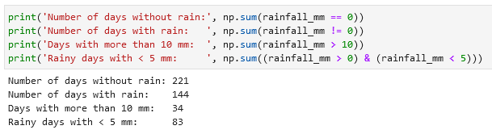

**Boolean arrays as masks**

Selecting values from an array using Boolean operators is called a masking operation. Example:

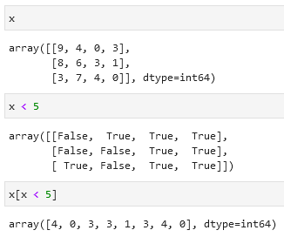

A one-dimensional array is returned with all the values that meet this condition.

**Examples of Boolean arrays as masks:**

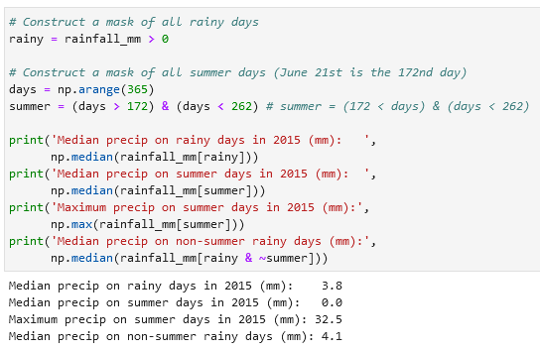

**Comment on using and/or instead of &/|**

The difference is this: and and or operate on the object as a whole, while & and | operate on the elements within the object.

and and or perform a single Boolean evaluation on an entire object, while & and | perform multiple Boolean evaluations on the content (the individual bits or bytes) of an object. **For Boolean NumPy arrays, the latter (& and |) is nearly always the desired operation.**

Using and and or instead of &/| will simply result in an error:

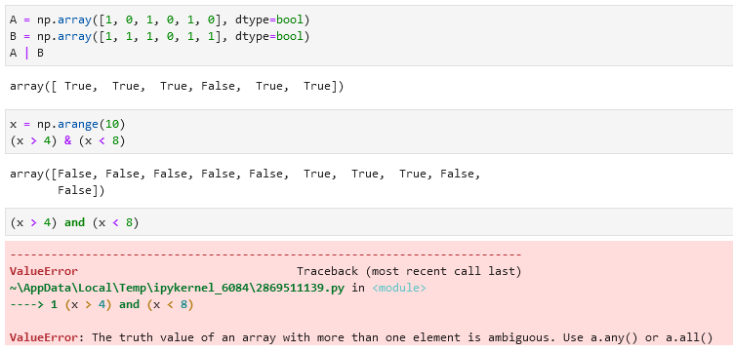

**Fancy indexing / vectorized indexing**

To access values with specific indexes you can use this:

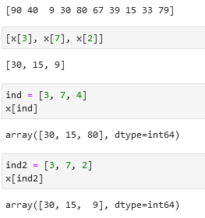

When using arrays of indices, the shape of the result reflects the shape of the index arrays rather than the shape of the array being indexed. In the example below x[ind] returns the same form as of *ind* but instead of index coordinates (*3, 7,* etc.) it returns values from *x*.

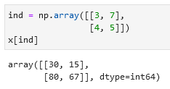

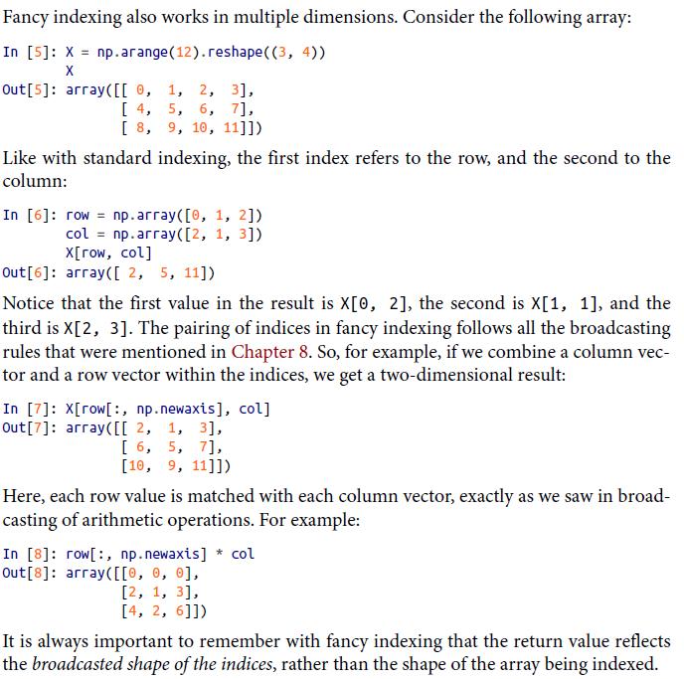

**Combined indexing**

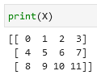

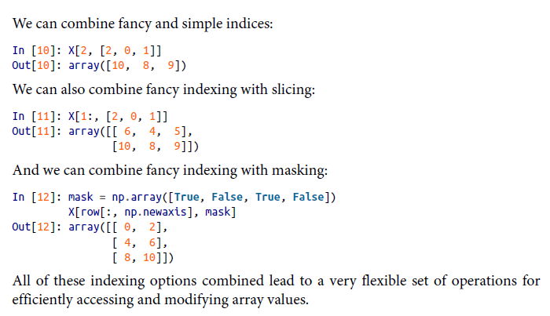

**Modifying values with fancy indexing**

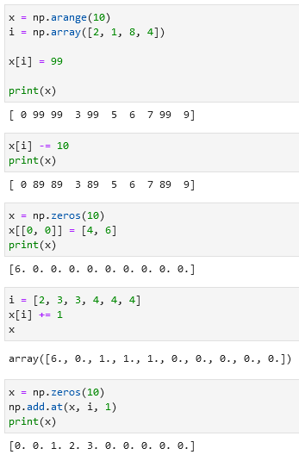

An alternative to np.add.at is reduceat.

**Example: Binning data**

You could use these ideas to efficiently do custom binned computations on data. For example, imagine we have 100 values and would like to quickly find where they fall within an array of bins. We could compute this using ufunc.at like this:

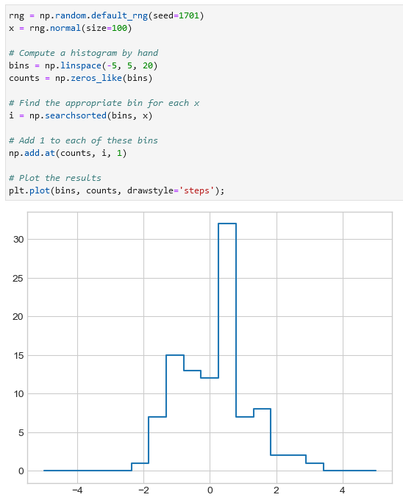

Alternatively using Matplotlib:

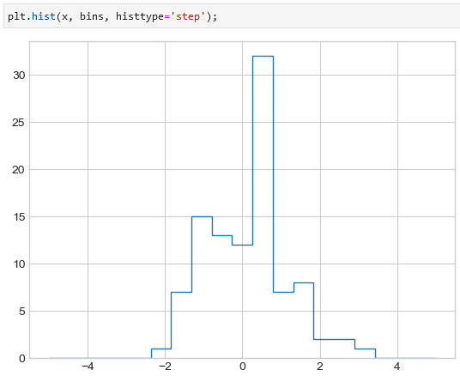

The difference between these two options is in the processing speed. Matplotlib is slower than the custom version for a small dataset and faster for a larger.

**Sorting arrays**

**In Python**

Python’s built-in functions to sort lists and other iterable objects: sorted(x) (returns a copy) and x.sort() (acts in-place). Two examples:

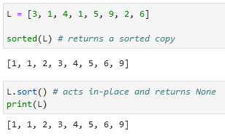

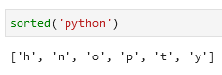

**In NumPy**

The np.sort function is analogous to sorted(). It will return a sorted copy of an array. Example:

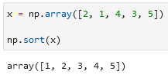

np.argsort() returns the indices of the sorted elements:

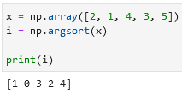

You can then use these indices to construct the sorted array using fancy indexing:

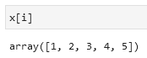

Sorting along rows or columns is possible by adding axis=0 for sorting columns or axis=1 for sorting rows. Note that this operation will treat each row or column as an independent array and any relationship between the row or column values will be lost.

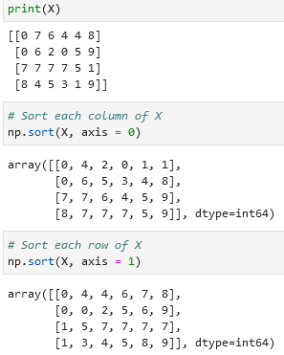

**You can also find e.g. 3 smallest values in an array using np.partition.** It will return these smallest values in arbitrary order followed by other values also in arbitrary order.

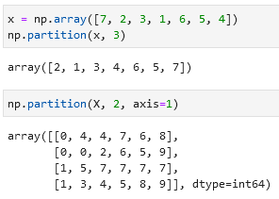

**Checking the diagonal of a matrix**

You can check the diagonal values of a matrix using x.diagonal():

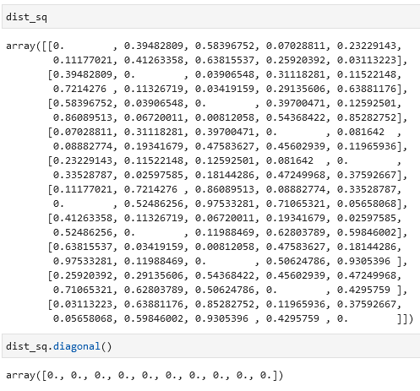

**NumPy’s structured arrays and record arrays**

Creating an empty container array:

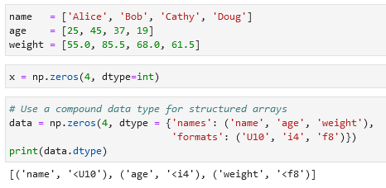

* U10 = Unicode string of maximum length 10
* i4 = 4-byte (i.e. 32-bit) integer
* f8 = 8-byte (i.e. 64-bit) float

Filling the empty array with data in a one structured array:

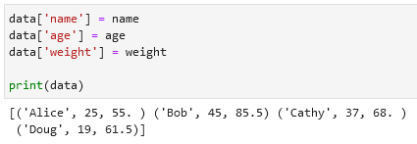

Filtering the data:

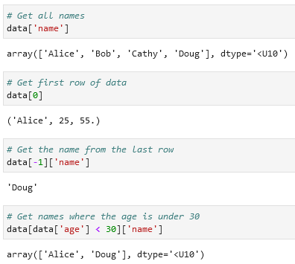

**Exploring structured array creation — specifying data type**

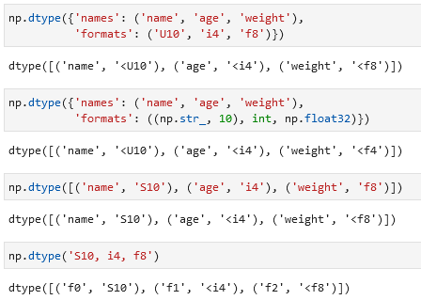

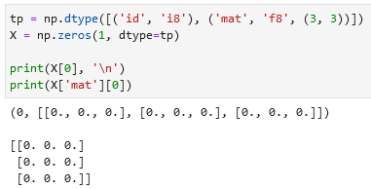

**NumPy data types:**

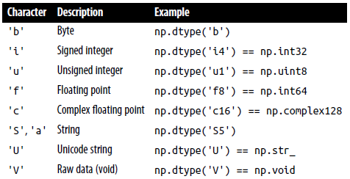

'b' Byte np.dtype('b') 'i' Signed integer np.dtype('i4') == np.int32 'u' Unsigned integer np.dtype('u1') == np.uint8 'f' Floating point np.dtype('f8') == np.int64 'c' Complex floating point np.dtype('c16') == np.complex128 'S', 'a' String np.dtype('S5') 'U' Unicode string np.dtype('U') == np.str_ 'V' Raw data (void) np.dtype('V') == np.void

**Accessing data using record arrays**

You can use view(np.recarray) to access columns:

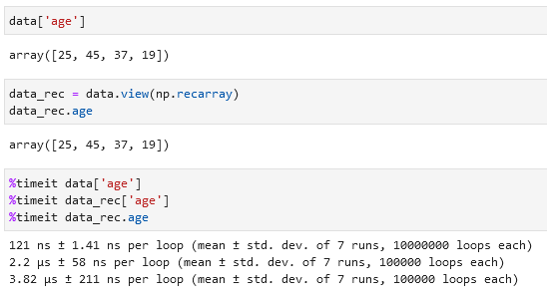

Note that record arrays are slightly slower than a simple data['age'].

**Pandas**

**Pandas has 3 fundamental data structures: the Series, DataFrame, and Index.**

**A series is a one-dimensional array of indexed data. It can be created from a list or array. Example of a series:**

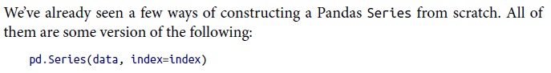

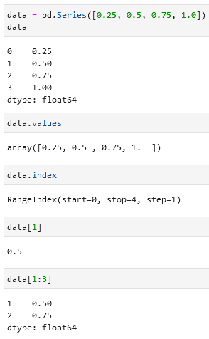

Use .values and .index to access values and indexes of a series.

You can assign indexes that you want (different from NumPy arrays):

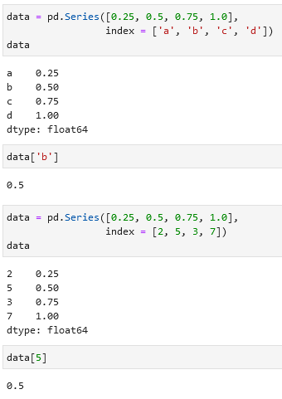

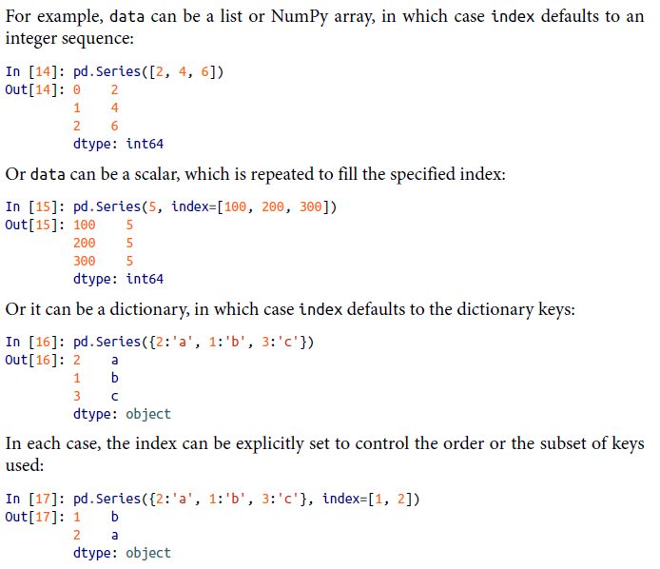

**Ways to create a DataFrame**

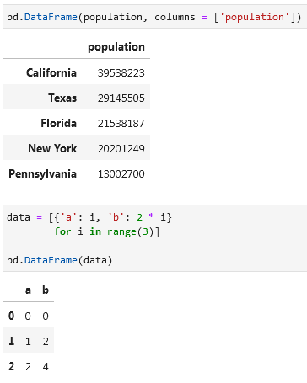

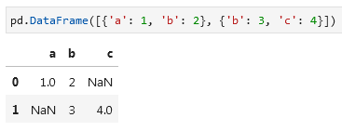

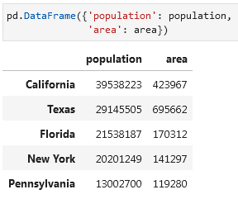

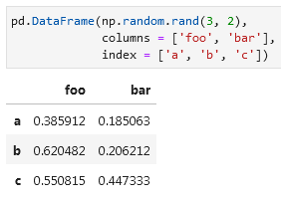

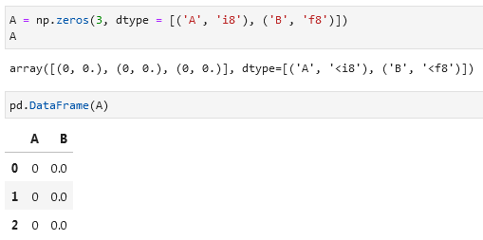

**The Pandas Index object**

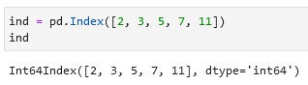

Difference between Index objects and NumPy arrays is that the indices are immutable — they cannot be modified via the normal means like ind[1] = 0. This will cause an error.

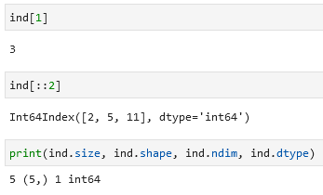

Using Index you can get values that are present in both sets, make a union of all values in both sets, and show only unique values in both sets. Use .intersection(), .union(), and .symmetric_difference() for these operations. Examples:

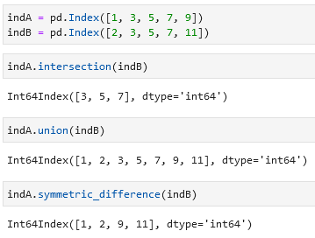

**Data Indexing and Selection**

**Accessing indices or values in a Pandas Series:**

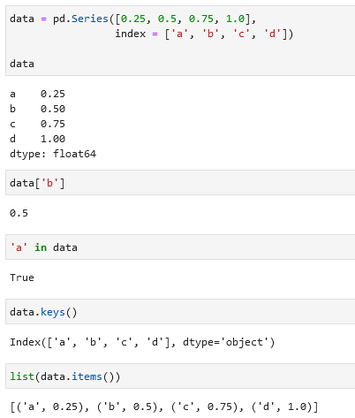 in, .keys(), .items()

**Add/change values to a series:**

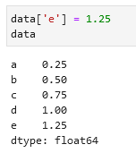

**Slicing, masking, and fancy indexing in a Series:**

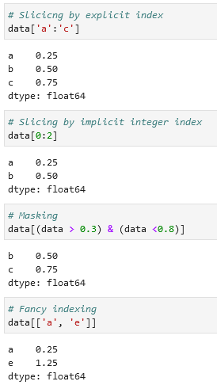

**.loc references the index provided (by e.g. you) while .iloc uses the standard index 0, 1, 2, 3, etc.:**

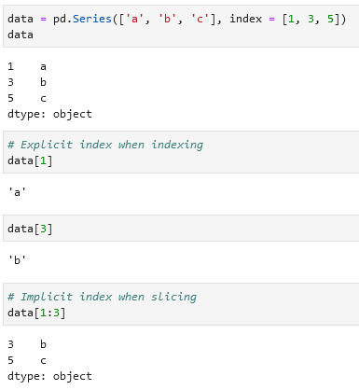

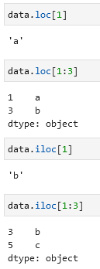

**Data selection in DataFrames**

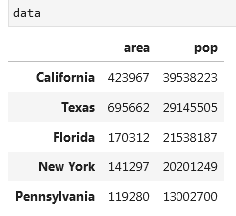

This way of selecting data is preferred:

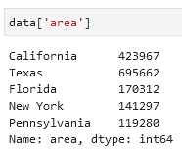

Over this one:

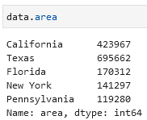

Adding columns created from given columns:

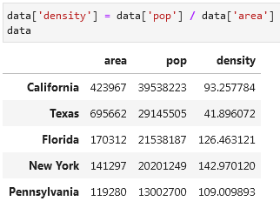

Example with .iloc and .loc:

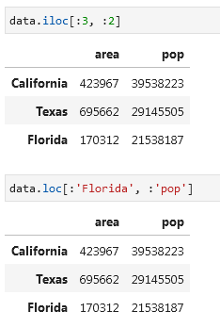

Getting all values from a DataFrame using .values and transforming the table using .T:

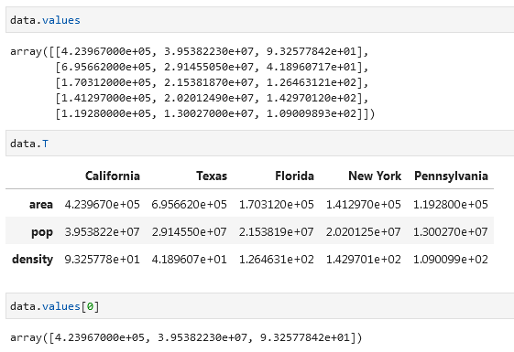

Other examples:

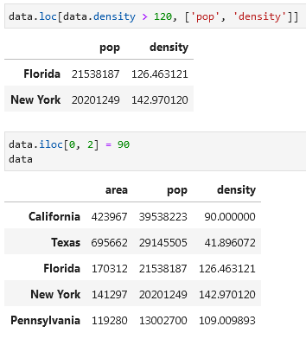

**Adding two Series/DataFrames**

If you add two series with different indices you will get NaN values:

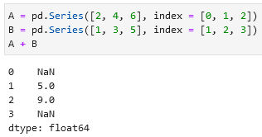

To avoid it use .add(fill_value = 0). It will use that specified value in place of missing entries. Example:

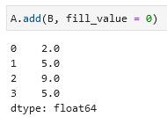

Same is applies for two DataFrames:

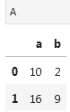 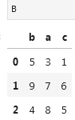

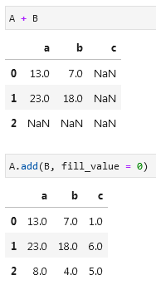

In this example the fill_value is the mean value:

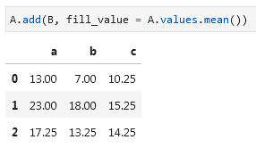

**Mapping between Python operators and Pandas methods:**

|  |  |
| --- | --- |
| **Python operator** | **Pandas method(s)** |
| + | add |
| - | sub, subtract |
| * | mul, multiply |
| / | truediv, div, divide |
| // | floordiv |
| % | mod |
| ** | pow |

**Subtract a row/column from a DataFrame**

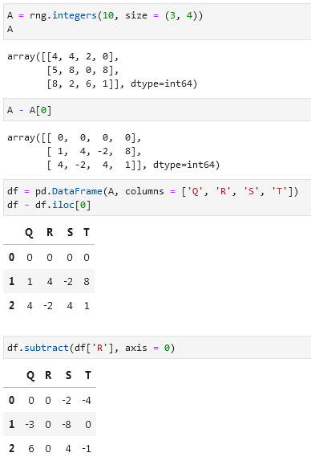

**Handling Missing Data in pandas**

**None as blank value**

Example:

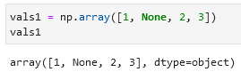

Downside is that it is counted as a Python object data type. Therefore processing times will be slow. In addition arithmetic operations are not supported with None.

**nan: Missing Numerical Data**

Example (np.nan):

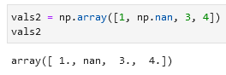

It supports fast operations but any arithmetic operations with nan will lead to a nan:

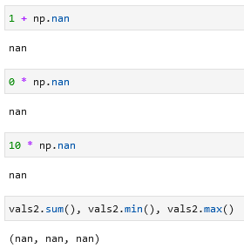

You can, of course, use special functions (e.g. np.nansum(), np.nanmin(), npnanmax()) that ignore nan:

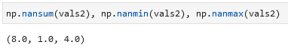

The main downside of nan is that it is specifically a floating-point value; there is no equivalent nan value for integers, strings, or other types.

**nan and None in pandas**

Both are transformed into a NaN value and the array gets a float64 data type:

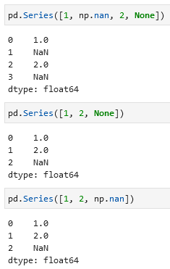

If a None value is added to a Series then the data type changes automatically to float64:

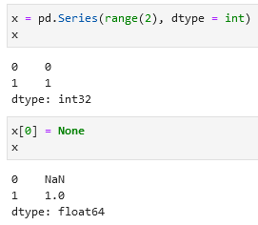

**Pandas handling of NAs by type:**

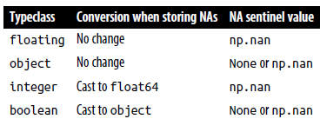float64, object, np.nan

**Pandas nullable dtypes**

Nullable dtypes are distinguished from regular dtypes by capitalization of their names, e.g. pd.Int32 vs np.int32.

Example that includes all three available markers of missing data (None, np.nan,and pd.NA):

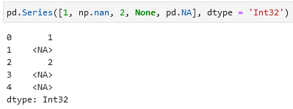

**Operation on null values in pandas**

There are several methods for detecting, removing, and replacing null values in pandas:

* isnull
* notnull
* dropna
* fillna

Example with .isnull() to see what values are null:

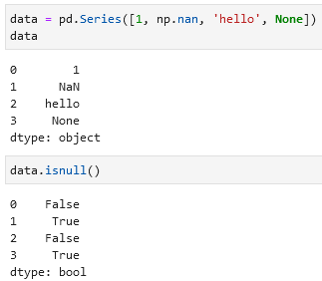

Example with .notnull() to filter values that are not null:

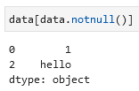

Example with .dropna() which removes null values:

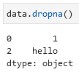

If you use .dropna() on a DataFrame you can drop entire rows or columns with null values. By default drops all rows where there is at least one null value.

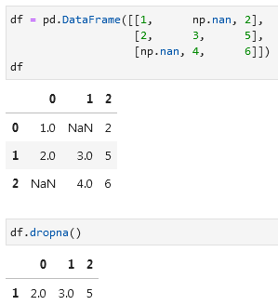

To drop columns with null values specify axis=1 or axis = 'columns':

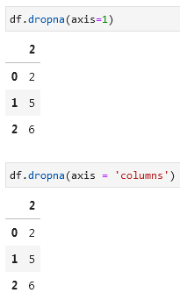

If you want to drop only rows or columns where *every* value is null instead of just *one*, you need to add how='all' (by default this field is how='any').

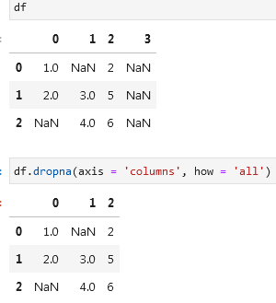

If you want to keep only rows or columns that have a minimum number of values that are not equal to null, then you can specify this using the thresh = _ parameter. In the example below only rows that have 3 or more non-null values will be kept:

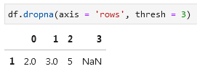

**Filling null values / replacing null values**

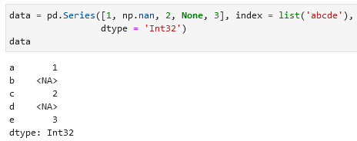

Depending on the situation, you may wish to keep the null values but replace them with something else. You can fill them with a number like in the example below. Function .fillna() is used for it.

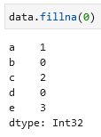

Using .fillna(method = 'ffill') you can copy the previous value to the empty cell:

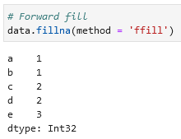

Alternatively you can use the bfill method to copy the next value to the empty cell:

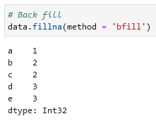

If you use a ffill or bfill on a DataFrame you can specify an axis along which the fills should take place. Note that if a previous value is not available during a fill, the null value will remain.

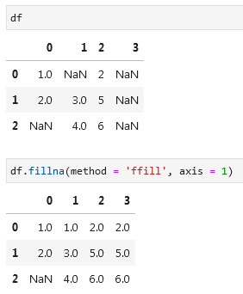

**Hierarchical Indexing**

If you want to create a multiply indexed series (an index with multiple layers) you can use this approach, but it is not efficient:

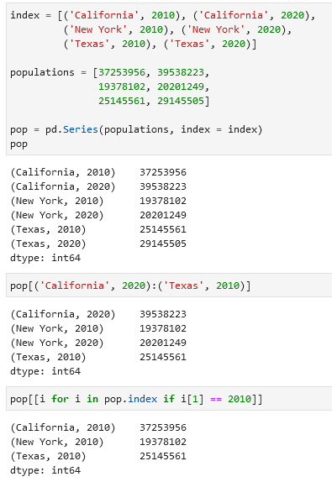

A much better one is to use pd.MultiIndex.from_tuples() with .reindex():

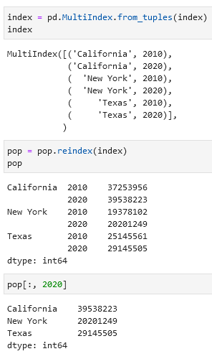

In case you want to unpivot a multiply indexed Series into a DataFrame you can use .unstack():

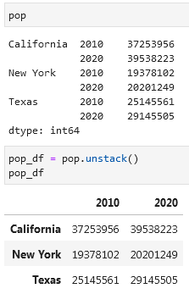

If you want to pivot a DataFrame you can use .stack():

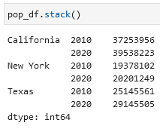

If you want to add a column to your DataFrame:

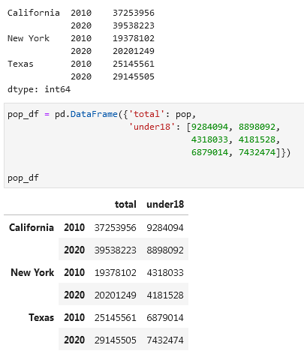

Calculating arithmetically the percentage of underage population per state per year using .unstack():

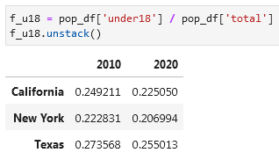

**Methods of MultiIndex creation**

**Automatic**

If you pass a list of two or more index arrays to the constructor you will get a multiply indexed Series or a DataFrame:

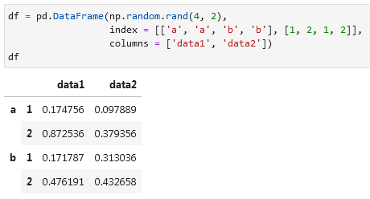

If you pass a dictionary with appropriate tuples as keys, pandas will automatically recognize this and use a MultiIndex by default:

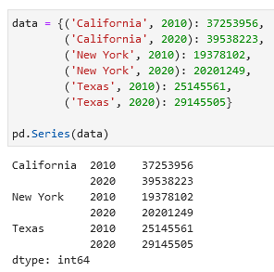

**Explicit**

Use pd.MultiIndex.from_arrays or pd.MultiIndex.from_product or pd.MultiIndex to create an explicit multiple index:

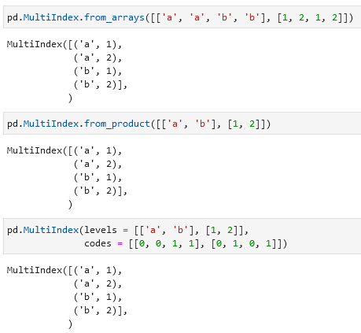

**Giving names to multiple indexes**

You can pass names to the multiple indexes that you have using .index.names = []:

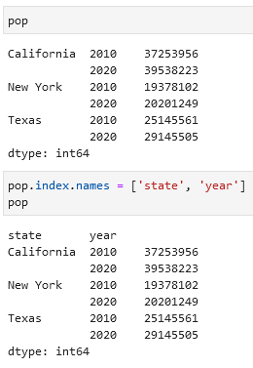

**MultiIndex for columns**

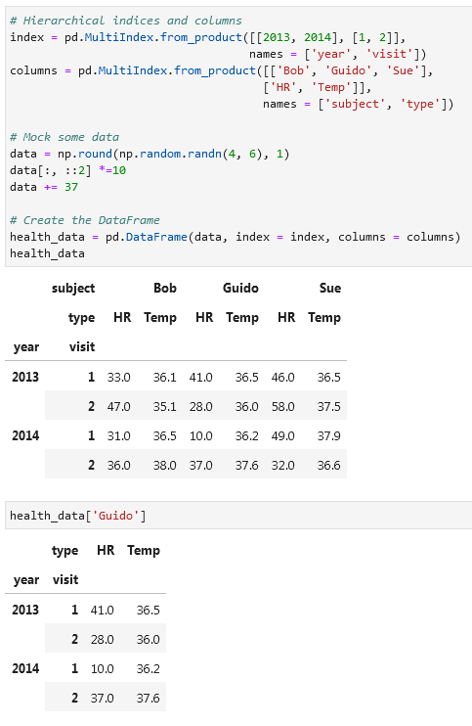

**Accessing values that have multiple indexes**

To access a value that has multiple indexes write these indexes one after another:

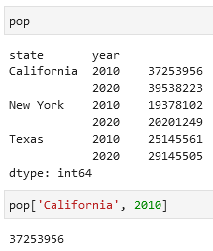

Accessing one index:

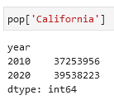

Selecting a specific part. Note that MultiIndex should be sorted to use partial slicing.

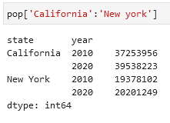

If you want to filter on the second/third/etc. index and not on first:

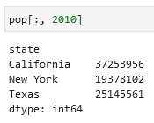

Selection based on Boolean masks or simply filtering values that fit your desired result:

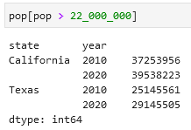

Selection based on fancy indexing or simply selecting specific rows:

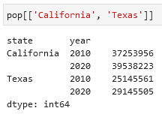

**Examples with multiple indexes in rows and columns**

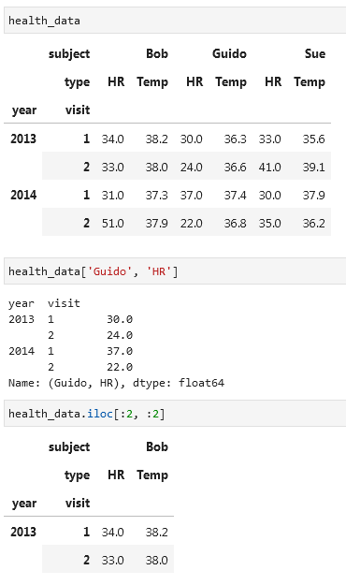

If you want to use index slicing use pd.IndexSlice:

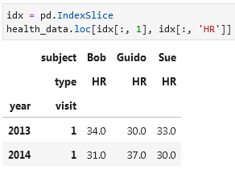

**Sorting indexes**

Many of the MultiIndex slicing operations will fail if the index is not sorted. For sorting indexes you can use .sort_index() or sortlevel:

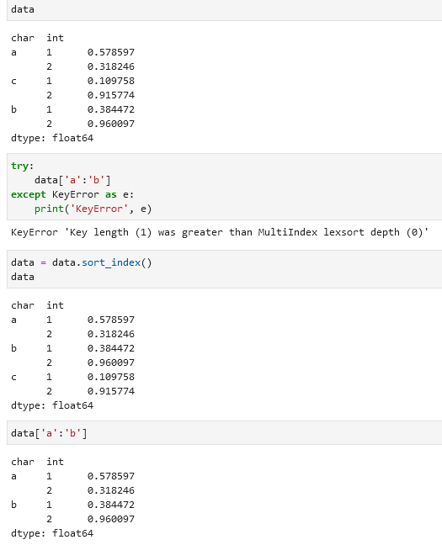

**Unstacking multilevel indexes (unpivoting)**

Same as with a normal Series/DataFrame you use .stack()/.unstack() to unpivot a table. To specify an index add (level = 0) or e.g. (level = 1):

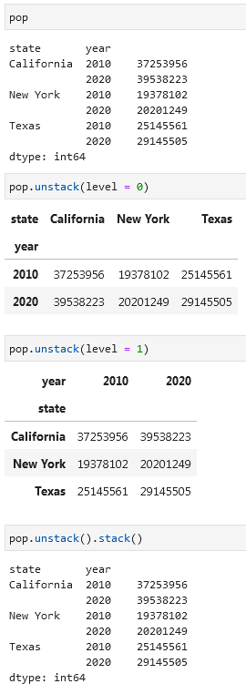

**Turning an index into a column**

You can turn an index into a column by using .reset_index(name = _) function. In the name field you specify the name of the column that will have data in it:

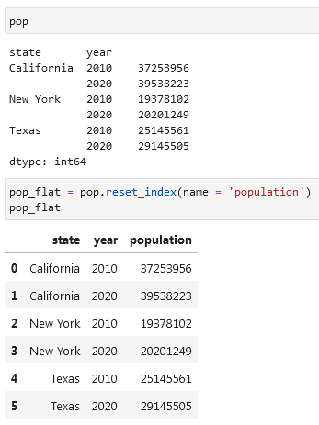

You can also turn columns into multiple indexes using .set_index():

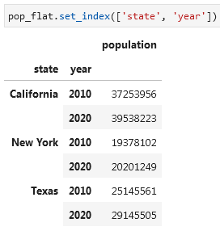

**Combining Datasets: concat and append**

Concatenation of Series and DataFrame is similar to concatenation of NumPy arrays, which can be done using the np.concatenate() function. If you have a multidimensional array you need to specify the axis along which you want to concatenate.

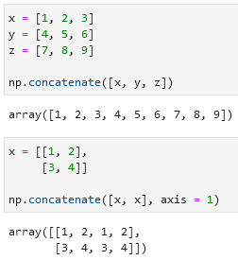

Combining datasets using pd.concat():

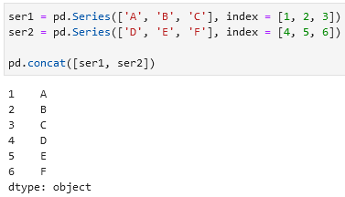

When used on DataFrames pd.concat() will by default concatenate rows (will place values below the first DataFrame). You can specify axis = 'columns' (or axis = 1) to concatenate columns.

**Handing duplicate indexes**

One important difference between np.concatenate and pd.concat is that Pandas concatenation preserves indexes, even if the result will lead to duplicates.

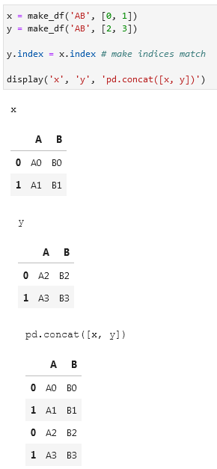

To check if your datasets contain duplicate indexes you can add the verify_integrity = True option. You will get an error if there are duplicates.

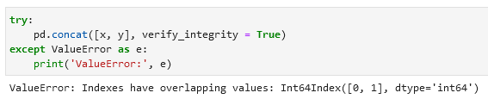

If you want to ignore the indexes of your datasets you can add the ignore_index = True option. You will get a standard index (0, 1, 2, 3, etc.) in your concatenated dataset.

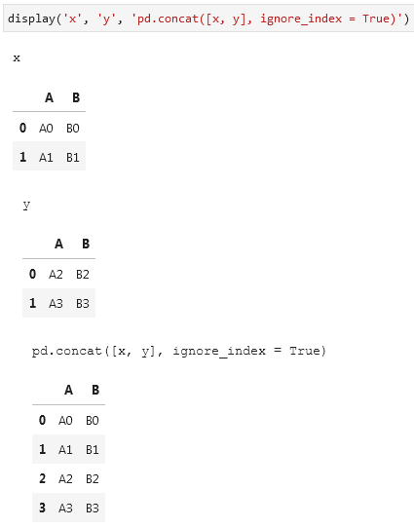

Another option with duplicate indexes is to add an extra index that will specify the origin of a dataset. You use for that the keys option.

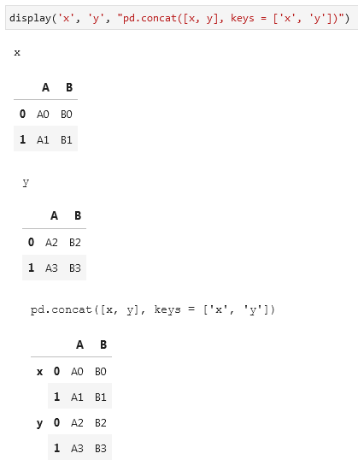

**Concatenation with joins**

If you want to concatenate datasets that have different columns along with some columns that both datasets have in common you will get this:

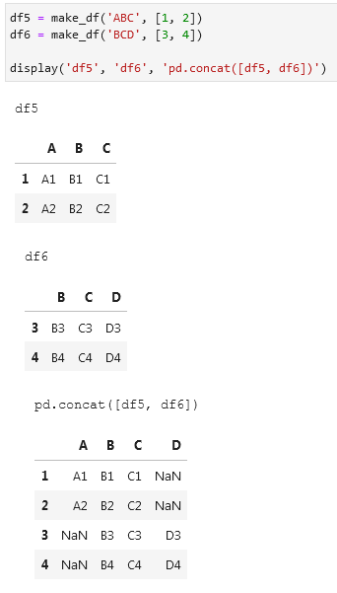

Columns that are unique to each dataset will be filled with null values where appropriate. This is because the default join takes everything from both datasets (option join='outer'). You can change it to inner to only concatenate columns that overlap in both datasets:

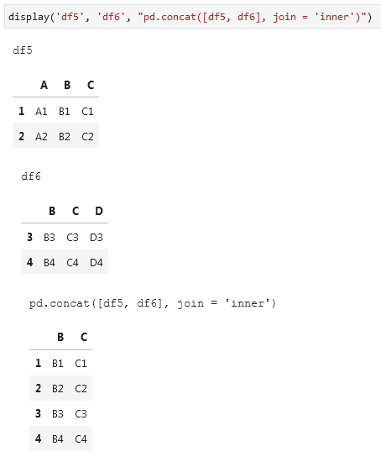

To get more control over which columns are dropped you can use the .reindex() function (не до конца понял, как оно работает):

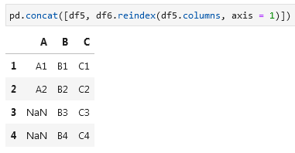

Alternative to pd.concat([df1, df2]) is df1.append(df2). But this function will be removed from pandas in the future versions, so use pd.concat.

**Combining Datasets: merge and join**

**One-to-One Joins**

If you want to merge two DataFrames you can use pd.merge(df1, df2). This function recognizes columns with the same name merges on them.

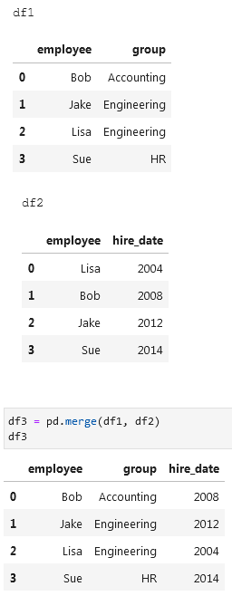

**Many-to-One Joins**

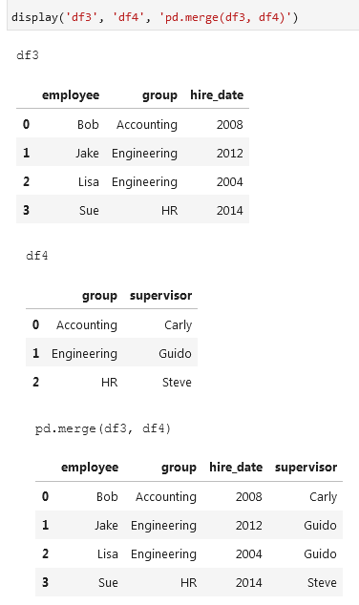

**Many-to-Many Joins**

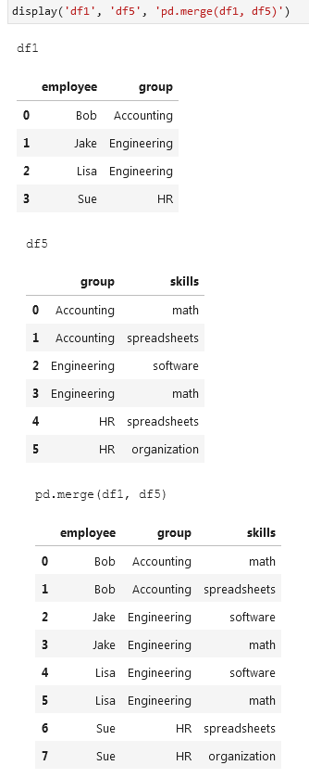

**Specification of the merge key**

**If you want to specify a column name that should be used for the merge in both DataFrames you can use the on key:**

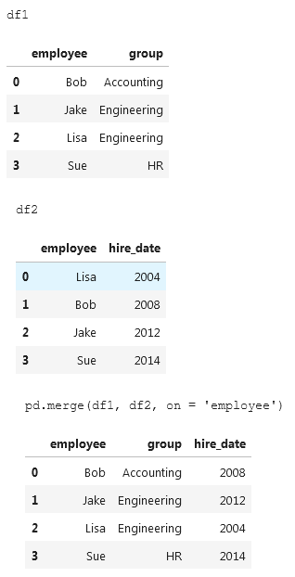

**However, if your DataFrames have different names for the same column you can specify which column to use from the first and second DataFrame using left_on and right_on:**

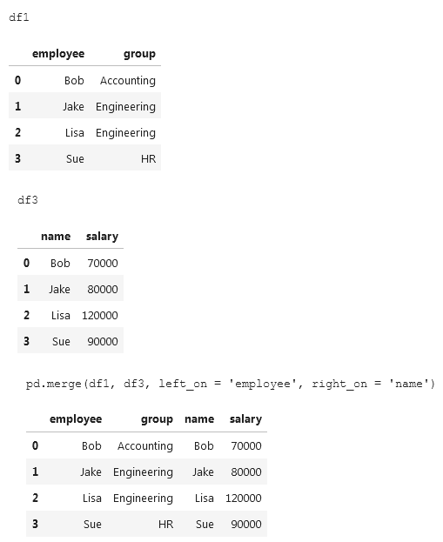

To drop the redundant column from the second table use .drop('column_name', axis = 1):

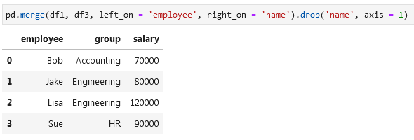

**If you want to merge two DataFrames on their indexes you can use left_index = True and right_index = True:**

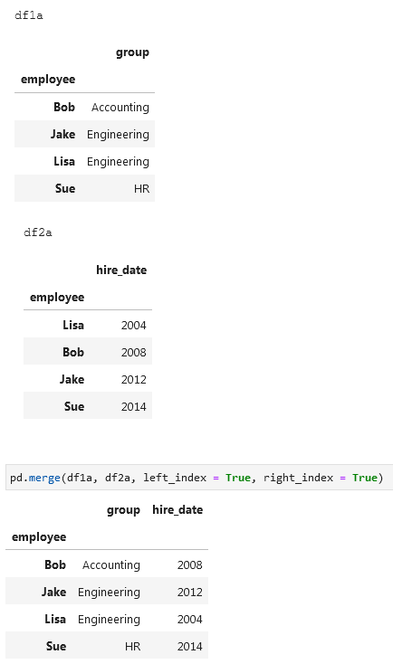

Alternatively, you can use df1.join(df2) to perform a join on indexes:

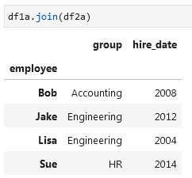

To merge two DataFrames on an index and a column you add left_index = True and right_on = column_name (or the other way around):

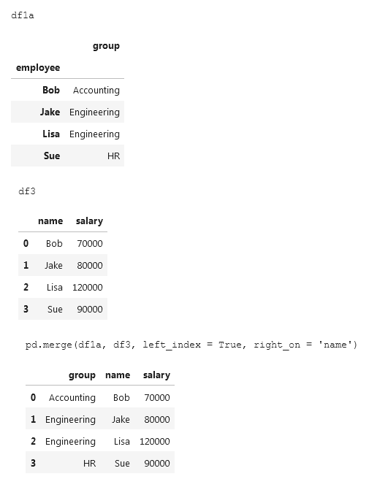

These options work with multiple indixes and/or multiple columns. For more information consult pandas [documentation](http://pandas.pydata.org/pandas-docs/stable/user_guide/merging.html).

**Conducting an inner/outer/left/right join**

By default pd.merge(df1, df2) will conduct an inner join. That means it will show only values that occur in both datasets. Alternatively, you can write pd.merge(df1, df2, how = 'inner'):

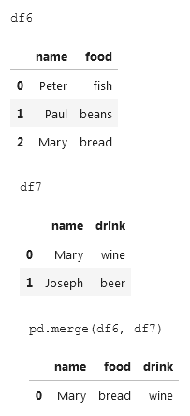 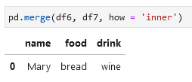

Other joins available are: outer, left, and right.

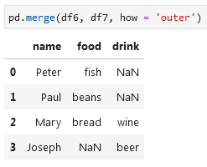 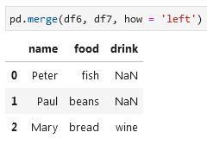 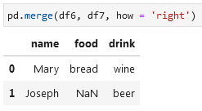

When merging two DataFrames with columns that have a same name (columns are not keys) pandas will give each column a suffix like columnname_x and columnname_y to make them distinguishable. Alternatively, you can specify which suffices you want to have by adding suffixes = [].

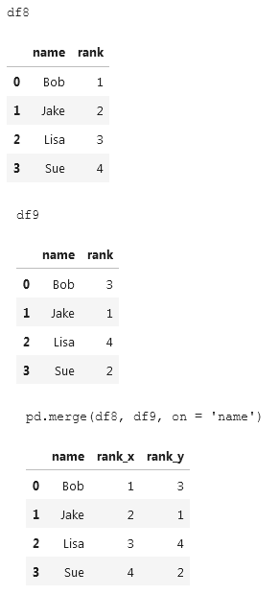 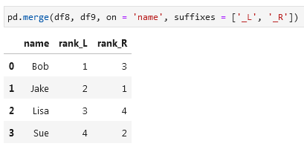

**Example of a .query() that helps to filter a dataset:**

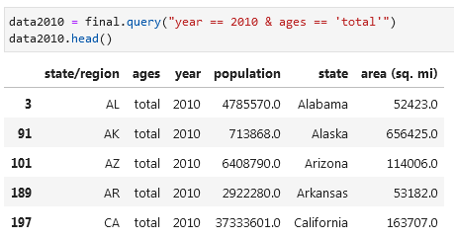

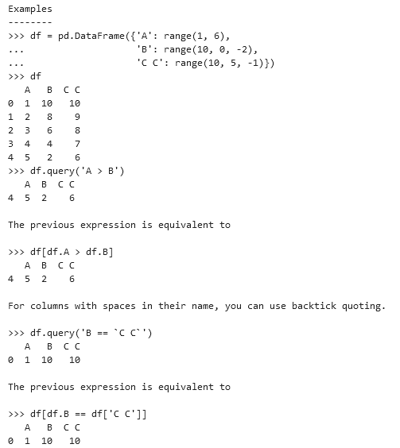

**Aggregation and Grouping**

Use df.mean() to get a mean value over each column or df.mean(axis = 1) (or axis = 'columns') to get a mean value over each row:

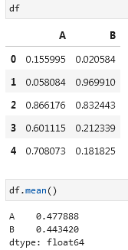 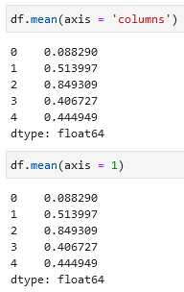

**Pandas aggregation methods:**

* **Aggregation: Returns:**
* count Total number of items
* first, last First and last item
* mean, median Mean and median
* min, max Minimum and maximum
* std, var Standard deviation and variance
* mad Mean absolute deviation
* prod Product of all items
* sum Sum of all items

**GROUPBY**

Example of a GROUPBY operation or split-apply-combine:

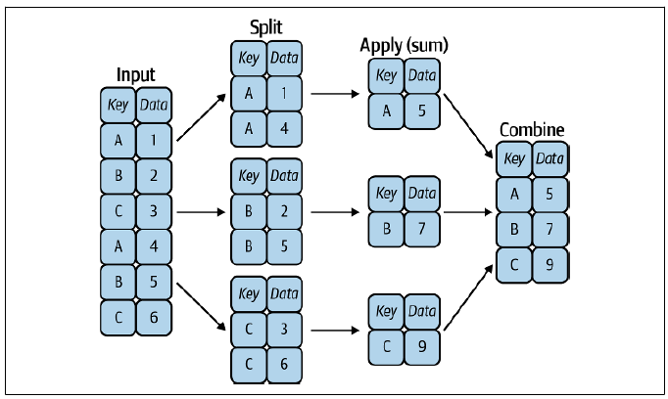

Performing a groupby on a dataset:

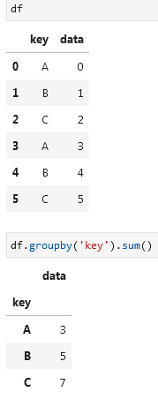

**Getting the shape of a groupby**

You can perform a loop:

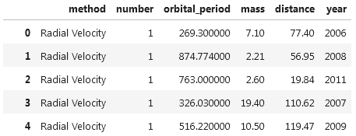

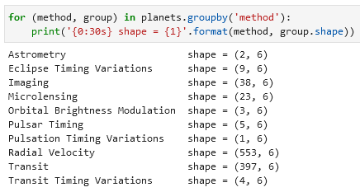

Or this:

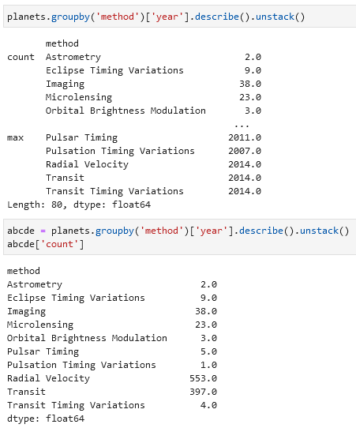

**A groupby aggregate**

You can have multiple calculations like min, max, median for your grouped values. You need to use the .aggregate() function for this:

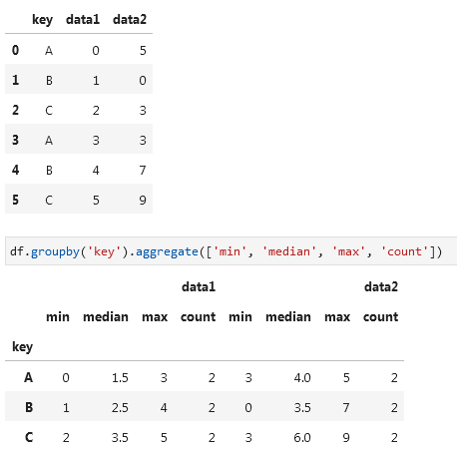

Note that you can write 'min', min or np.median, 'median'.

You can also aggregate every column differently, e.g. column 1 as a min and column 2 as a max:

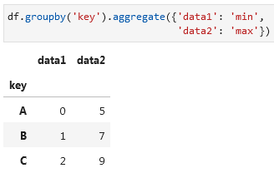

**Filtering with a groupby is also possible:**

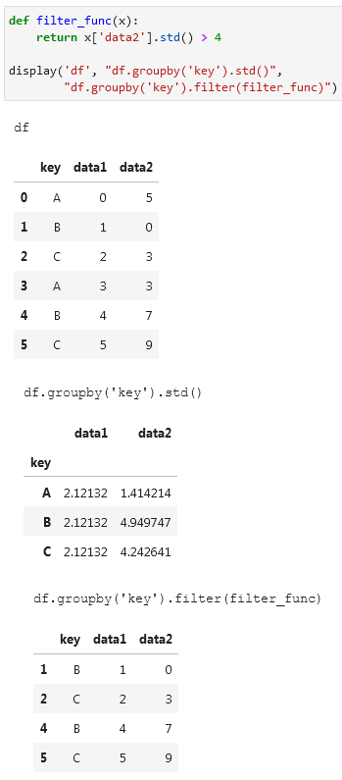

**Centering data by subtracting the group-wise mean or an other variable can be done using this (.transform()):**

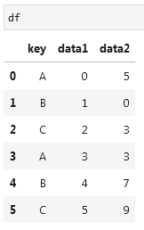 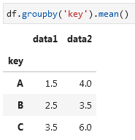 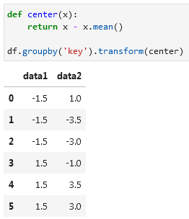

**Use .apply() to apply an arbitrary function to the group results. E.g. you want to normalize the first column by the sum of the second:**

 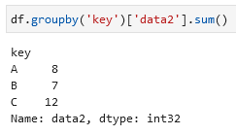 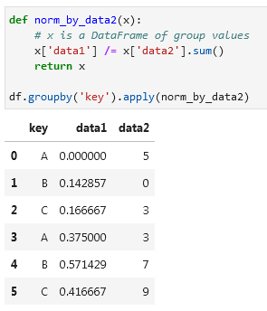

**You can specify the index that should be used in the groupby:**

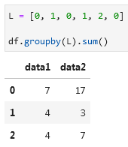 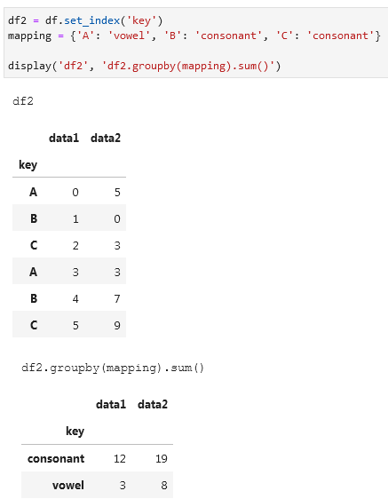

**Modify the index within groupby:**

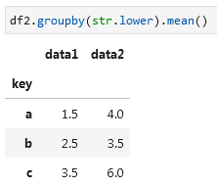

**You can also combine various functions to group on a multi-index:**

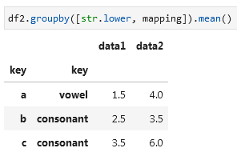

Example of a groupby:

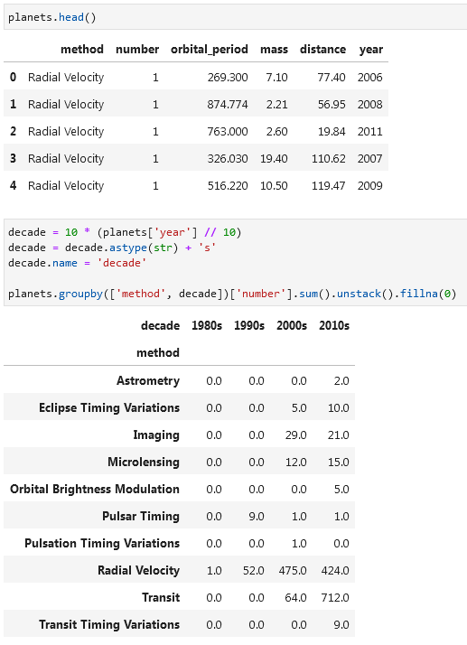

**Pivot tables**

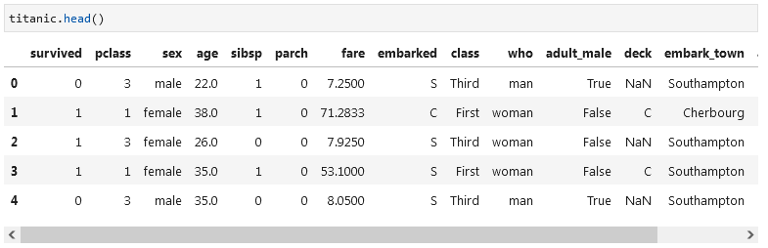

Example of a pivot table:

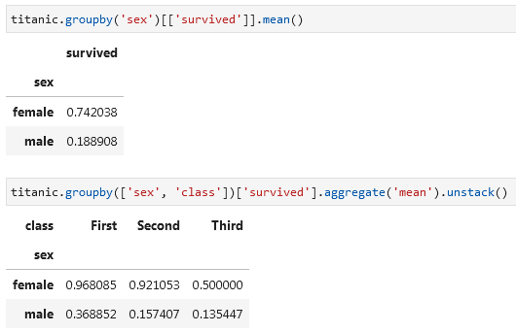

**To achieve the same result as the second example make use of the .pivot_table() function:**

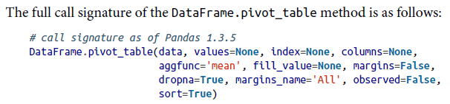

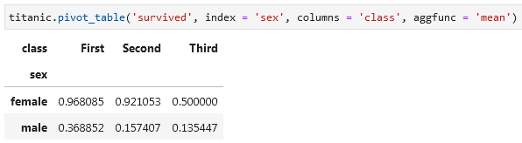

**Creating bins using pd.cut():**

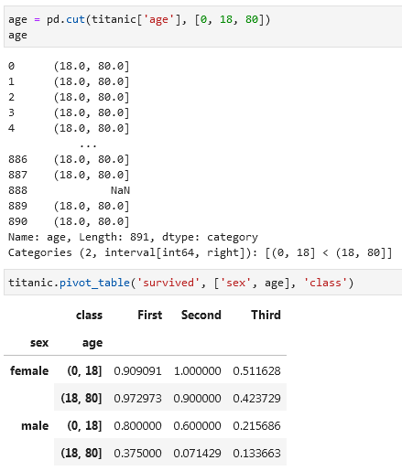 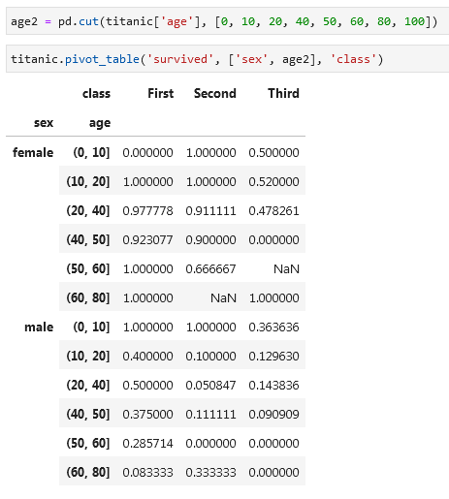

You can also create column bins. For example using pd.qcut to automatically compute quantiles:

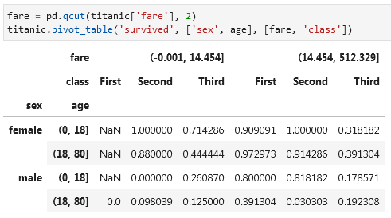

**Having two aggfunctons in your pivot (e.g. one for sum and another for mean):**

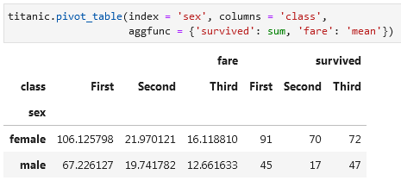

**Add totals to your pivot by writing margins = True:**

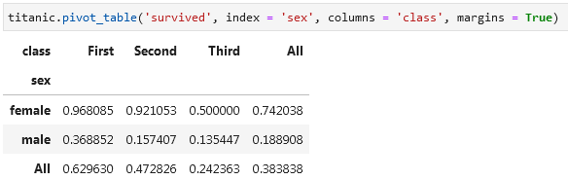

**Analyzing a dataset in padas. Example**

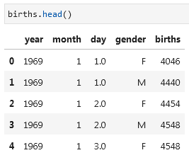

Adding a new column with decades information:

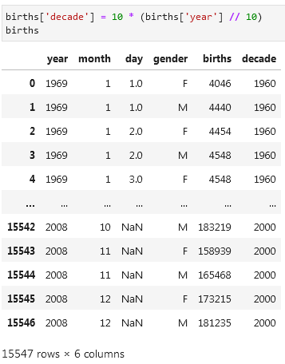

Making a pivot:

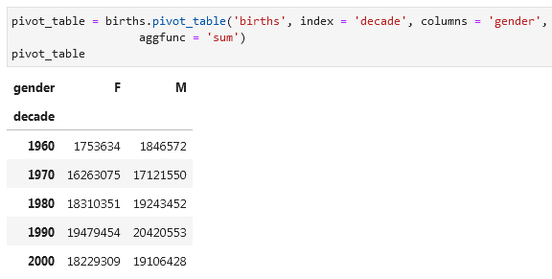

Formatting the pivot to have spaces in numbers using .applymap():

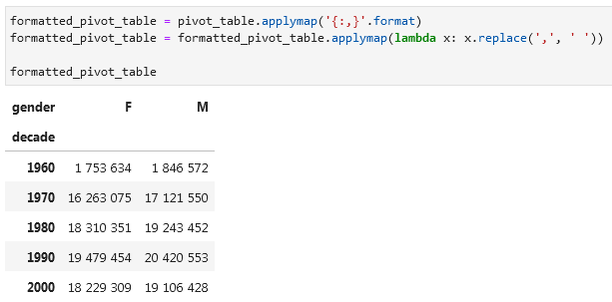

Dropping values that are outliers:

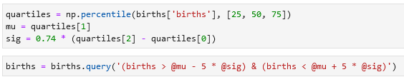

Create a datetime index from the year, month, day and adding a column with day of the week information (pd.to_datetime() and .dayofweek):

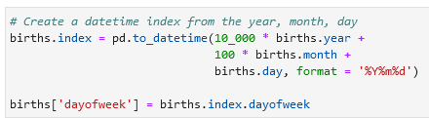

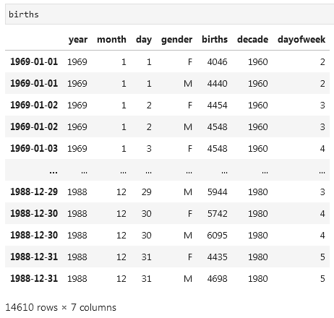

Plotting the graph with a custom x-axis using plt.gca().set():

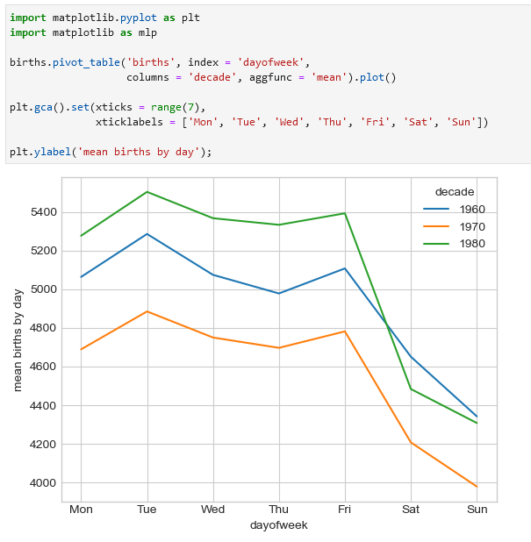

Changing the index of a dataframe into month and day:

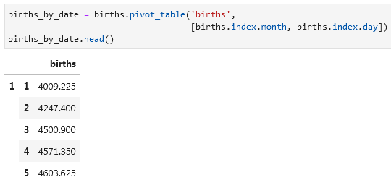

Change the index of a dataframe to a date:

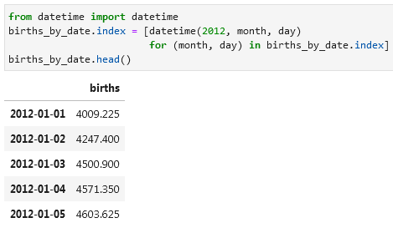

**Vectorized String Operations**

You can capitalize values in your array using a loop like:

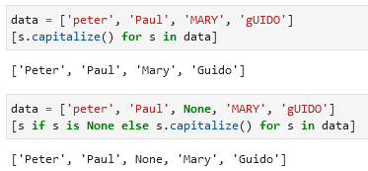

Or you can use capitalize():

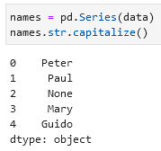

Pandas df.str. string functions (same as in Python):

* len return the lengths of characters of a value (e.g. ’for’ will return ’3’)
* lower turn all values into lowercase
* translate
* islower
* ljust
* upper
* startswith check whether a value starts with symbol (see example below)
* isupper
* rjust
* find
* endswith
* isnumeric
* center
* rfind
* isalnum
* isdecimal
* zfill
* index
* isalpha
* split Split a value like *Alex Smith* to *Alex, Smith*.
* strip
* rindex
* isdigit
* rsplit
* rstrip
* capitalize
* isspace
* partition
* lstrip
* swapcase

Examples with df.str.lower(), df.str.len(),df.str.startswith(), and df.str.split():

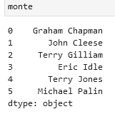 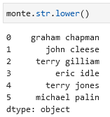 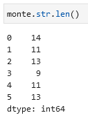 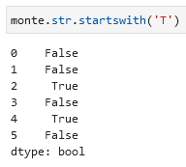 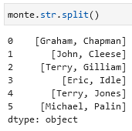

**Regular expressions**

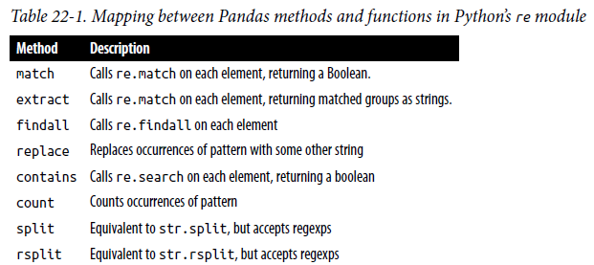

match, extract, findall, replace, contains, count, split, rsplit, re.match, re.findall, re.search, str.split

Examples with regular expressions. Extract the name using df.str.extract('([A-Za-z]+)', expand = False):

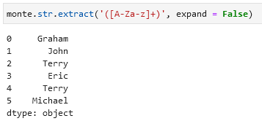

Show all values that begin and end with a consonant using df.str.findall(r'^[^AEIOU].*[^aeiou]$'):

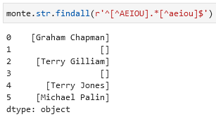

**Other pandas string functions**

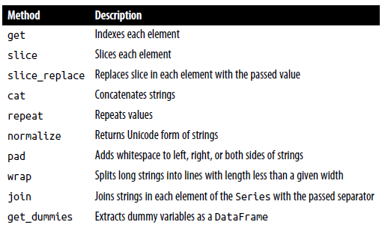

get, slice, slice_replace, cat, repeat, normalize, pad, wrap, join, get_dummies

Use df.slice[] or df.str.slice() to select symbols from your values:

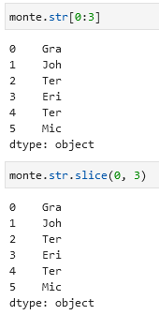

Use df.str.get() or df.str[] to return the n-element of the values. For example, returning the first element:

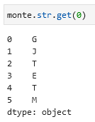 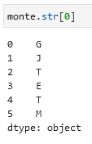

Use df.str.split().str[-1] to return the last name of each entry:

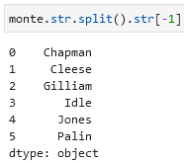

You might have in your data columns that mean something like A = born in the US, B = born in the UK, C = wears glasses, etc. Just like in the example below:

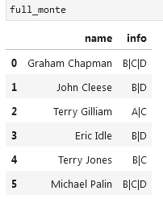

You can split these values into 0/1 columns using df.str.get_dummies ('|'):

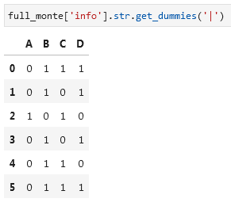

[**Working with text data in pandas documentation**](https://pandas.pydata.org/pandas-docs/stable/user_guide/text.html)

**Working with text in pandas example**

When importing JSONs use line = True if each line of a file is a JSON entry:

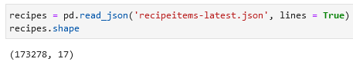

Reading one row:

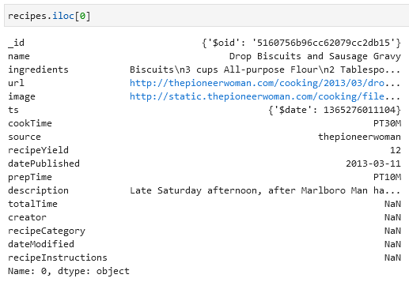

Getting basic information on a column (in this example *ingredients*):

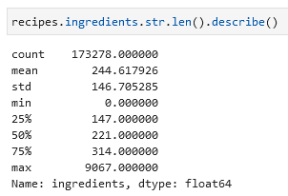

Get the name of the ingredient with the longest description using np.argmax (it returns the index of the max value):

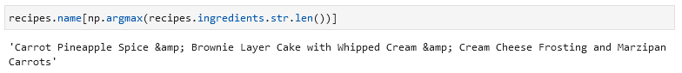

Example with .str.contains() (see how many recipes contain a specific ingredient/word):

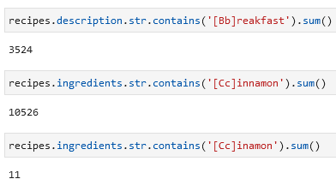

Check whether values appear in a list (ingredients appear in the list) using import re and re.IGNORECASE:

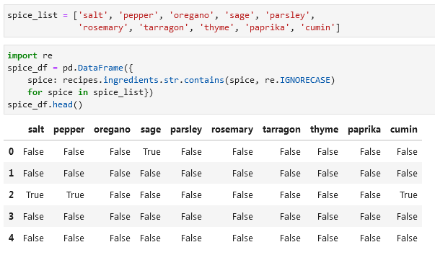

Check how many recipes include the ingredients you provide using .query():

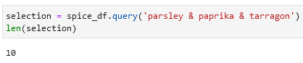

Return the names of these recipes:

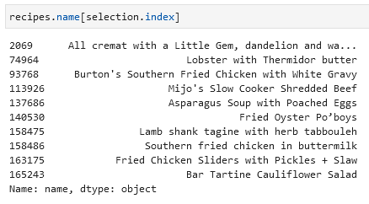

**Working with Time Series**

**Dates and Times in Python**

To manually build a date you can use the datetime function:

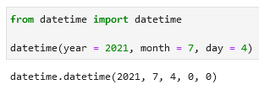

Alternatively, you can parse the date using the parser.parse:

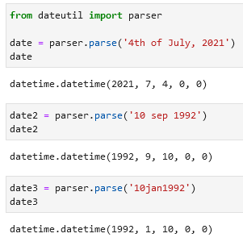

To get the day of week use df.strftime('%A'):

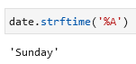

%A is one of the options, look up other options in the [strftime documentation](https://docs.python.org/3/library/datetime.html#strftime-and-strptime-behavior). Part of the documentation:

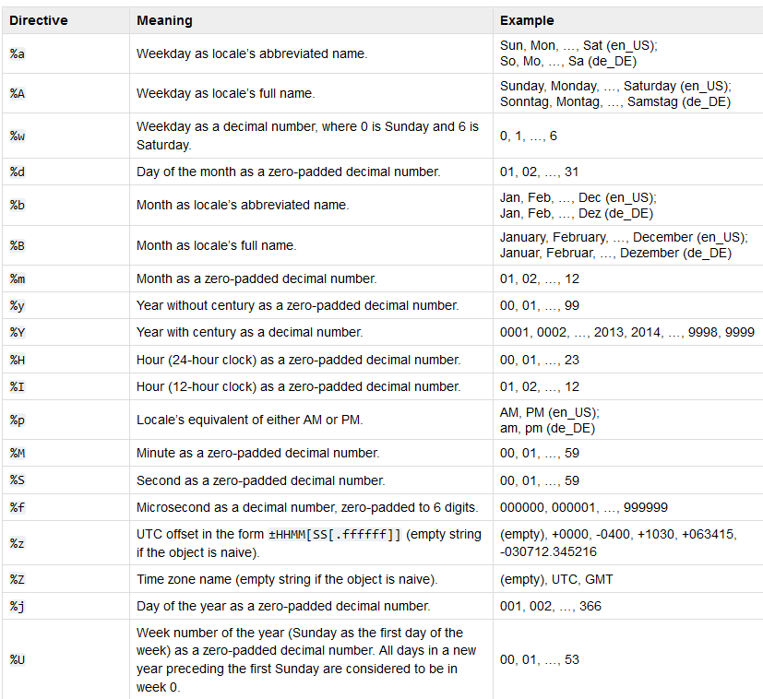

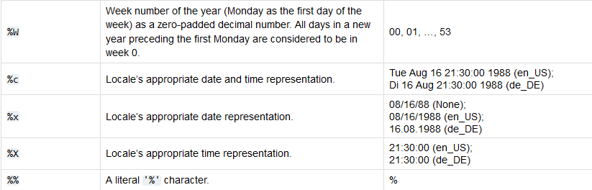

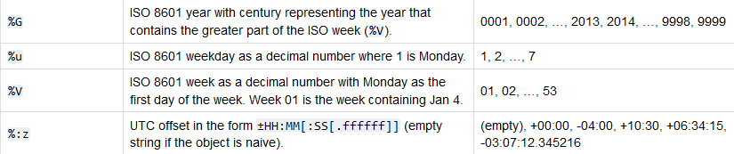

**Dates in NumPy**

Use dtype = np.datetime64 to make an array a date:

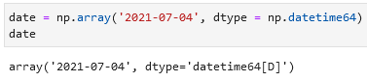

Have dates in this form allows you to perform (arithmetic) operations like summation:

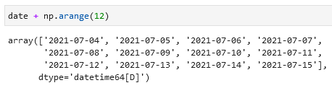

Encoding YMD, YMD & time, YMD & time & nanoseconds in np.datetime64:

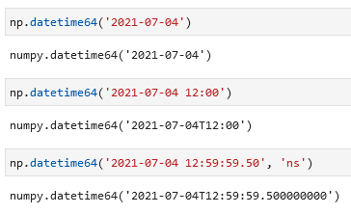

**np.datetime64 time spans encoding overview:**

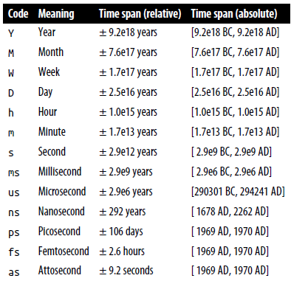

**Working with dates in pandas**

Use pd.to_datetime() to parse through a date:

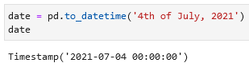 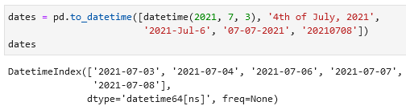

Using df.strftime('%A') to get the day of the week:

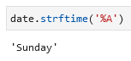

It is possible to perform (arithmetic) operations on this object:

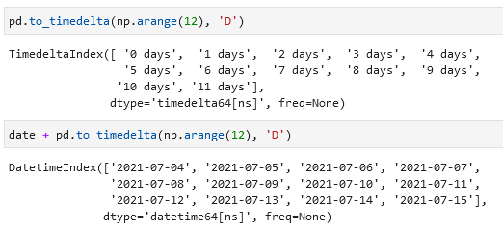

You can pass a date as an index using: Slicing/filtering with dates as index:

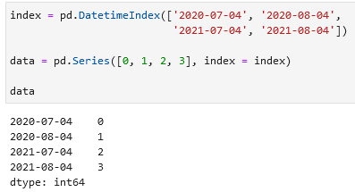 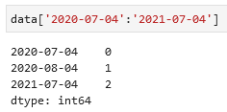 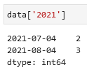

A datetime dtype can be converted into a periodindex using .to_period():

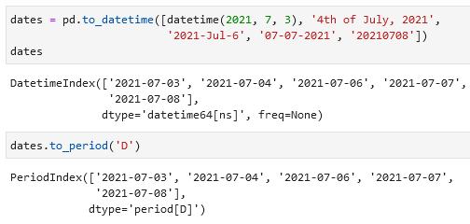

A TimedeltaIndex is created when e.g. a date is subtracted from another date:



**Timestamps, time periods, time deltas in pandas**

Use pd.date_range to create timestamps, pd.period_range for periods, and pd.timedelta_range for time deltas.

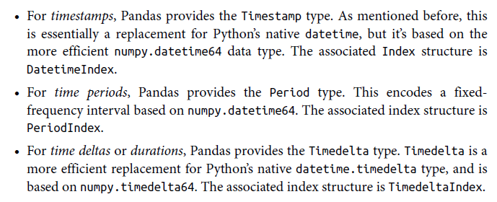

Example of a pd.date_range(), also using the periods = feature:

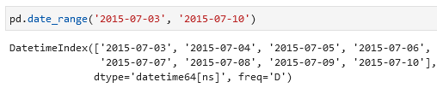

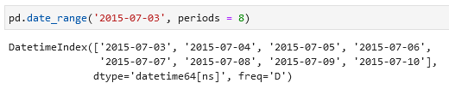

You can use the freq = argument to modify the default altering from days to e.g. hours:

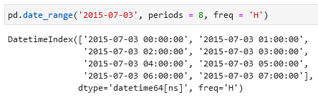

Example of the pd.period_range() function:

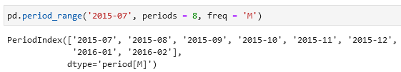

Examples of the pd.timedelta_range() function with frequency every hour/2,5 hours:

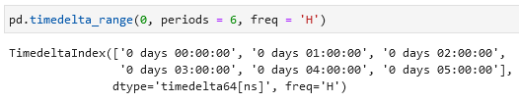

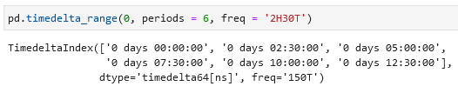

**Pandas frequency codes:**

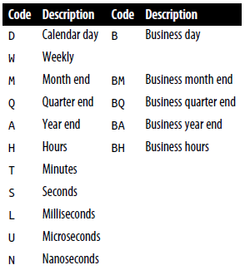

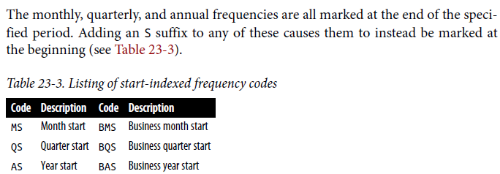

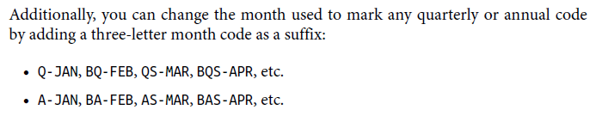

These codes can be found in the pandas.tseries.offsets module. Example with listing the next 5 working days using freq = BDay():

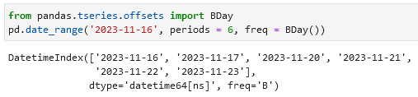

**Resampling and converting frequencies**

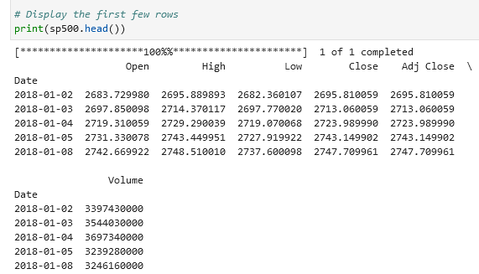

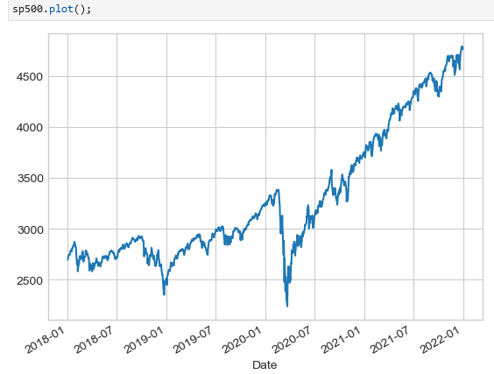

One common need when dealing with time series data is resampling at a higher or lower frequency. This can be done using the resample method, or the much simpler asfreq method. The primary difference between the two is that resample is fundamentally a data aggregation, while asfreq is fundamentally a data selection.

Example of usage .resample() and .asfreq(). Notice the difference: at each point, resample reports the *average of the previous year*, while asfreq reports the *value at the end of the year*.

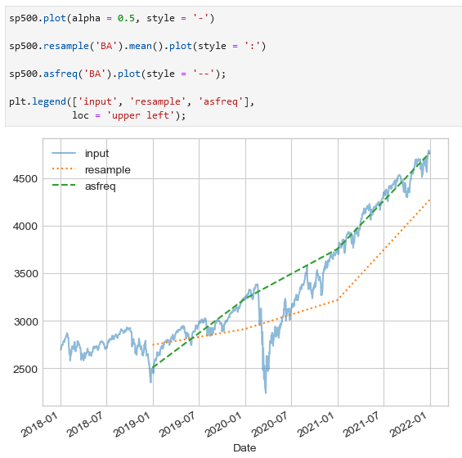 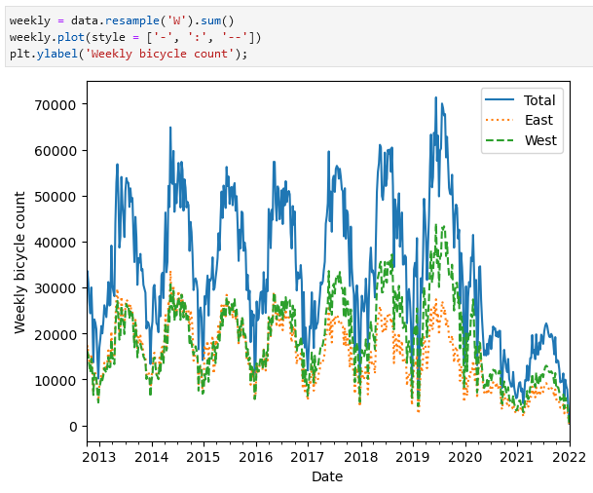

Forward-fill and backward-fill interpolation with afsreq:

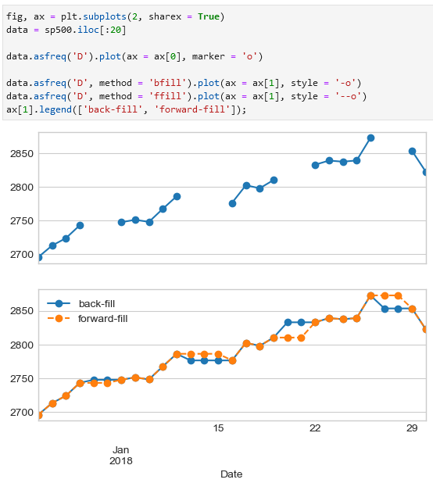

**Time shifts**

Shift data by a given number of entries using the .shift function. For example, here we resample the data to daily values, and shift by 364 to compute the 1-year return on investment for the S&P 500 over time:

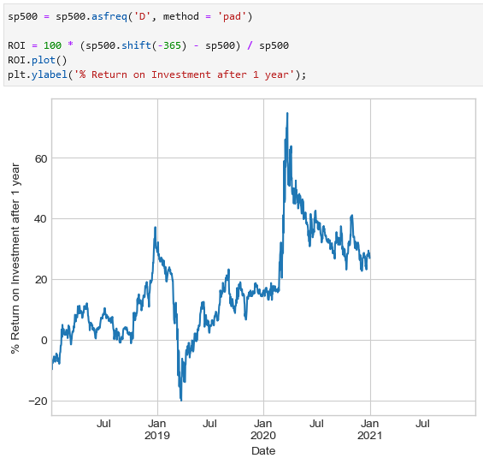

**Rolling windows**

E.g. one-year centered rolling mean and standard deviation of the stock prices can be viewed using .rolling:

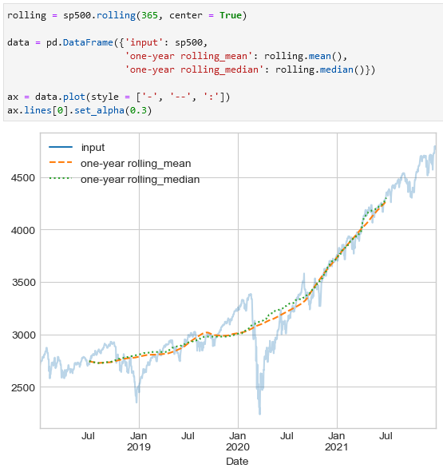

**Examples**

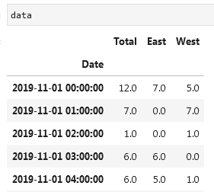

Example with a rolling mean function (pd.rolling_mean)S

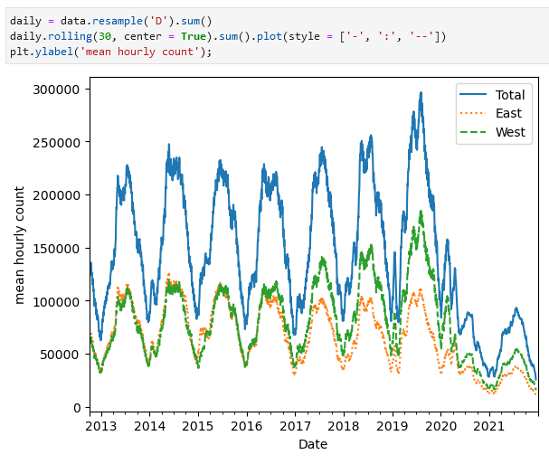

To get a smoother line you can use a window function (.rolling), for example, a Gaussian window (win_type = 'gaussian'). The code specific both the width of the window (in the example 50 days) and the width of the Gaussian window (in the example 10 days).

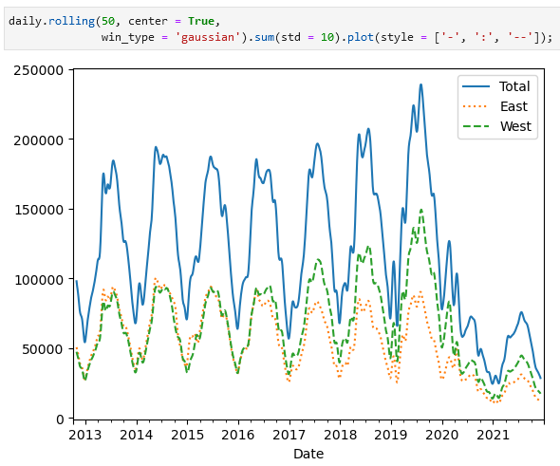

Build a graph that shows development during the day (below — average hourly bicycle counts):

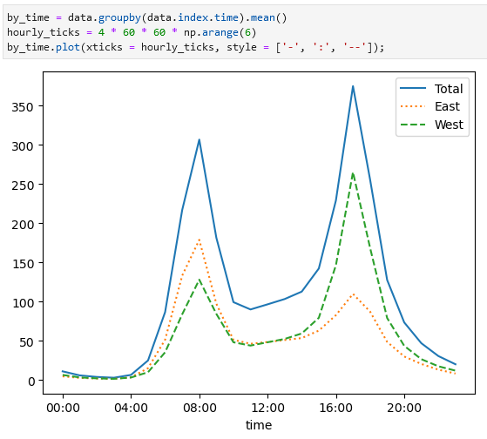

Build a graph that shows development during the week (below — average daily bicycle counts):

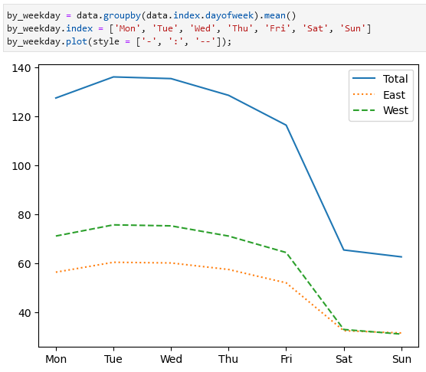

Hourly trends on weekdays and weekends. Example of the np.where() function. Below — average hourly bicycle counts by weekday and weekend.

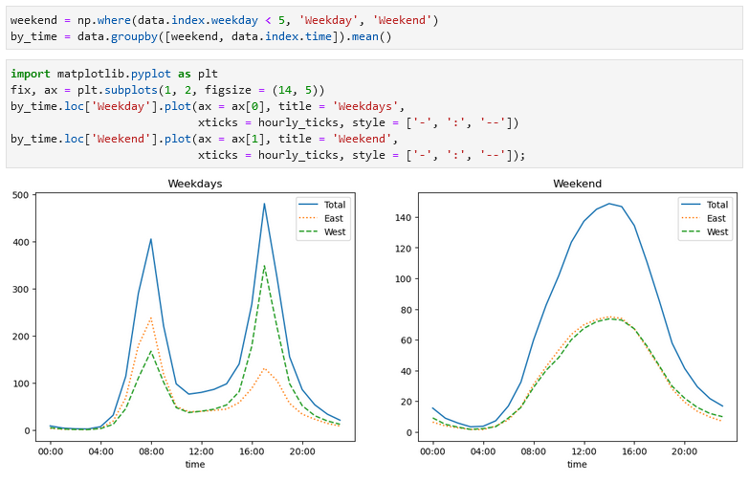

**High-Performance Pandas: eval and query in NumExpr library**

Example with numexpr.evaluate() and np.all():

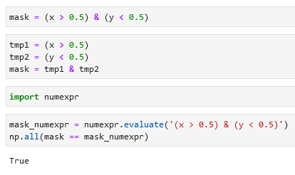

pd.eval() is more efficient in terms of speed and computational power:

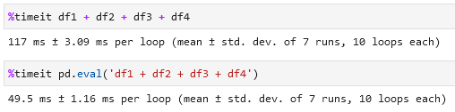

np.allclose() checks whether both arrays are the same:

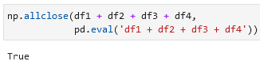 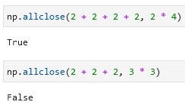

**Operations that np.eval() supports:**

* Arithmetic
* Comparison
* Bitwise
* Object attributes and indices

Other operations, such as function calls, conditional statements, loops, and other more involved constructs are currently not implemented in pd.eval(). If you’d like to execute these more complicated types of expressions, you can use the NumExpr library itself.

Arithmetic: Comparison:

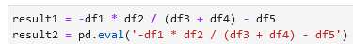 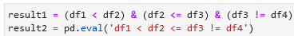

Bitwise: Object attributes and indices:

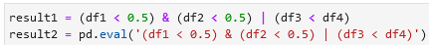 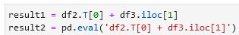



**If you want to *use column names for operations* then you can use df.eval() as an alternative to pd.eval():**

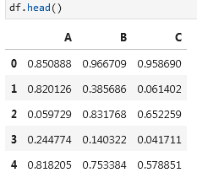

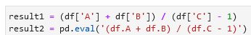



You can use df.eval() to create a new column or to modify an existing column:

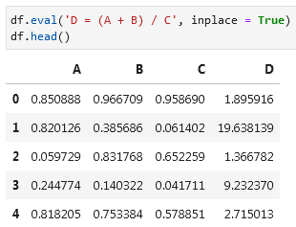 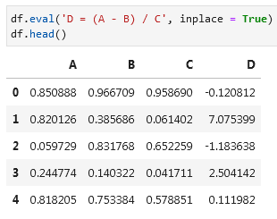

If you want to use *a local variable* in a DataFrame.eval() you can do it this way using @:

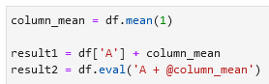

**In addition to pd.eval() and df.eval() there is also df.query(). Example with it:**

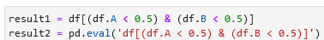

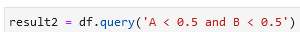

Example with a *local variable* where you use @:

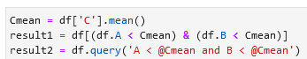

**Matplotlib**

Importing Matplotlib using import matplotlib as mpl & import matplotlib.pyplot as plt and setting the styles plt.style.use('classic'):

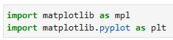 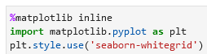

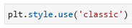

**In Jupyter Notebooks you have the option to embed graphics directly in the notebook with two possible options:**

* %matplotlib inline (default) will lead to *static* images of your plot embedded in the notebook;
* %matplotlib notebook will lead to *interactive* plots embedded within the notebook.

Basic plotting example in Matplotlib:

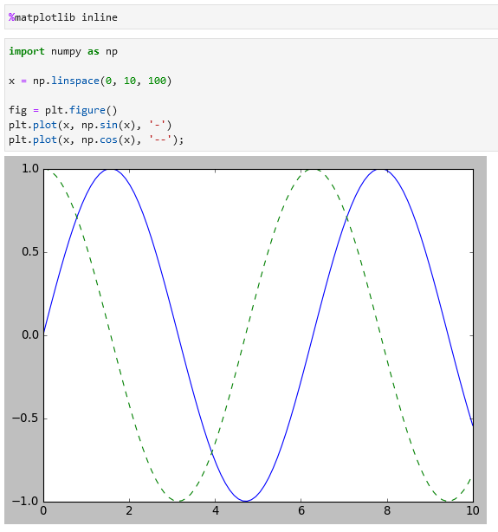

**To save a figure in Matplotlib** in your current working directory use fig.savefig():

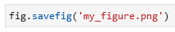

Check available formats using fig.canvas.get_supported_filetypes():

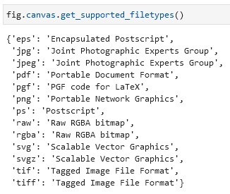

You can **import an image** using from IPython.display import Image:

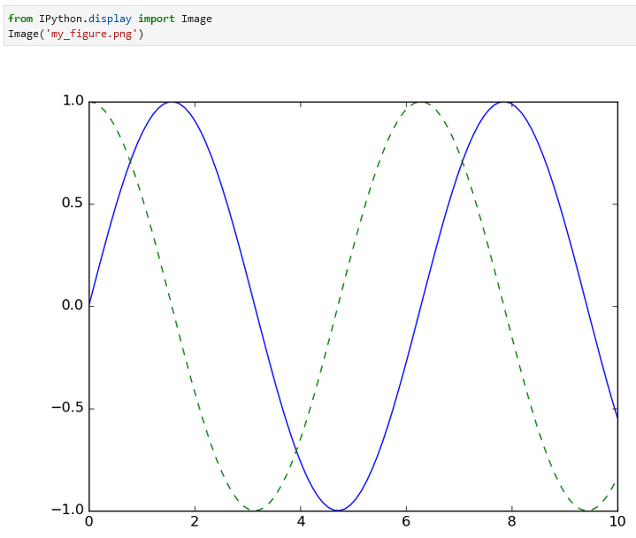

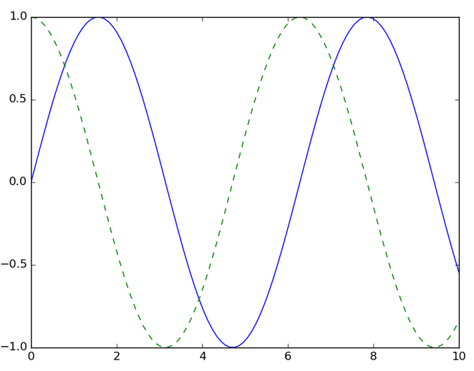

**Two interfaces in Matplotlib: MATLAB-style and the object-oriented one**

**MATLAB-style**

* The MATLAB-style tools are contained in the pyplot (plt) interface.
* It is useful for simple plots, but can easily run into problems.

MATLAB-style example:

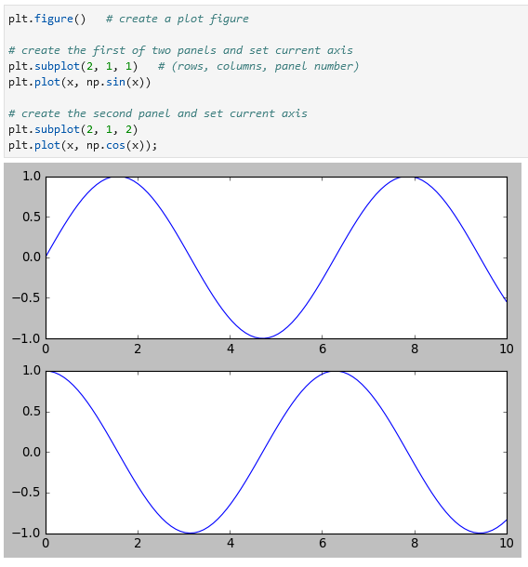

**Object-oriented interface**

* For more complicated situations;
* When you want more control over your figure.

Example:

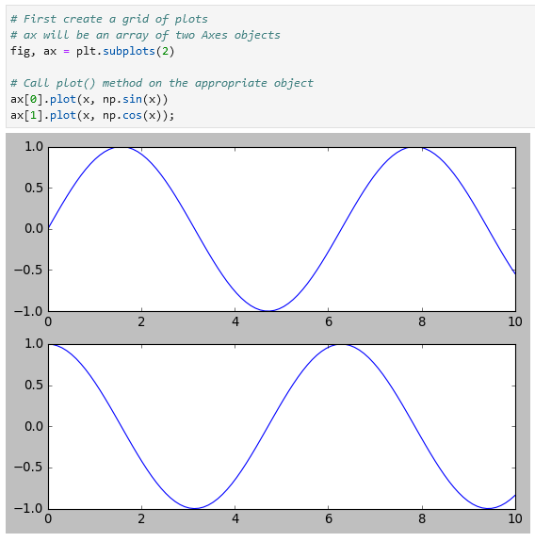

**Simple Line Plots**

Some information on figure (fig = plt.figure()) and axes (ax = plt.axes()):

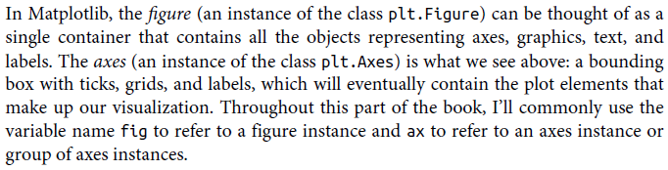

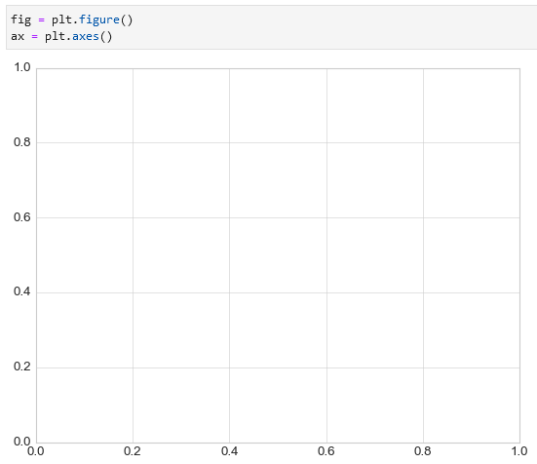

**Creating a simple sinusoid using both methods (OO and MATLAB):**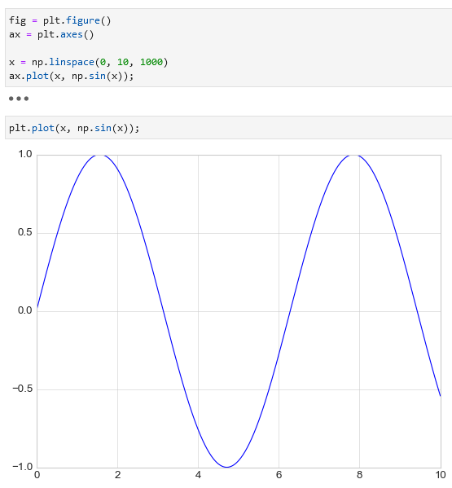

To create a single figure with multiple lines call the function multiples times:

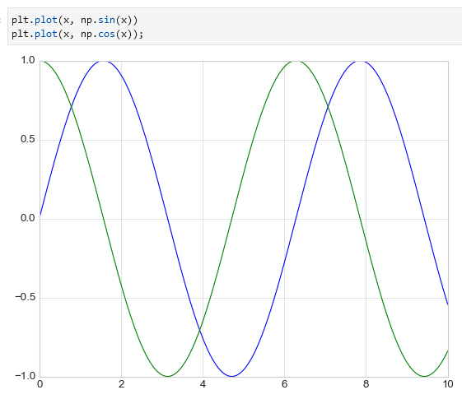

**Specifying a color** in plt.plot() using the color = feature:

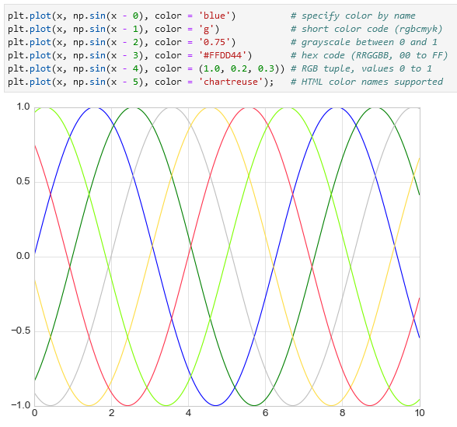

To change the line style use the linestyle = feature where you can choose from solid, dashed, dashdot, and dotted (example on the left). You can also combine the line style with line color (example on the right).

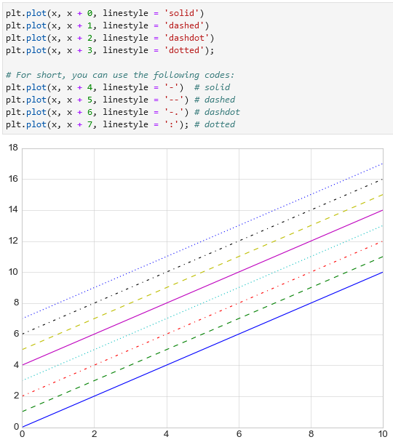 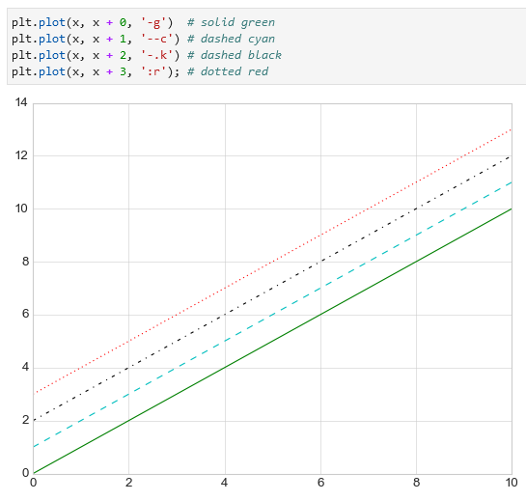

**To set the axes limits use plt.xlim() or plt.ylim() for x/y-axes:**

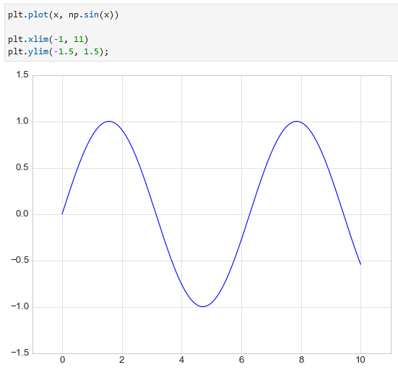

To reverse an axis simply reverse the order of the arguments like (10, -10) instead of (-10, 10):

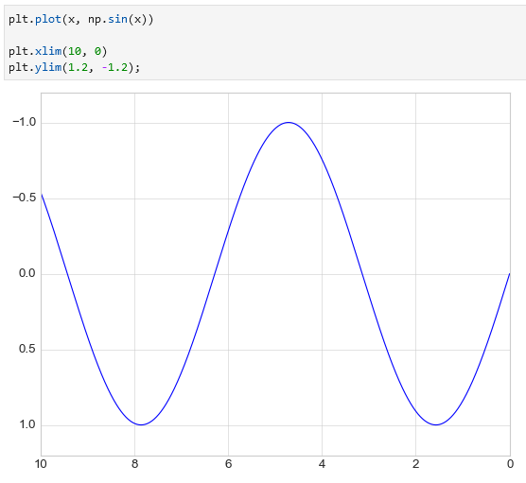

You can also use text to describe your axis. Words like plt.axis('tight'), equal, on, off, square, image, and more.

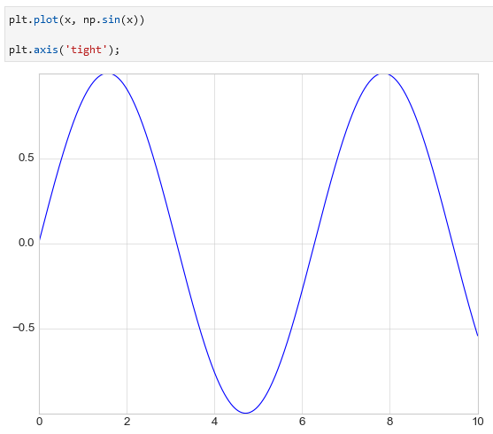 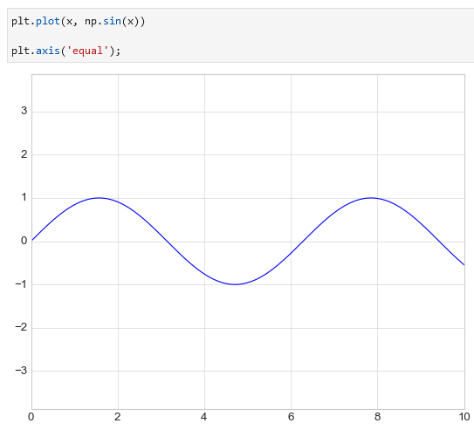

**Adding labels to the plot (title, x-axis name, y-axis name)** is possible using plt.title(), plt.xlabel(), and plt.ylabel():

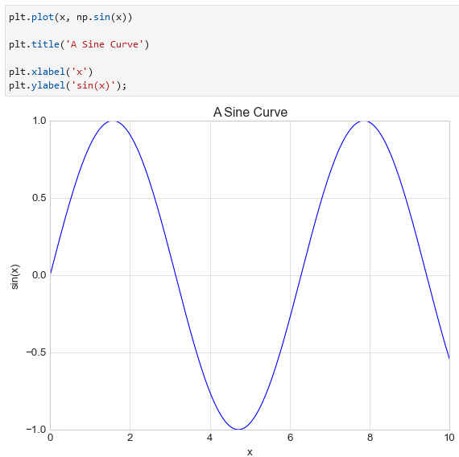

To add a legend you need to specify a label to each line/graph element using a label = feature and add plt.legend():

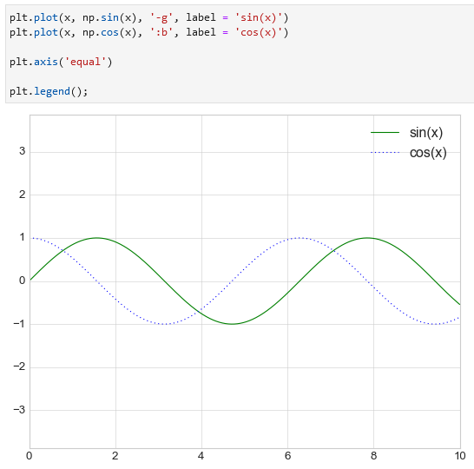

**plt.plot vs ax.plot**

Most plt. functions translate directly to ax. functions, however, there are differences.

|  |  |
| --- | --- |
| **plt.** | **ax.** |
| plt.xlabel | ax.set_xlabel |
| plt.ylabel | ax.set_ylabel |
| plt.xlim | ax.set_xlim |
| plt.ylim | ax.set_ylim |
| plt.title | ax.set_title |

**You can use ax.set() to set multiple properties at once.** See example:

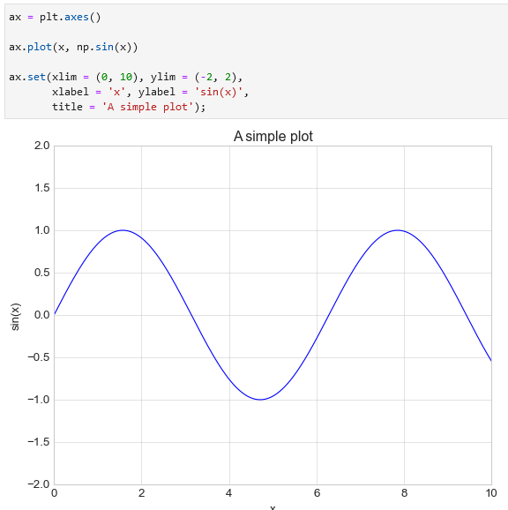

**Simple Scatter Plots**

There are two ways to plot a scatterplot: plt.plot() or plt.scatter(). For large datasets plt.plot() is preferred.

To plot a scatterplot use plt.plot() and specify 'o':

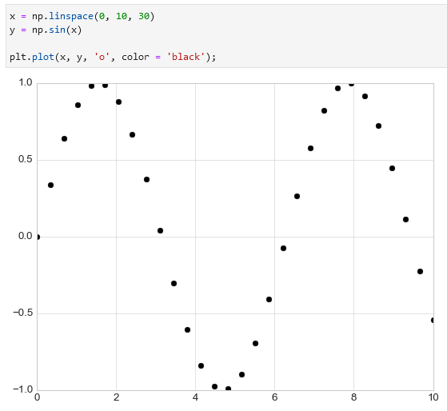

Alternatively you can use plt.scatter():

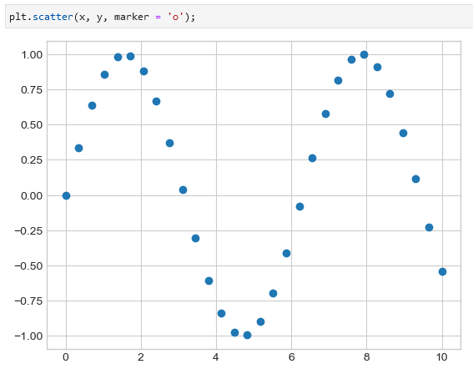

You can use **different symbols for scatterplots**. Example of scatterplots symbols:

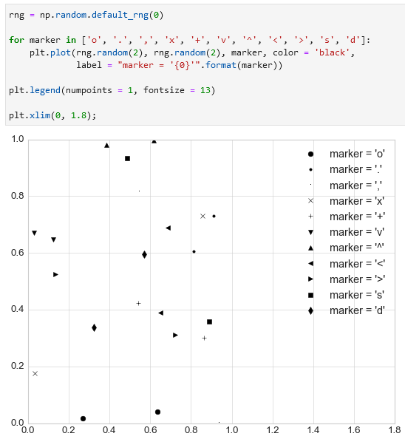

**You can also combine line charts with plot points (markers):**

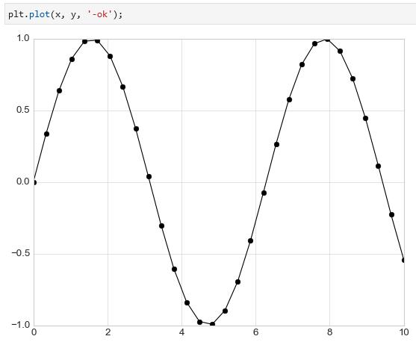

**Additional features of line markers line color, width, fill, etc. (markersize =, linewidth = , markerfacecolor =, markeredgecolor =, markeredgewidth =):**

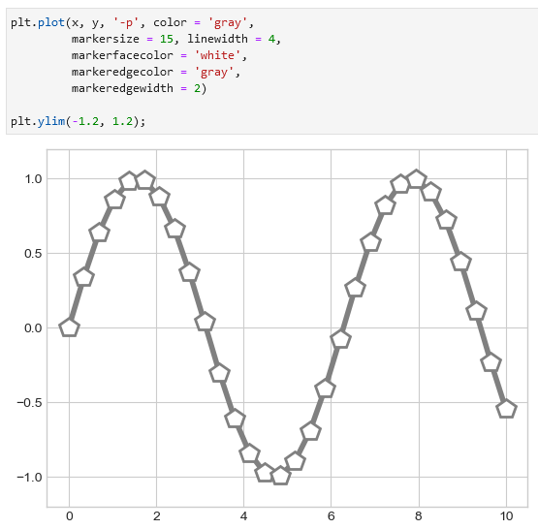

Changing the size and color in scatter points (also adding a colorbar using plt.colorbar()):

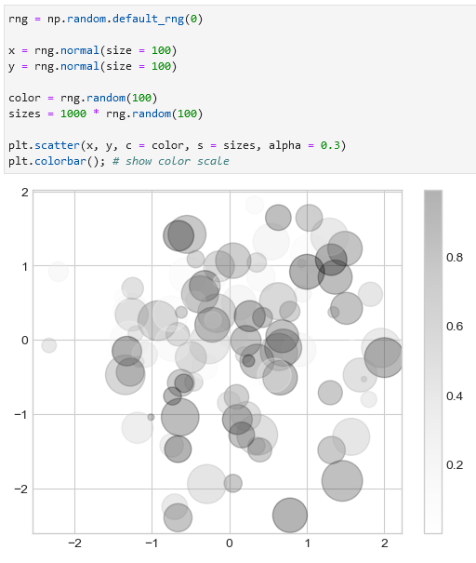

Scatterplot example:

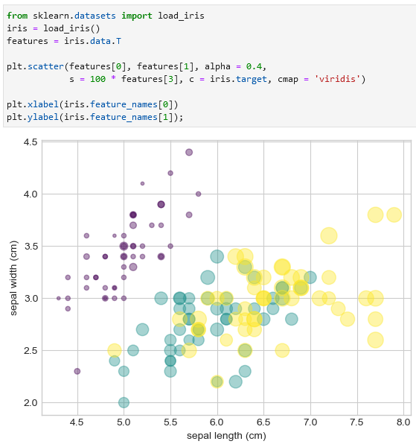

**Visualizing Uncertainties**

**Basic errorbars**

Use plt.errorbar(x, y, yerr = _, fmt = _) to make an errorbar. Feature yerr = is responsible for the vertical lines (uncertainties) and fmt = is responsible for the appearance of lines and points. Additional features are ecolor =, elinewidth =, capsize =.

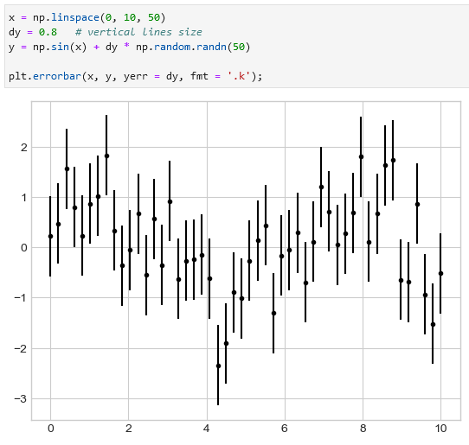 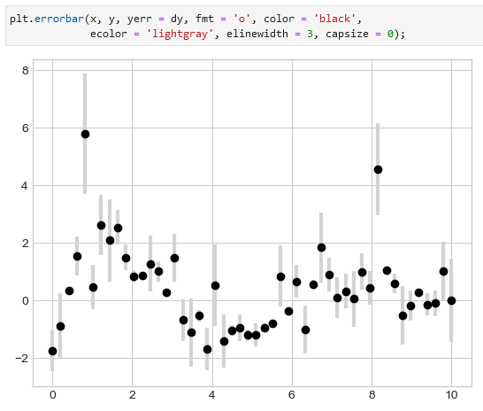

**Continuous uncertainty with filled regions (plt.fill_between):**

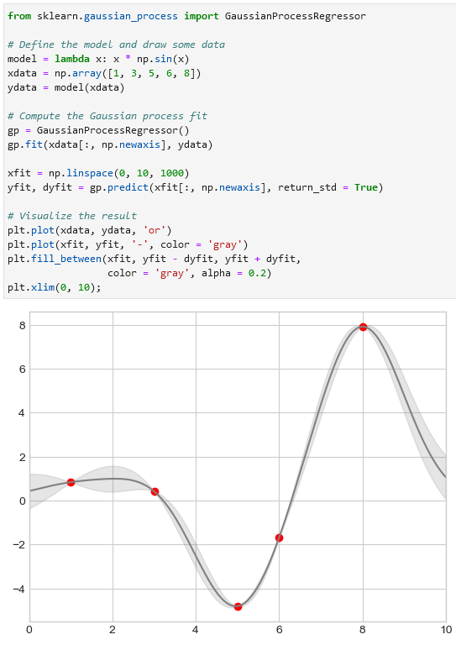

**Density and Contour Plots**

**Visualizing a three-dimensional functions like *z = f(x, y)***

* The np.meshgrid function builds two-dimensional grids from one-dimensional arrays;
* The plt.contour function is helpful for contour plots;
* Negative values are dashed lines while positive values are solid lines;
* 20 in plt.contour(X, Y, Z, 20) means ‘draw more lines’.

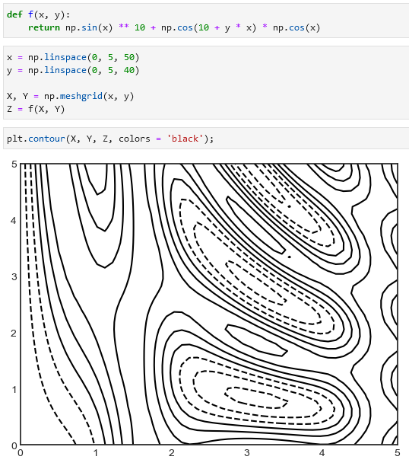 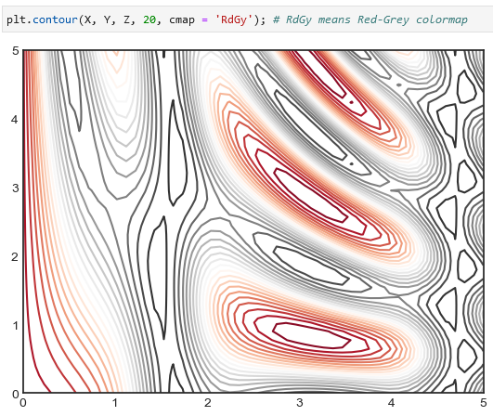

**Colormaps in Matplotlib are available using plt.cm.<TAB>.**

**Another contour plot is plt.contourf() that fills the contours:**

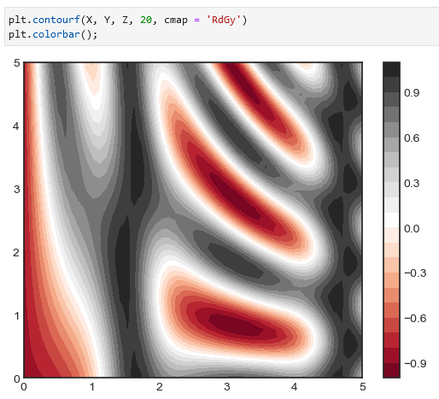

You can further improve this contour plot by using plt.imshow(), where the color will be gradient. Note that this function does not accept x and y grid, so you must manually specify the extent [xmin, xmax, ymin, ymax] of the image on the plot, origin should be also corrected to lower.

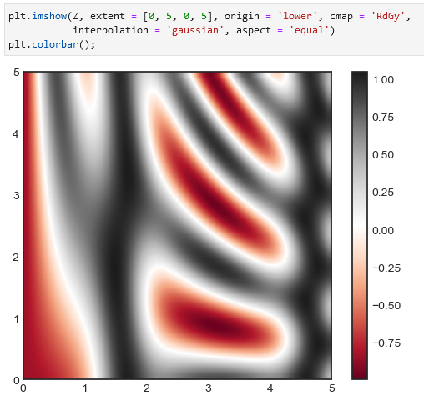

You can also add contours using plt.contour() and plt.clabel():

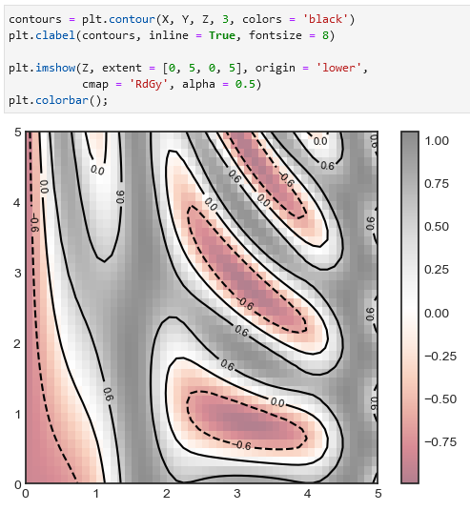

**Histograms, Binnings, and Density**

A simple histogram can be build using plt.hist(data).

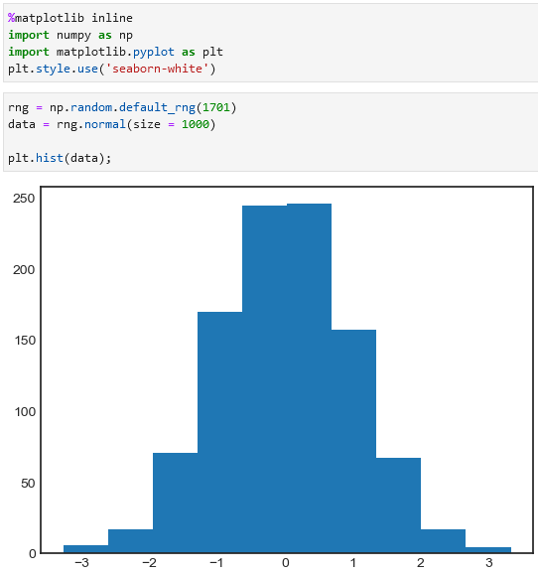 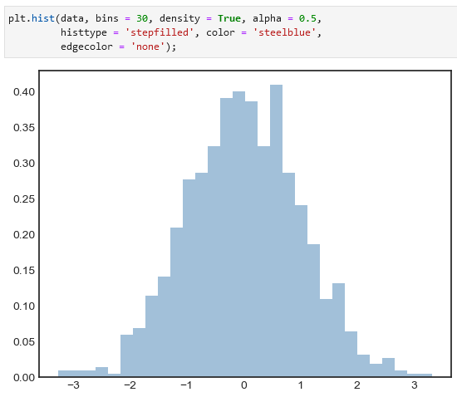

Plotting multiple histograms:

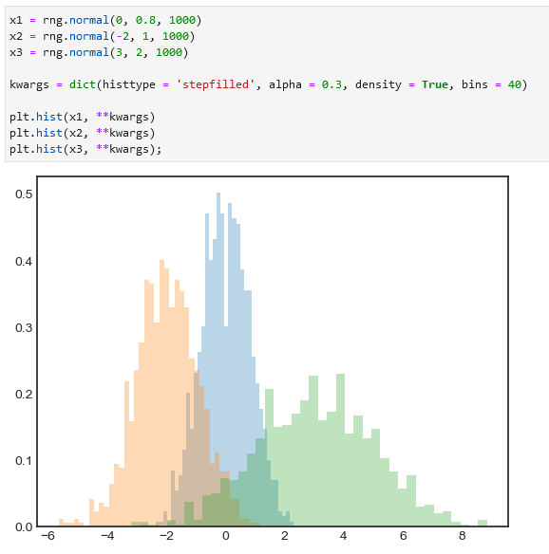

**To count the number of points in a given bin without plotting a graph is possible using np.histogram():**

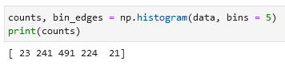

**Two-Dimensional Histograms and Binnings**

rng.multivariate_normal():

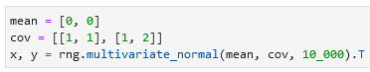

Plot a two-dimensional histogram using plt.hist2d():

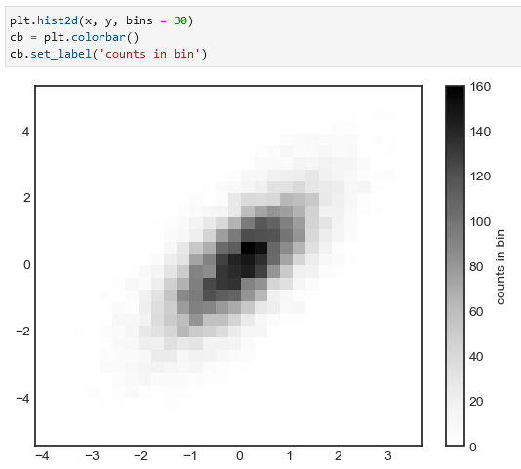

There is also np.histogram2d() which is similar to np.histogram():

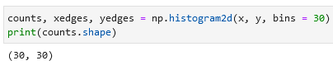

Example of plt.hexbin():

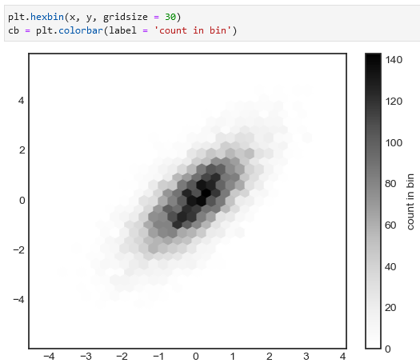

**Kernel density estimation (KDE)**

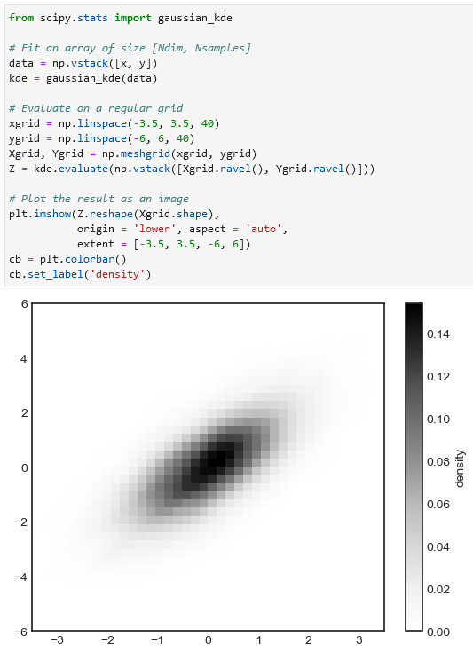

**Customizing plot legends**

A simple legend can be created using ax.legend():

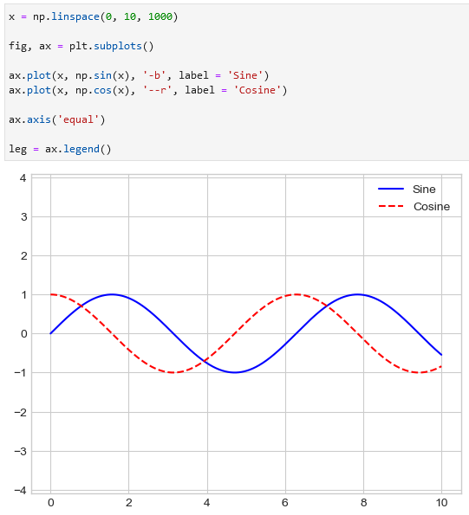

Add loc = and frameon = True to specify the location of the legend and to add the frame:

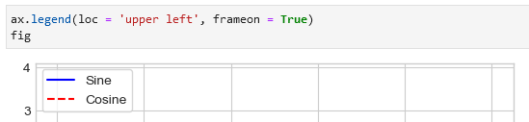

You can also print the legend in the lower middle part of the graph, add ncol = 2 to portray the values next to each other instead of below each other:

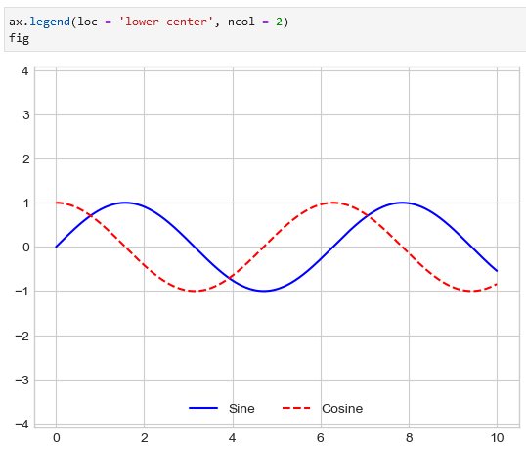

Other features are:

* fancybox = True (rounded corners),
* framealpha = 1 (transparency of background),
* shadow = True (add shadow),
* borderpad = 1 (size of the border).

Example:

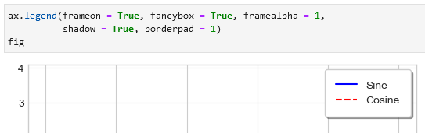

**Choosing elements for the legend**

You can specify which elements to choose inside the plt.legend() function like here:

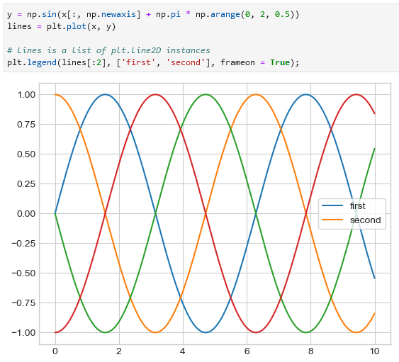

**Alternatively, you can add labels to each line that you want to have a label. This method is probably easier to use:**

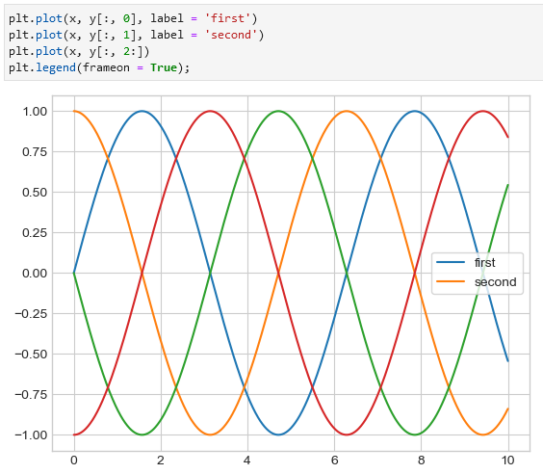

**Legend for size of points**

Example of a legend with area sizes:SS

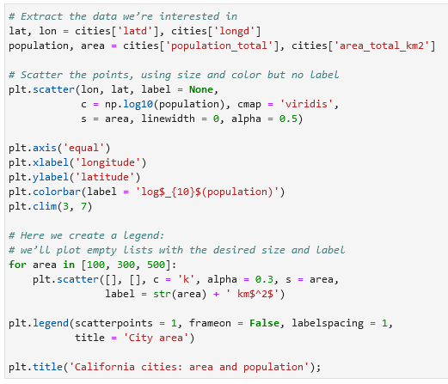



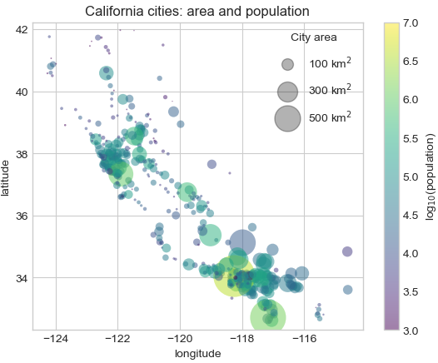

**Multiple legends**

Example of a graph with two legends:

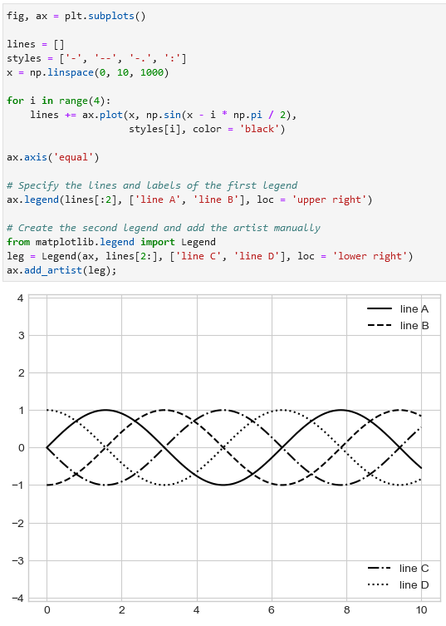

**Customizing colorbars**

Colorbar example using plt.colorbar():

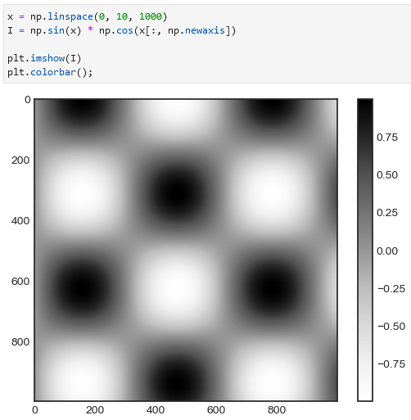

Add color to a colorbar using plt.imshow():

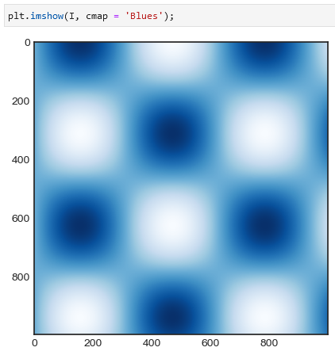

**Choosing the colormap**

Colormaps like viridis or RdBu are a good choice:

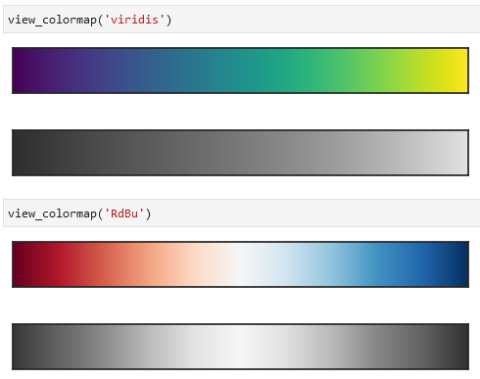

**Color limits and extensions**

Specifying colormap extensions:

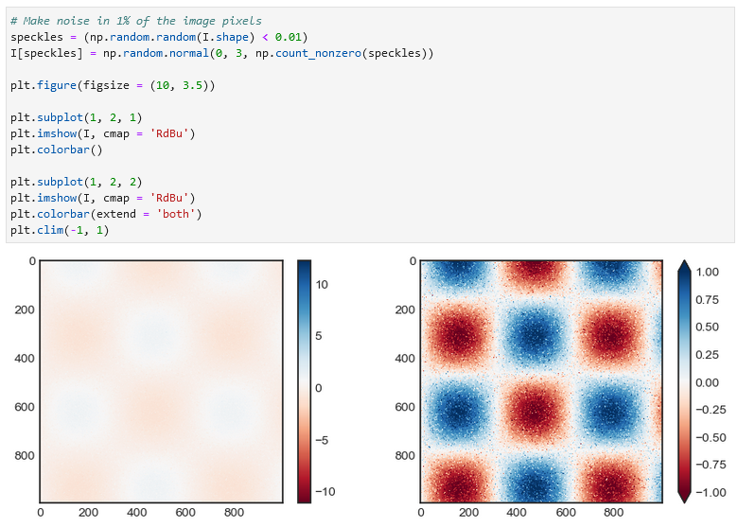

**Discrete colorbars**

Could be added using plt.cm.get_cmap():

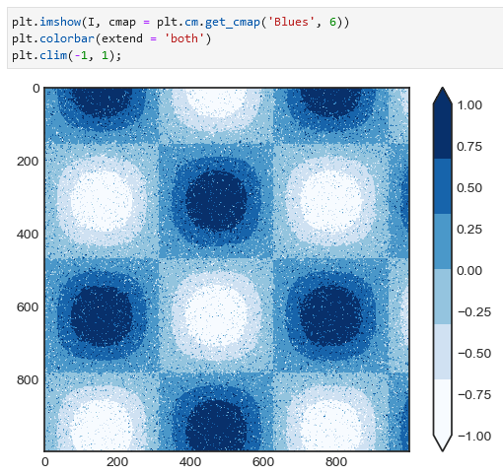

**Multiple Subplots**

Example of an inset axes:

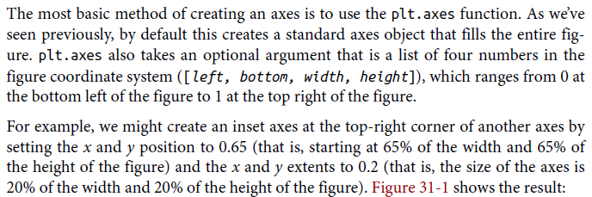

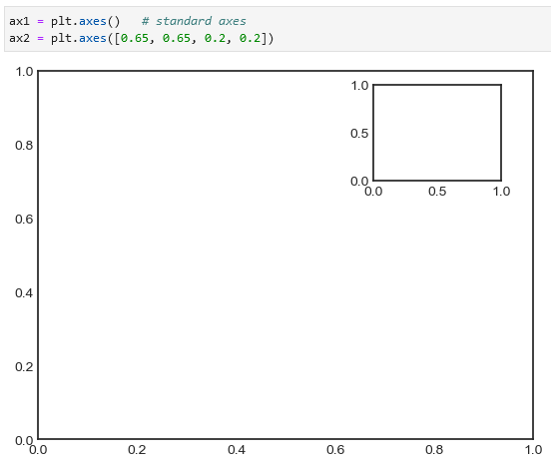

**Vertically stacked axes example**

The equivalent is fig.add_axes(). We now have two axes (the top with no tick labels) that are just touching: the bottom of the upper panel (at position 0.5) matches the top of the lower panel (at position 0.1 + 0.4).

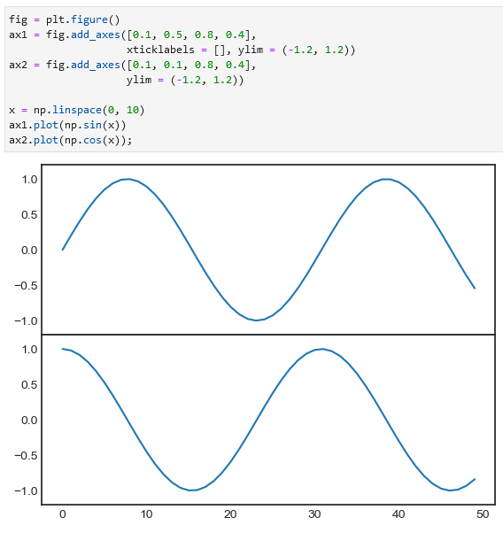

**Creating a grid using plt.subplot**

You can use plt.subplot(rows, columns, index) to create a grid. The first number is the number of rows, second is the number of columns, and the last number is the index of the created grid. In the example below also function plt.text() is used.

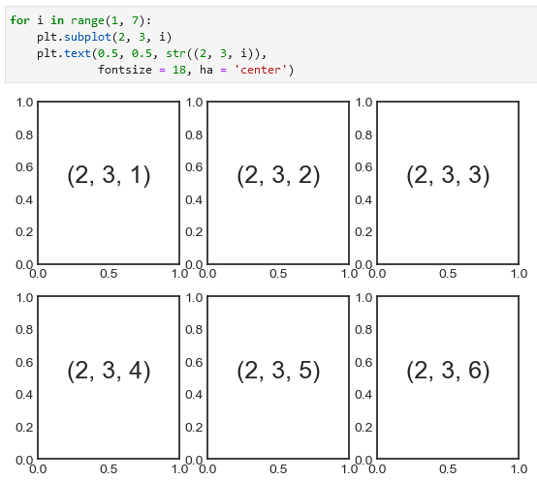

To **adjust the spacing between plots** use plt.subplots_adjust() / fig.subplots_adjust(). Use hspace = and wspace = to specify the specing along the height/width of the figure in units of the subplot size. In the example below the space is 40% of the subplot height/width.

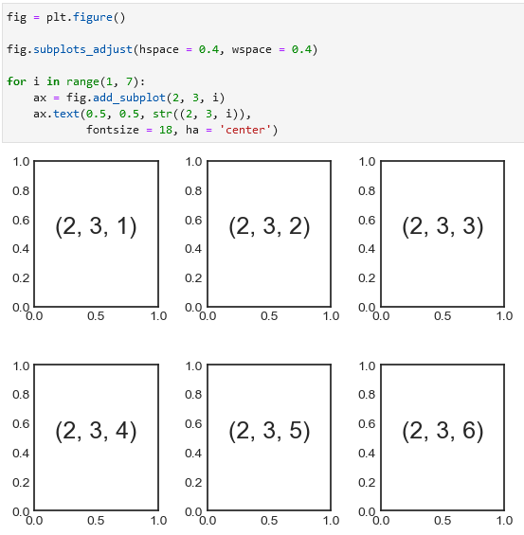

**Creating a grid using plt.subplots**

An alternative to plt.subplot() is plt.subplots(). You specify the number of rows and columns, and, using sharex = and sharey =, share the x- and y-axes along each graph.

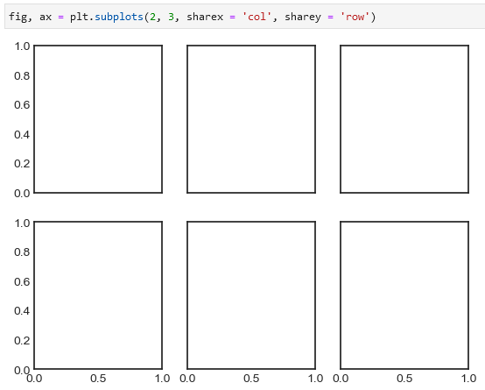

To check what is the index of each graph:

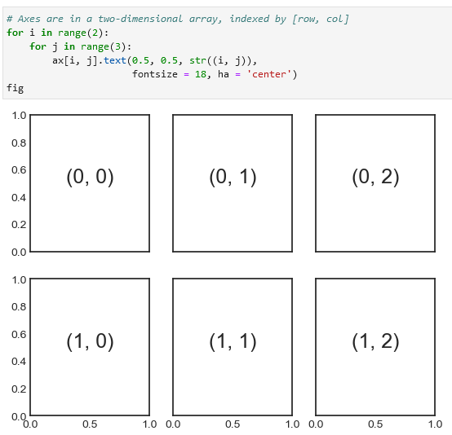

**Creating a grid using plt.GridSpec**

If you want to create graphs that have different sizes you can use plt.GridSpec():

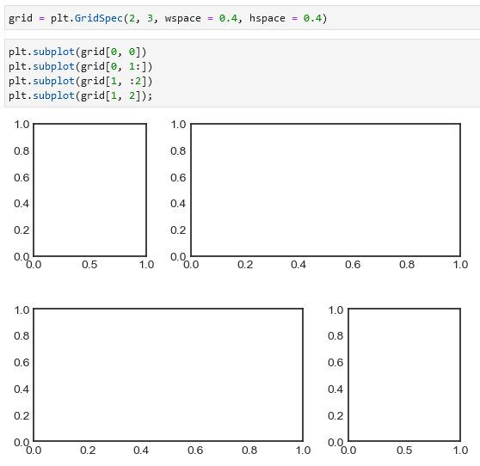

**Usage example (multiaxes histogram plot):**

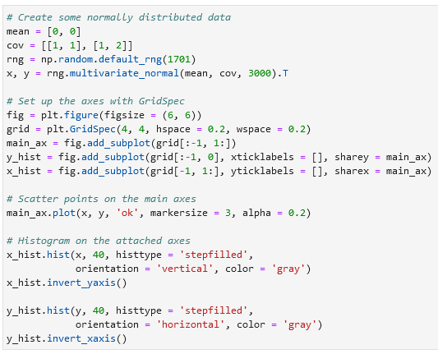

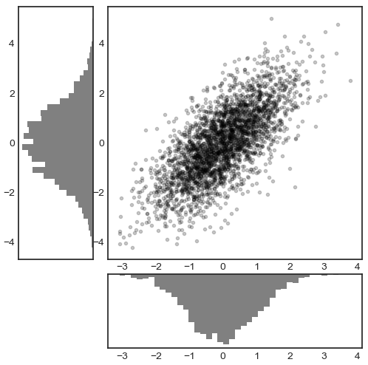

**Text and annotation**

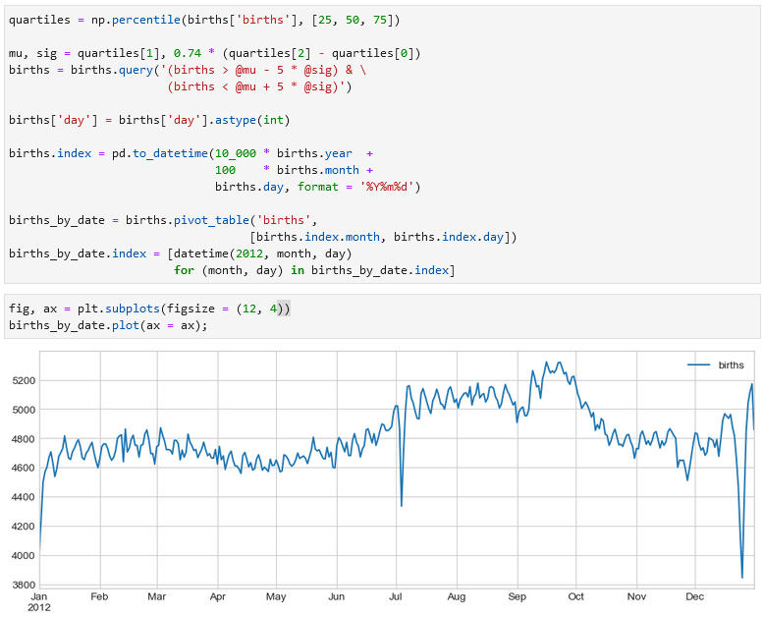

**Use ax.text() to add textual information to the graph:**

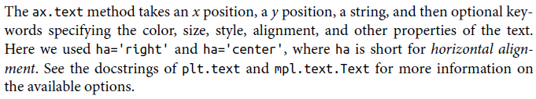

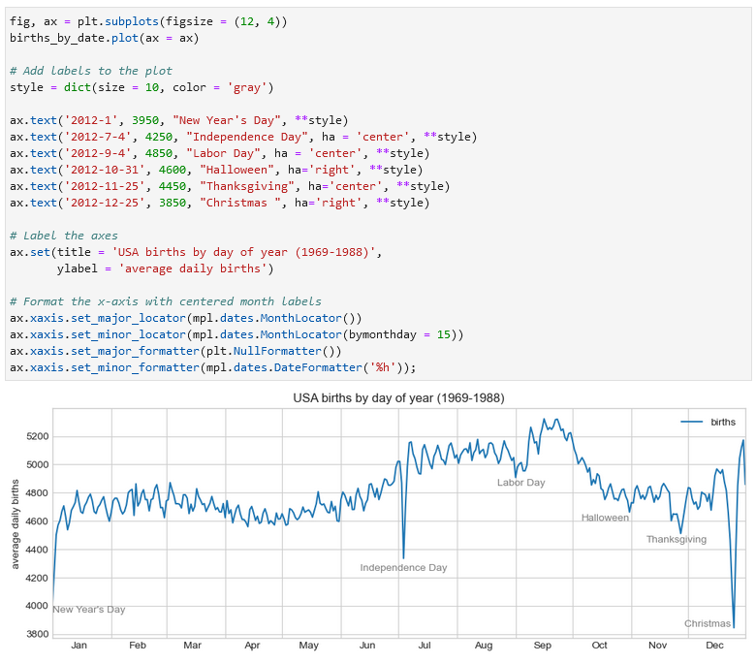

**Transforms and text position**

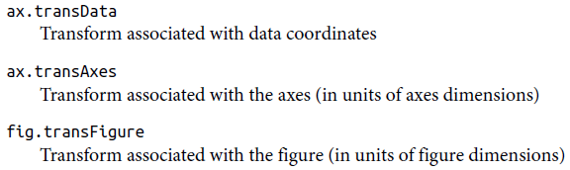 ax.transData, ax.transAxes, fig.transFigure

**Comparing Matplotlib’s coordinate systems.** Matplotlib’s default text alignment is such that the “.” at the beginning of each string will approximately mark the specified coordinate location.



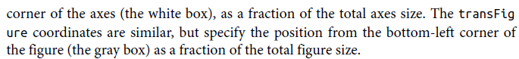

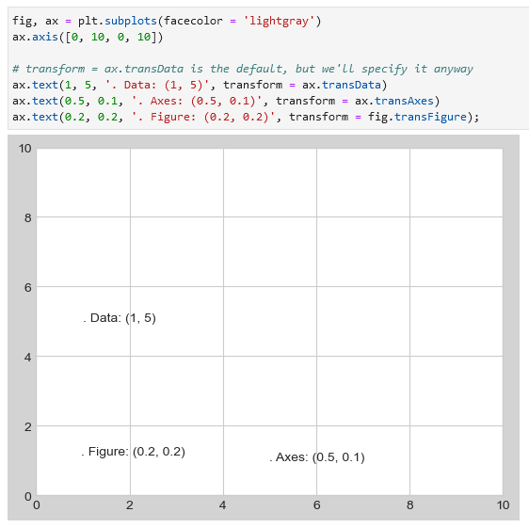

If the axes limits are changed only ax.transData coordinates will be affected:

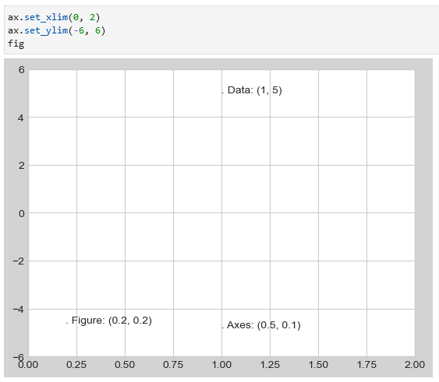

**Arrows and annotation**

Instead of plt.arrow use plt.annotate, arrowprops =:

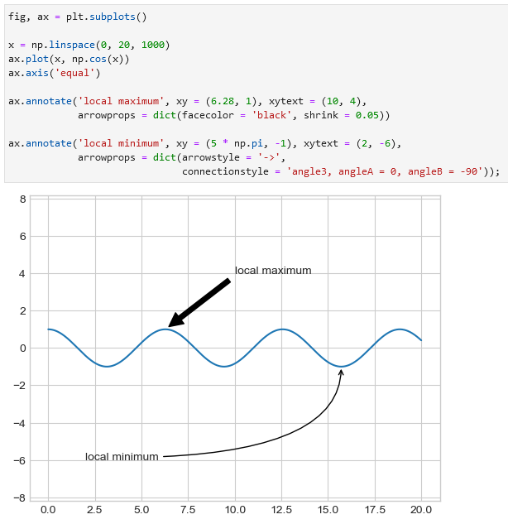

Example:

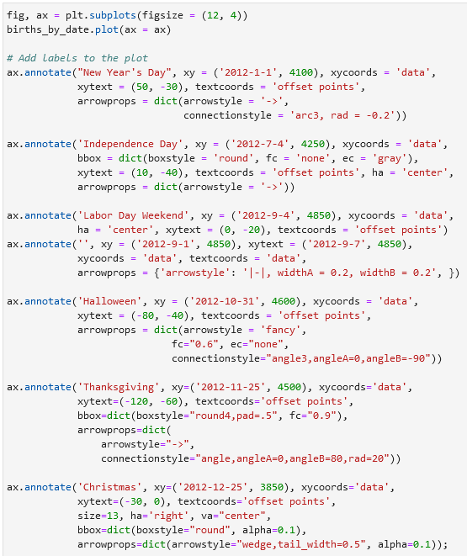

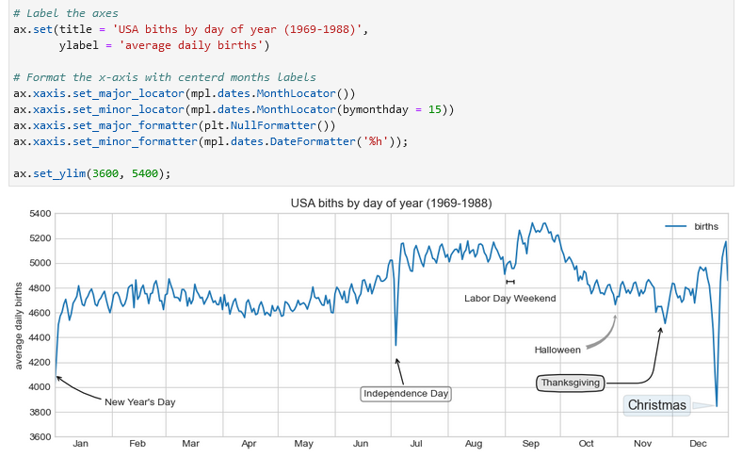

**Customizing ticks**

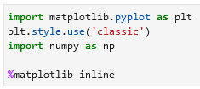

**Major and minor ticks**

Example with major and minor ticks:

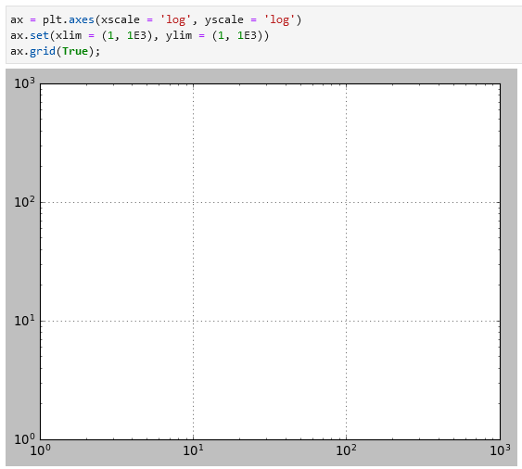

**Hiding ticks or labels**

Example without hiding ticks or labels: Use .set_major_locator(plt.NullLocator()) or .set_major_formatter(plt.NullFormatter()) to hide axis ticks or labels:

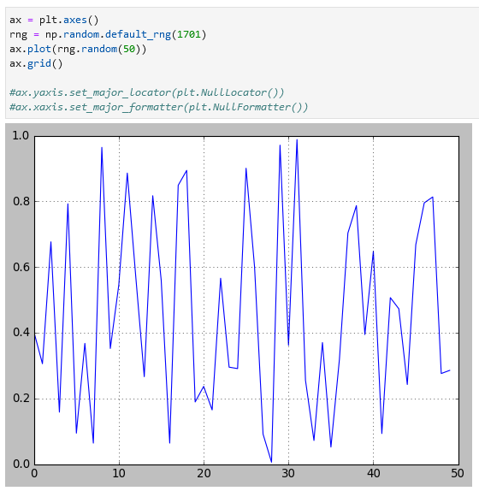 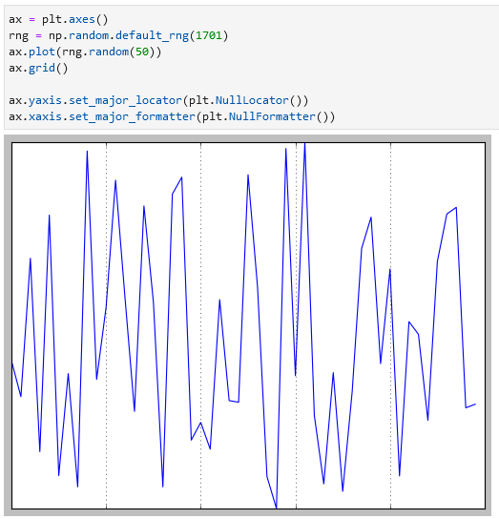

**Reducing or increasing the number of ticks**

If you want to reduce the number of ticks you can specify the maximum number of ticks using .xaxis.set_major_locator(plt.MaxNLocator(number)) or the same for .yaxis. Example:

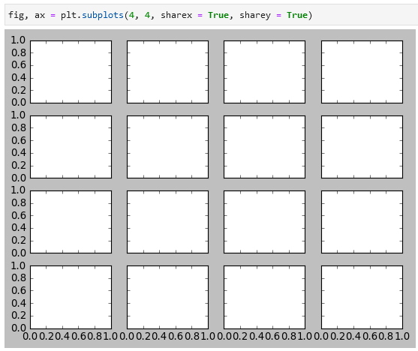 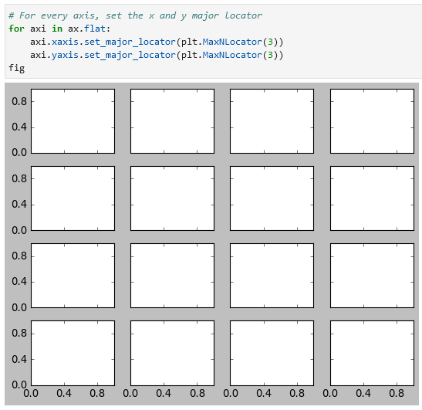

**Fancy tick formats**

LaTeX note: $\pi$ is *pi* or symbol *π* in Matplotlib’s LaTeX support.

If you have a sine and a cosine curve (left example) you might want to change the axis to be displayed in terms of *pi* (example on the right).

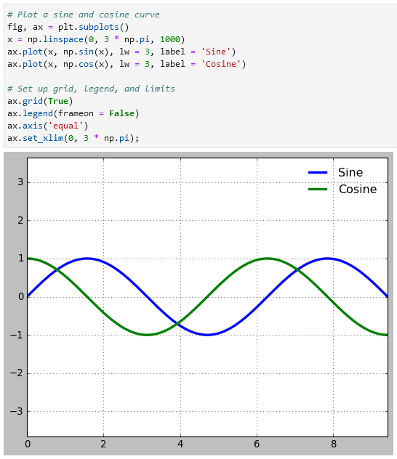 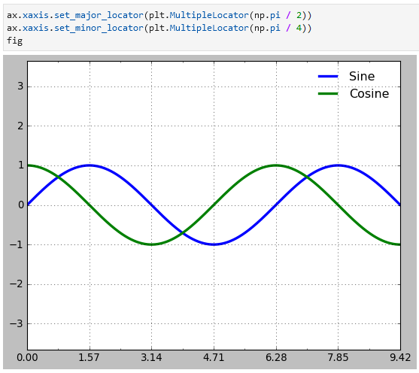

You can go even further and add the *pi* symbol using plt.FuncFormatter:

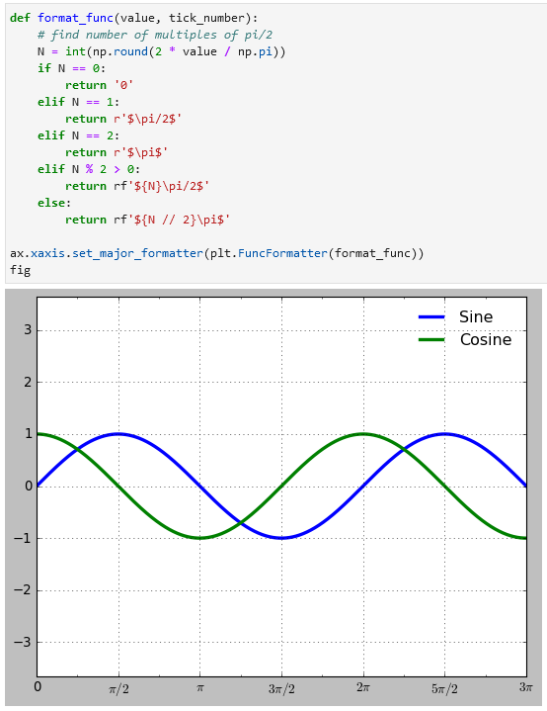

**Summary of formatters and locators**

List of all built-in plt. locator options in Matplotlib:

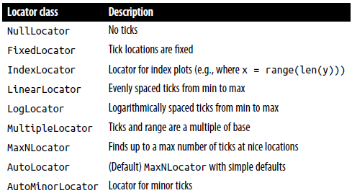

NullLocator, FixedLocator, IndexLocator, LinearLocator, LogLocator, MultipleLocator, MaxNLocator, AutoLocator, AutoMinorLocator

List of all the plt. formatter options in Matplotlib:

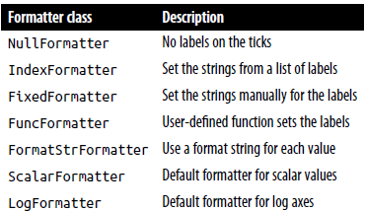

NullFormatter, IndexFormatter, FixedFormatter, FuncFormatter, FormatStrFormatter, ScalarFormatter, LogFormatter

**Customizing Matplotlib: Configurations and Stylesheets**

**Plot customization by hand**

Example of two histograms with default settings and with manual settings (left and right):

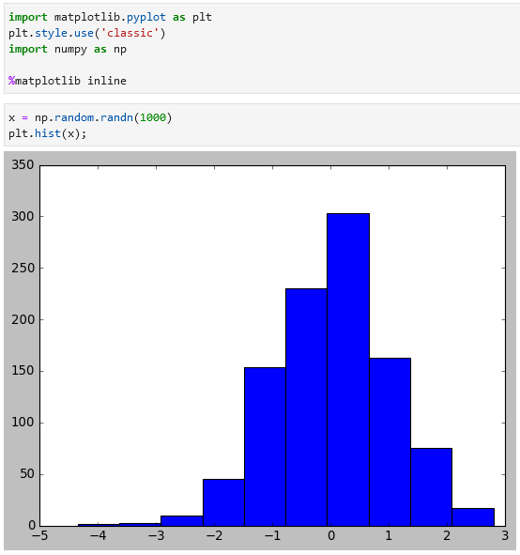 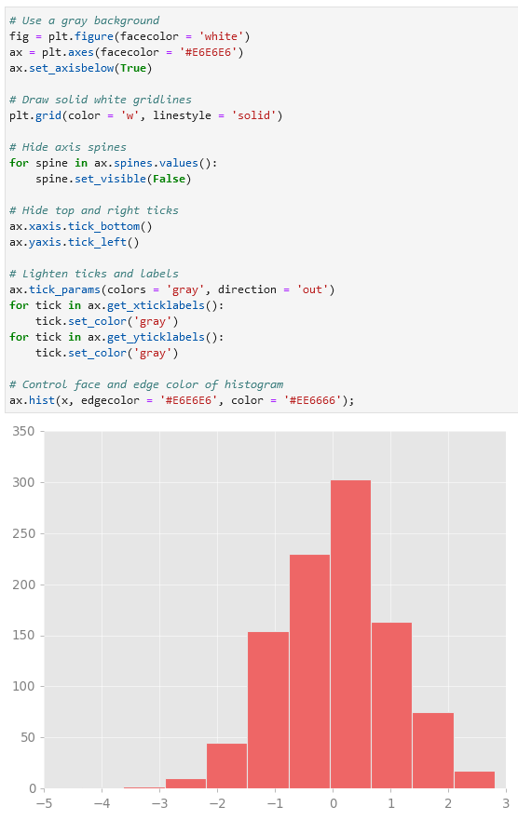

**Changing the defaults: rcParams**

Use plt.rc() to change the defaults. These defaults can also be saved in a *.matplotlibrc* file.

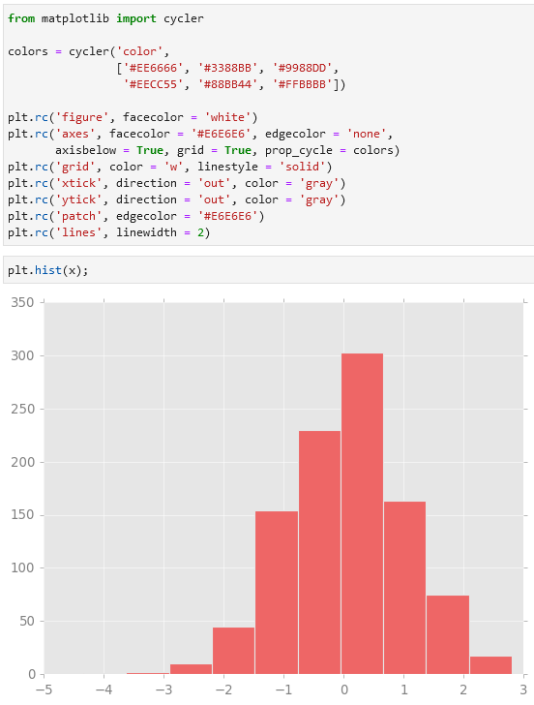

**Stylesheets**

A newer mechanism for adjusting overall chart styles is via Matplotlib’s style module, which includes a number of default stylesheets, as well as the ability to create and package your own styles. These stylesheets are formatted similarly to the *.matplotlibrc* files, but must be named with a *.mplstyle* extension.

Check the first five styles available in Matplotlib using plt.style.available:

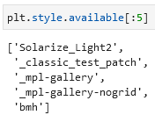

To *select a style permanently for the whole session* use plt.style.use(stylename):

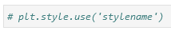

To *select a style temporarily* use:

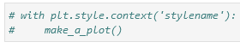

**Examples of stylesheets**

Default:

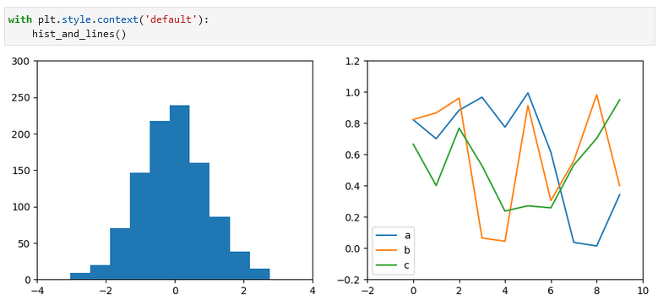

538 or fivethirtyeight:

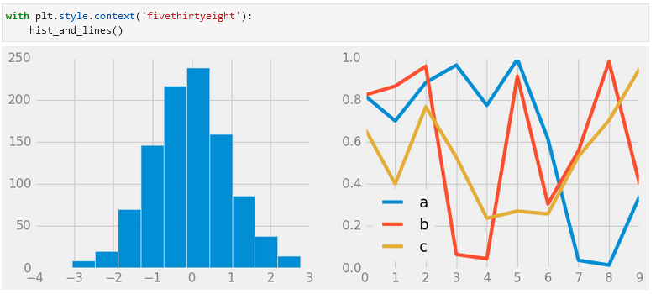

ggplot:

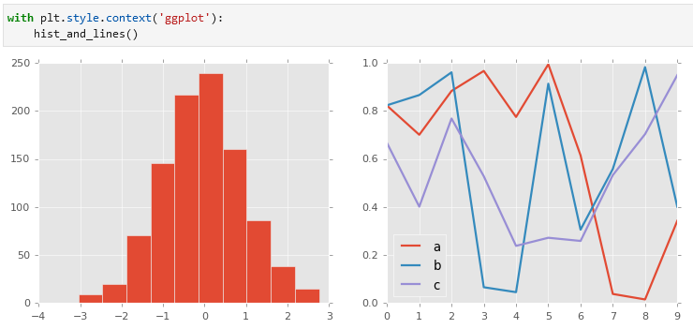

Bayesian methods for hackers style (bmh):

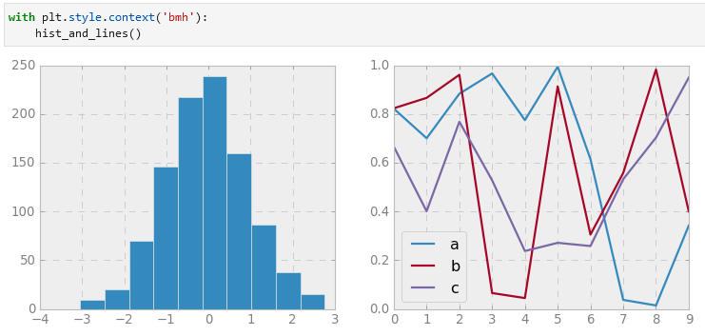

Dark background:

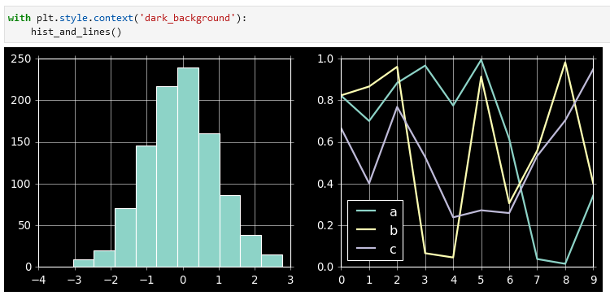

Grayscale:

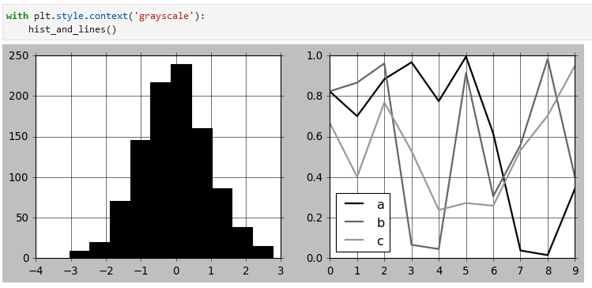

Seaborn style:

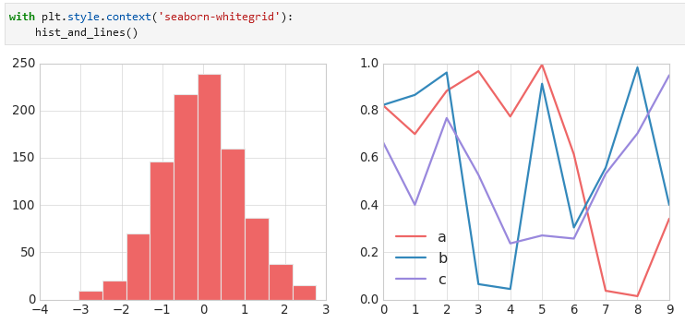

**Three-dimensional plotting in Matplotlib (3D-plotting)**

To create an empty 3D-figure in Matplotlib first import the mplot3d library. After than specify in the plt.axes(projection = '3d'):

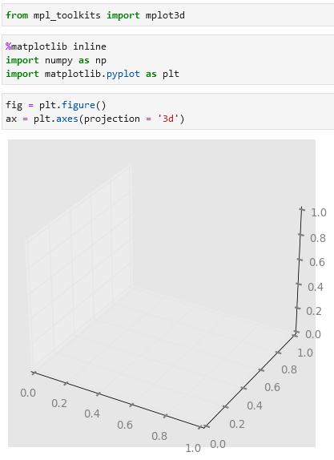

**Three-dimensional points and lines**

Plotting a 3D-lineplot and a 3D-scatterplot using ax.plot3D() and ax.scatter3D():

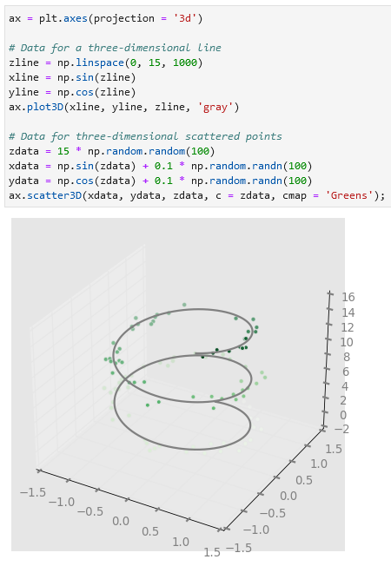

**Three-dimensional contour plots**

Use ax.contour3d() to plot a 3D contour plot:

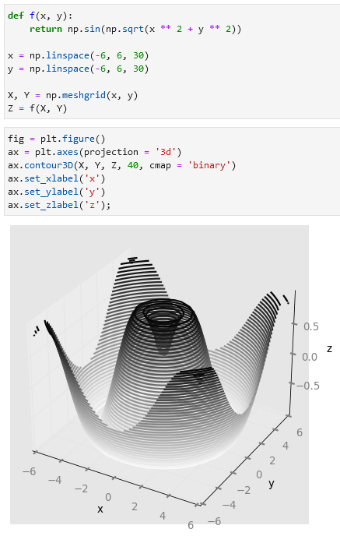

To change the viewing angle use ax.view_init(). The first number is rotation above the *x-y* plane and the second is counter-clockwise rotation about the *z*-axis.

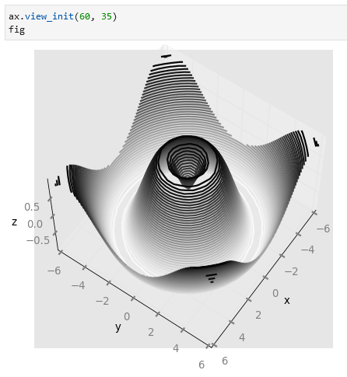

**Wireframes and surface plots**

Make a wireframe plot using ax.plot_wireframe(X, Y, Z): Make a surface plot using ax.plot_surface(X, Y, Z):

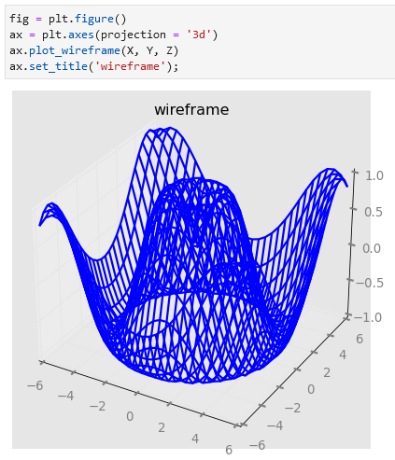 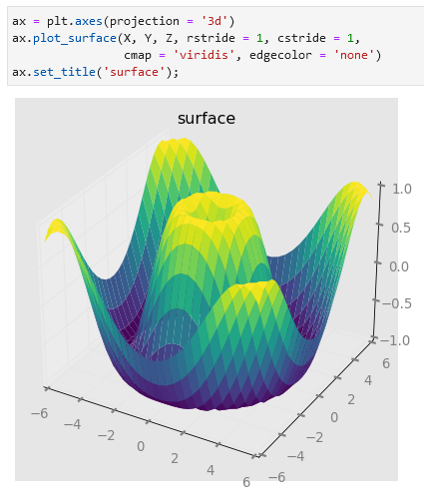

Example with a polar surface plot (a plot that does not have a part):

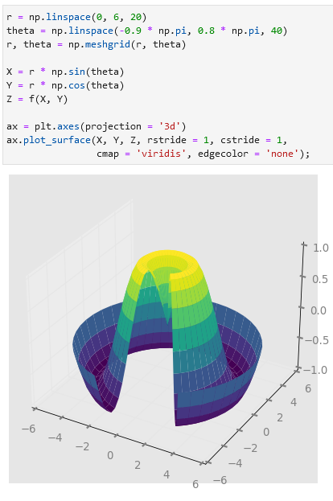

**Surface triangulations**

Example of a 3D sampled surface plot: A somewhat better version using ax.plot_trisurf():

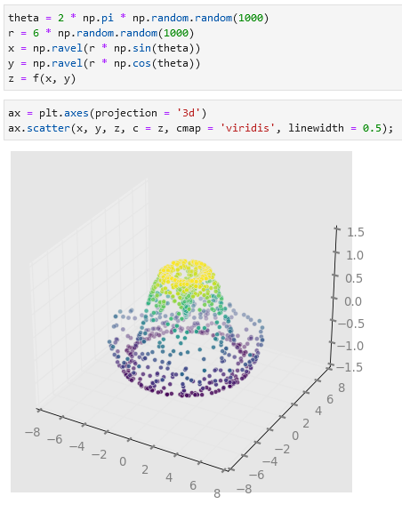 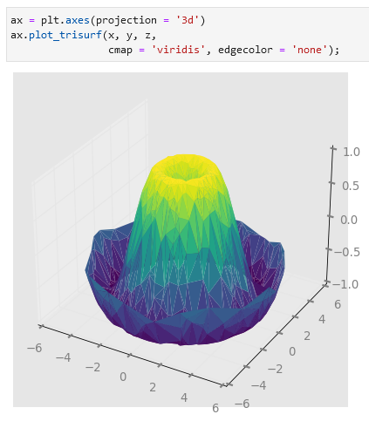

**Visualization with Seaborn**

**Importing Seaborn** is done using import seaborn as sns:

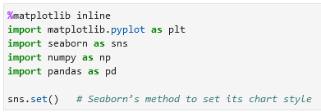

**Histograms, KDE, and Densities**

You can use a histogram to visualize a distribution, like here below using plt.hist():

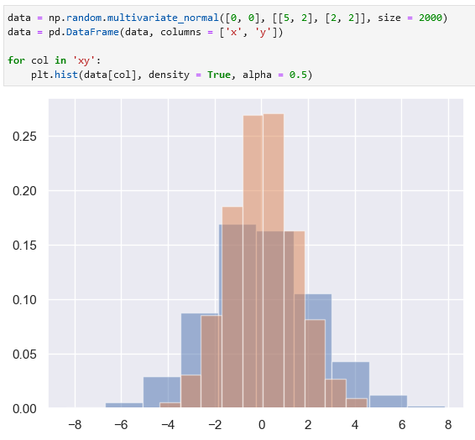

Or, as an alternative, you can use sns.kdeplot() to plot a KDE-plot to get a smooth estimate of the distribution:

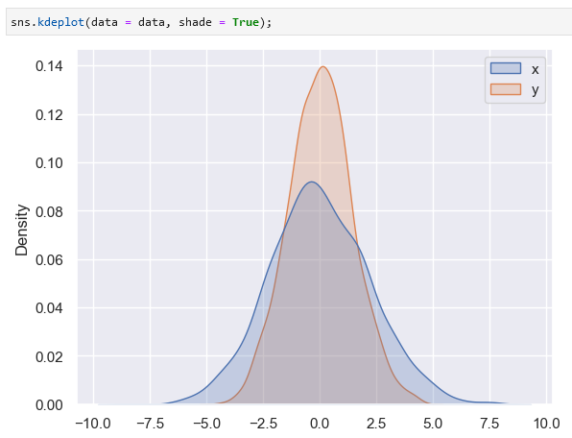

To plot a two-dimensional kernel density plot pass (set) *x* and *y* columns:

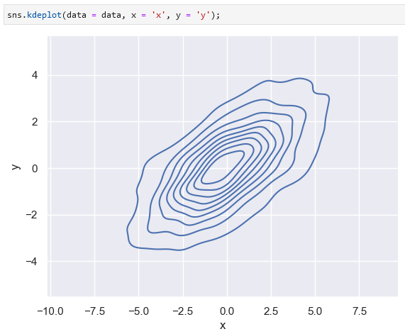

**Pair plots**

If you want to plot multiple graphs (an overview) of relationships between variables, you can use sns.pairplot():

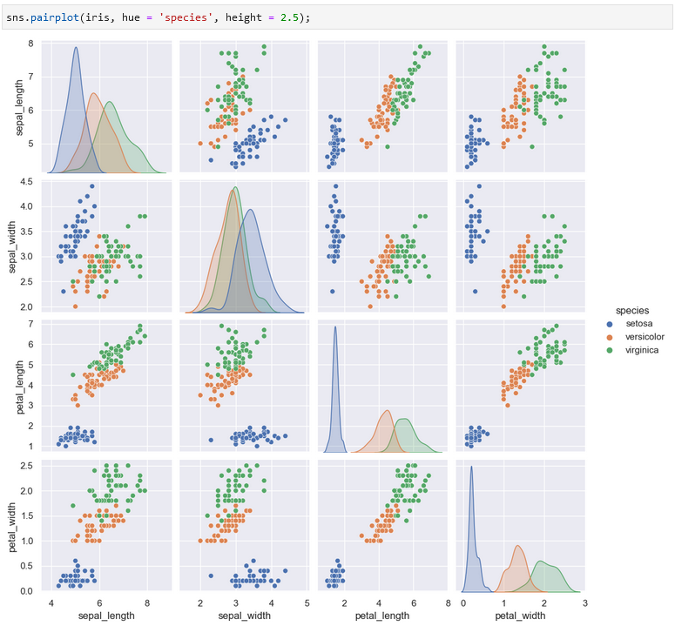

**Faceted histograms**

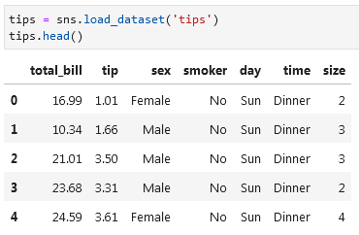

If you want to create a segmented histogram on several categories, you can use sns.FacetGrid() and .map():

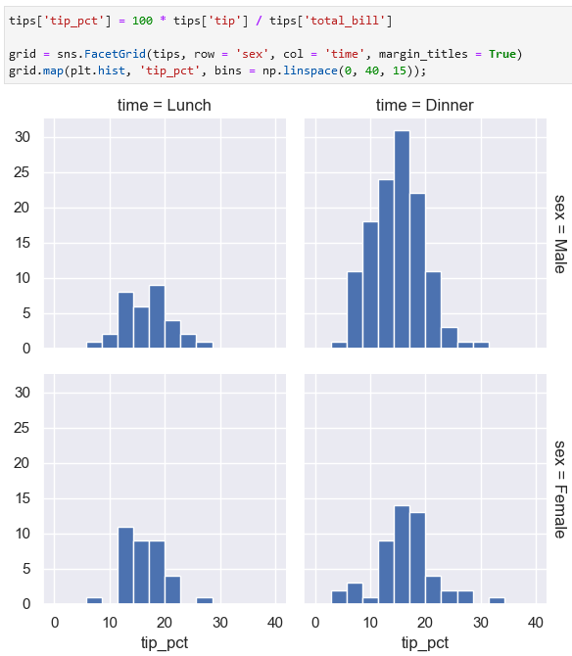

**Categorical plots**

Example of a factor plot that compares distributions given various discrete factors. It can be built using sns.catplot():

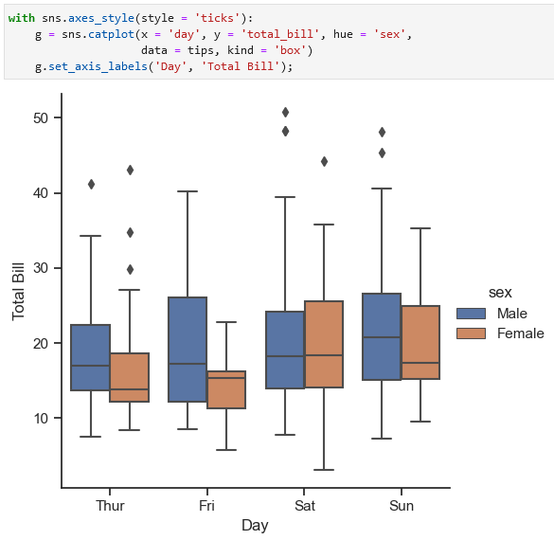

**Joint distributions**

To build a joint distribution plot use sns.jointplot():

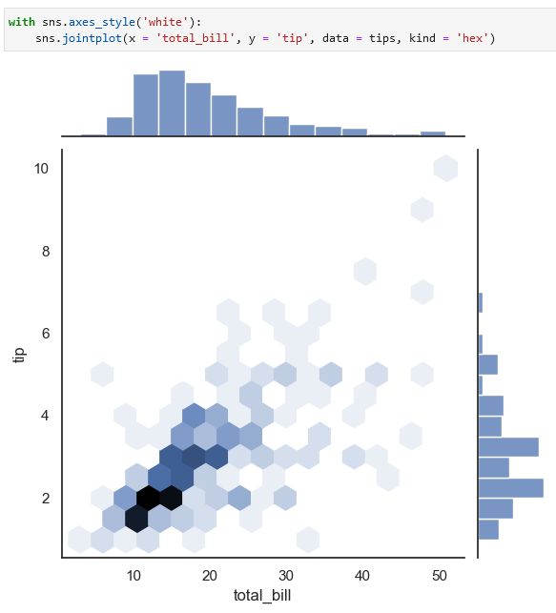

You can also plot a join distribution plot with a regression fit (“automatic KDE and regression”):

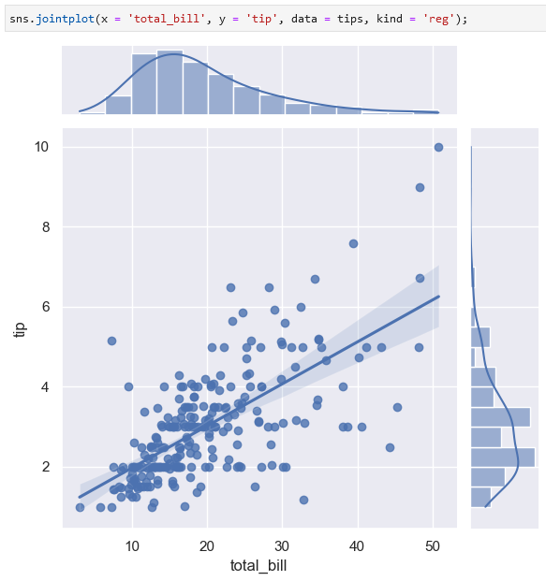

**Bar plots**

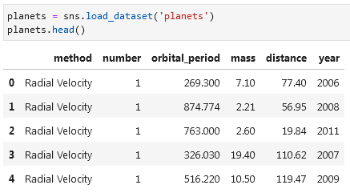

To get a bar chart use sns.catplot():

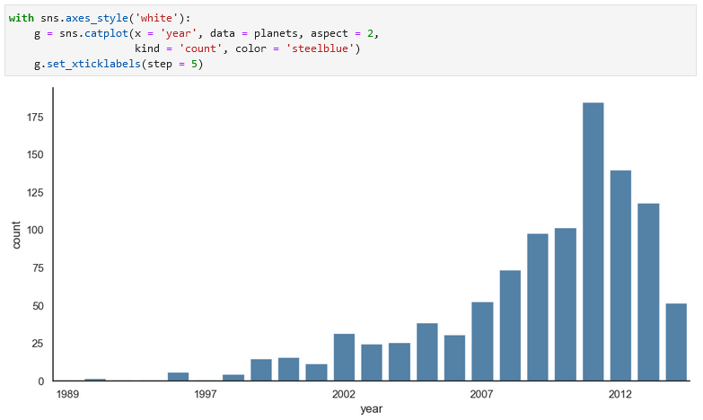

Example with a hue feature:

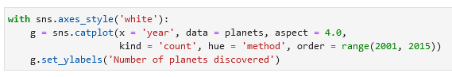

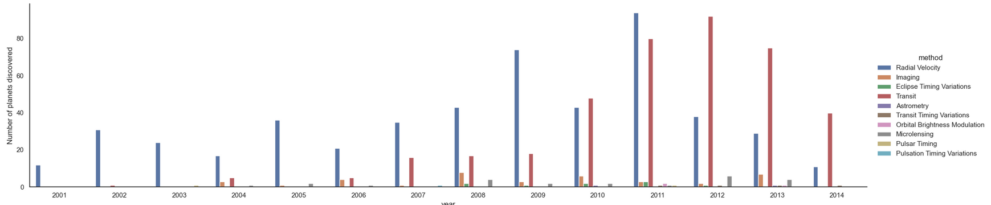

**Example: exploring marathon finishing times**

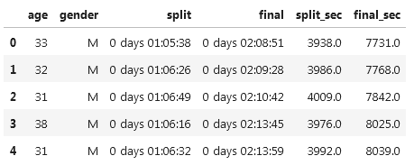

Plotting an sns.jointplot():

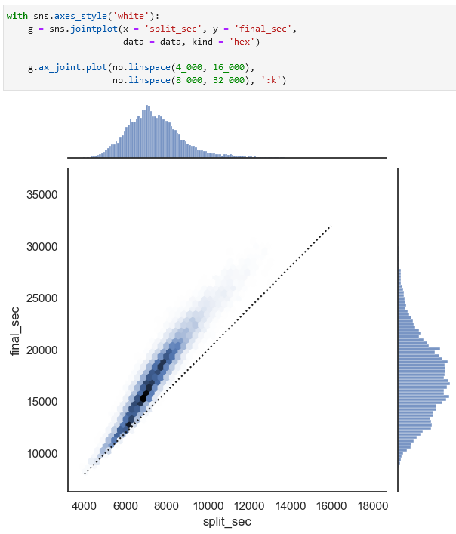

Example of a sns.displot() and a plt.axvline():

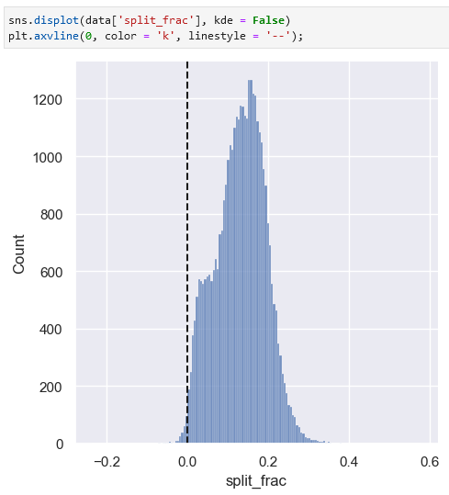

Plotting an sns.PairGrid():

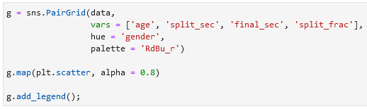

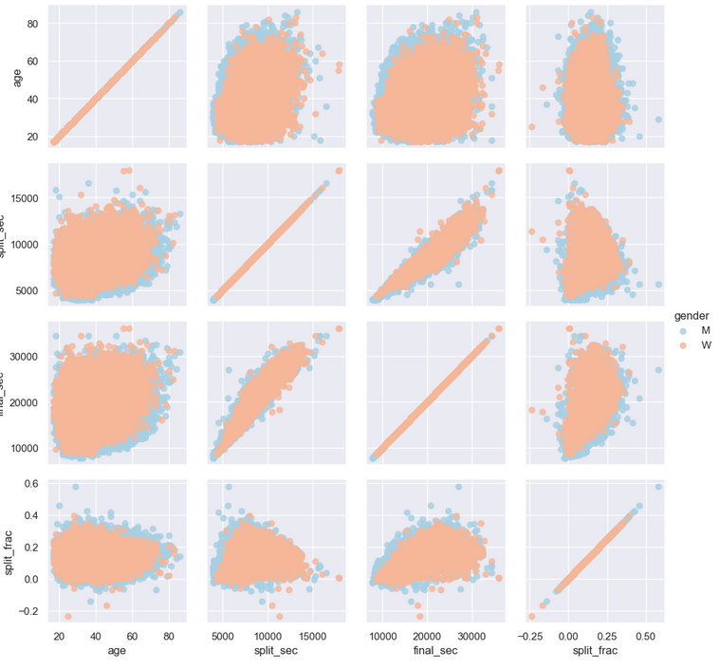

Distribution of split fractions by gender (sns.kdeplot()):

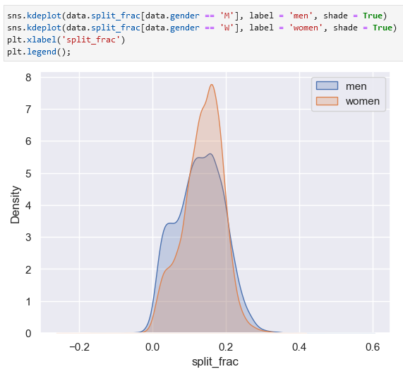

A violin plot can be built using sns.violinplot():

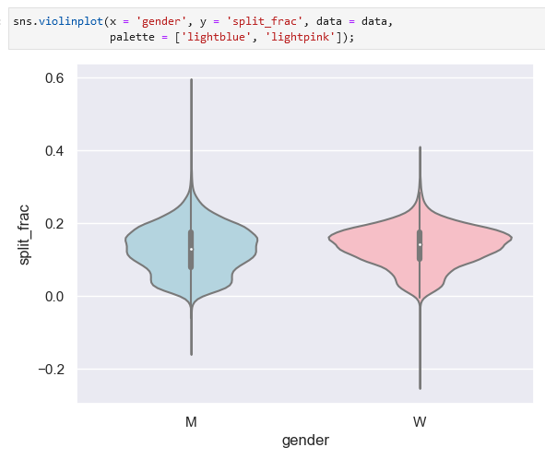

Adding an age group column:

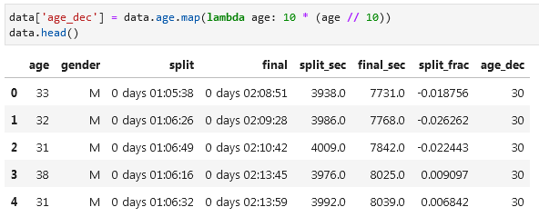

Plotting a violin graph (sns.violinplot()):

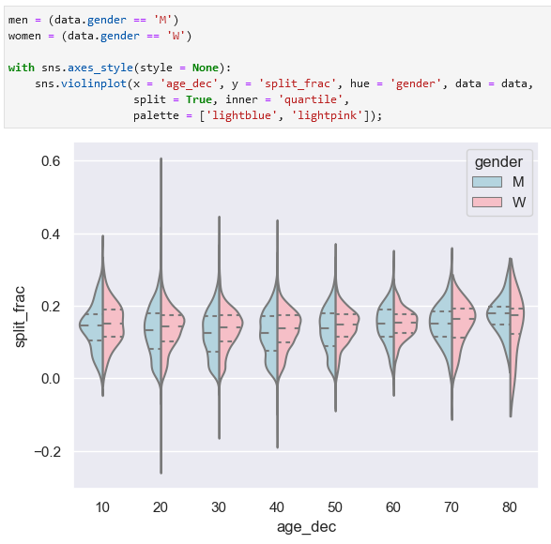

Split fraction plot (sns.lmplot()):

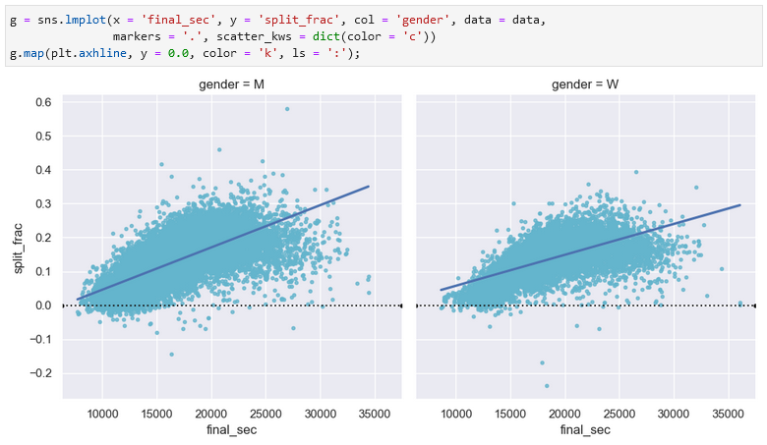

**Machine Learning**

Categories of ML:

* Supervised learning
  + Classification tasks
  + Regression tasks
* Semi-supervised learning
* Unsupervised learning
  + Clustering tasks
  + Dimensionality reduction tasks

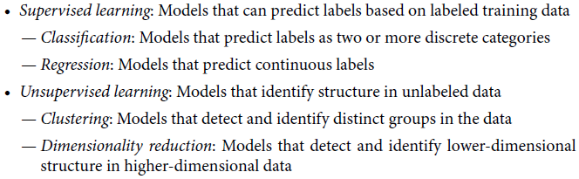

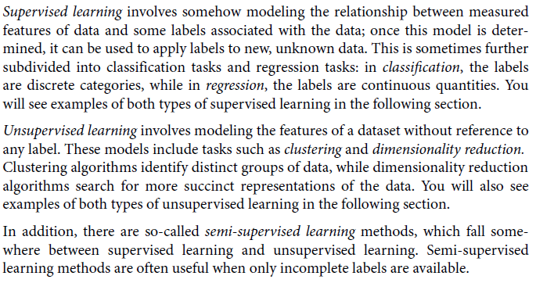

**Supervised learning | Classification: predicting discrete labels**

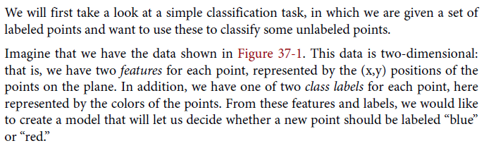

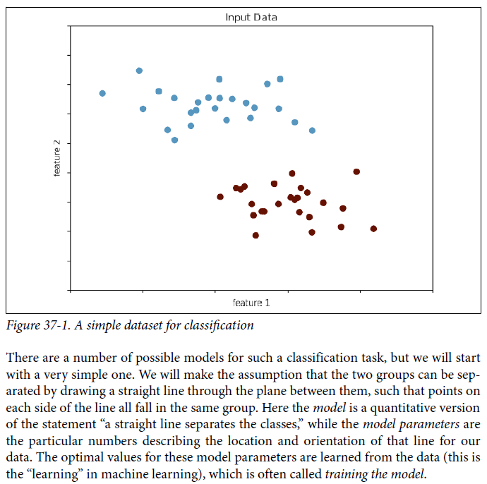training the model

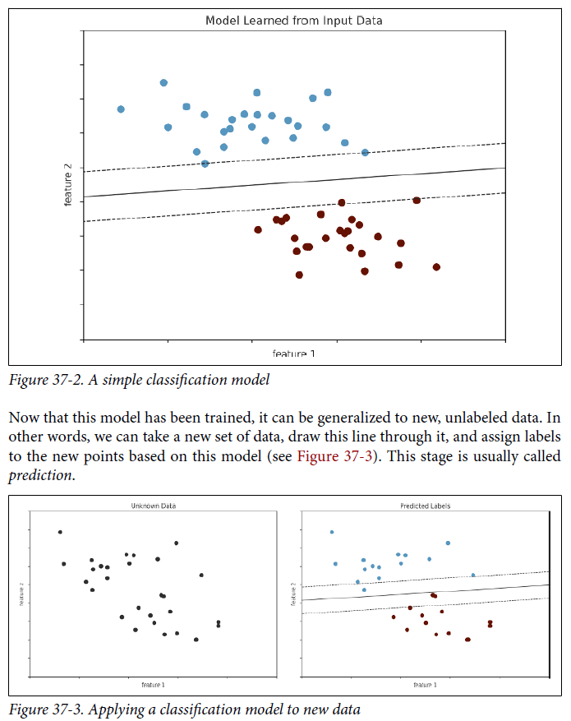prediction in machine learning

**Supervised learning | Regression: predicting continuous labels**

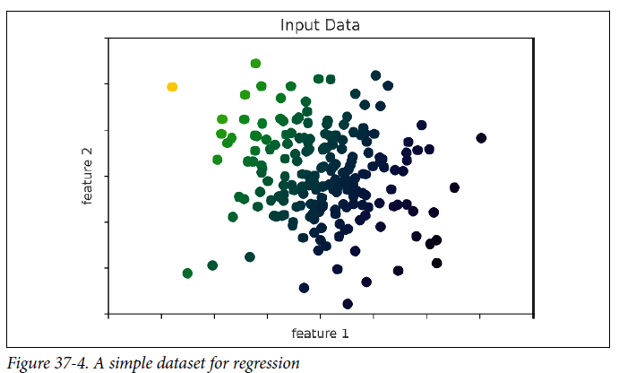

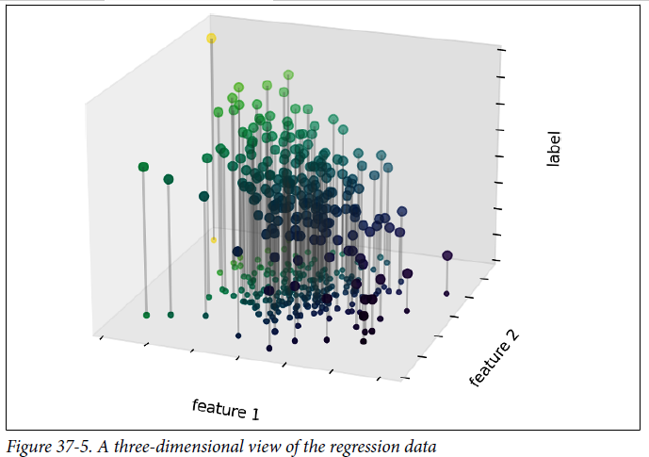

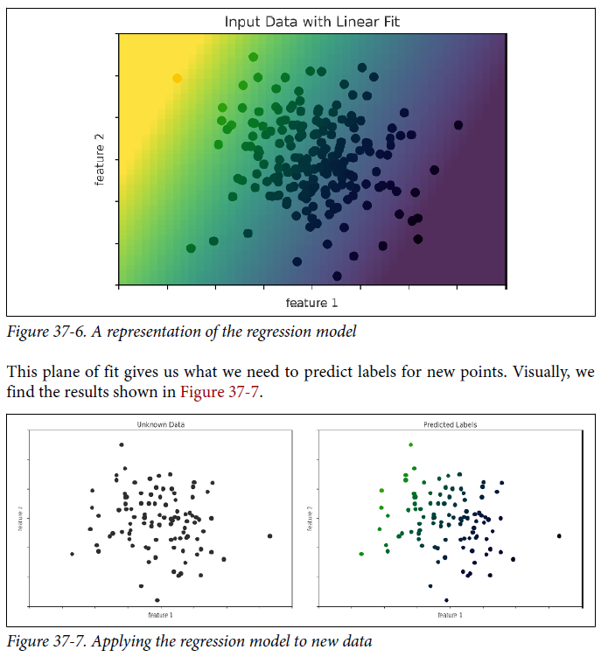

**Unsupervised learning | Clustering: inferring labels on unlabeled data**

Unsupervised learning involves models that describe data without reference to any known labels. One common case of unsupervised learning is “clustering,” in which data is automatically assigned to some number of discrete groups.

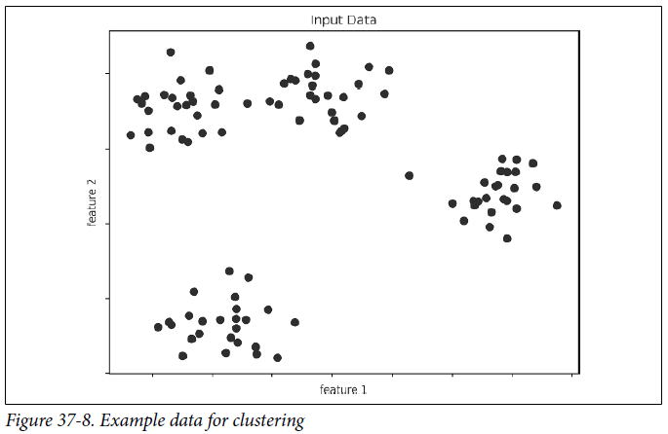

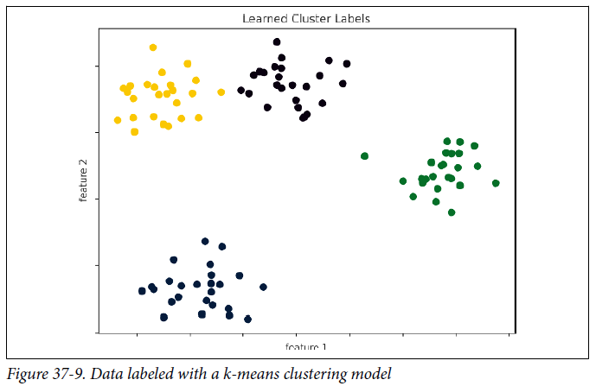

**Unsupervised learning | Dimensionality Reduction: inferring structure of unlabeled data**

